^{LUDEN}
^{General Assembly Meeting}
&
^{Study Tour 2015}

11 – 13 June 2015, Vantaa and Helsinki

^{AGENDA & INFO PACK}

In case of Emergency
Contact: Haroon Saad, Director 0032 498123403; h.saad@ludenet.org
Chiara Vestrini, Project Coordinator 0032 485661371; chiara.vestrini@ludenet.org
Marianna Mattera, Project Assistant 0032 488352590; m.mattera@ludenet.org
Jacopo Troise, Project Assistant 0032 489674492 ; jacopo.troise@ludente.org
Agenda
Thursday 11 June

Arrival of the participants
Hotel (see info pack below)

LUDEN General Assembly Meeting
Venue: Kielotie 13, 01300 Vantaa
(see infopack below)

AGENDA
***15.00 Start of Meeting***

15:00 Welcoming speech by City council member Ranbir Sodhi, Chair of Advisory Board for Multicultural Affairs, City of Vantaa (Meeting room is located at basement floor)
15:10 LUDEN General Assembly Meeting (room 391a)
- Announcements and Apologies
- Adoption of Agenda
- Admission/Presentation of New Members
- Approval of minutes of the 2014 General Assembly in Birmingham
- Report of the Activities of the Association since the last General Assembly
- Report and approval of accounts 2014
- Any other business

16:00 Presentation by Vantaa on pattern and trends of immigration/migration.
Issues and challenges faced.
16:20 Discussion
16:40 Introduction to “Sports for All” project
17:00 Tea/Coffee and sandwiches
Interpretation provided in English, French
17:30 Depart for Nordic Walking
19:45 End of Nordic Walking
20:15 Arrive at restaurant by Nordic Walking
20:15 Dinner at “La pasteria italiana” restaurant (see infopack below)

Friday 12 June

Workshop on “Second Generation +: a European perspective”
Venue: City Hall, Asematie 7, 01300 Vantaa (see infopack below)

9:00 Welcoming and setting The European context - presentation by Haroon Saad,
LUDEN Director
09:45 Presentation of study on the impact of the European Integration Fund on Finland – presentation by Maryan Hussein, Moniheli ry NGO Helsinki
10:15 Migrant Women in Finland – presentation by Jenni Tuominen, Managing Director, Monika NGO Helsinki
11:00 Coffee Break
11:30 Vantaa presentation: Multicultural program and partnership with NGOs
12:00 Introduction to the excursion organized by Vantaa City planning department, presentation by Johanna Rajala
12:30 Excursion in Vantaa neighborhoods by bus
13:15 Lunch
17:00 Back to the hotel by bus
Interpretation provided in English, French
18:00 Reception hosted by Mayor of Vantaa, Kari Nenonen
Venue: City Hall, Asematie 7, 01300 Vantaa (see infopack below)
19:30 Meeting to leave by bus for having dinner
20:00 Dinner at Hakunila international NGO
22:30 Back to hotel by bus

Saturday 13 June

9:30/45 Train to Helsinki
10:45 Meeting in the lobby of the Holiday Inn Helsinki (see infopack below)
11:00 – 13:00 City guided Tour with a coffee break
13:00 End of AGM and Study tour

Afternoon free

Info Pack

All the AGM/Study Tour participants will stay at the Sokos Hotel in Vantaa until Saturday 13 June.
Those staying until Sunday 14th will be staying on Saturday in Holiday Inn Hotel in Helsinki.

Those delegates who are paying their own hotel costs will separately receive details from LUDEN as to what will be the cost that the hotel will charge. All other participants have already paid.
Please note that all extras will be paid directly by all participants

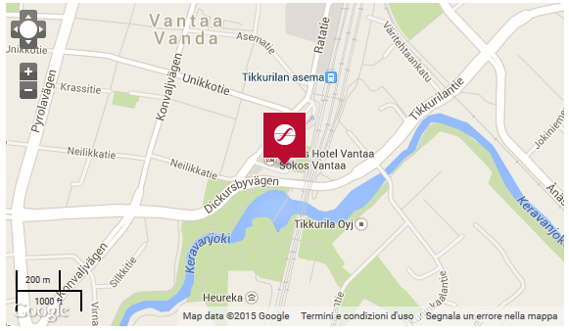
CONTACT INFORMATION
Sokos Hotels Sales Service Center
Hertaksentie 2
Tel. +358 20 1234 600 or 09 4153 4612
Mon-Fri 8 a.m. - 8 p.m.

How to reach the hotel from the Airport
Arriving to Sokos Hotel from the Helsinki Vantaa Airport is very easy. BUS 61 leaves from platform 1B in front of the airport, you need to get off at Tikkurila Station (please note that it is not the final stop!). The journey time is approx. 30 minutes, and the station is located only about 100m from the hotel. The ticket cost is 2.80 euro.
For those who will arrive at the airport late in the evening, bus number 61 goes to Tikkurila Station every half an hour, all night long. If the bus timetable does not fit with your arrival, you can take a taxi that will drive you to the hotel for approx.44 euro.

Helsinki-Vantaa Airport
POB 29, FIN-01531 Vantaa, tel. +358 9 82 771, fax +358 9 8277 3296, Info 24 h 0200 1 4636 (chargeable), www.helsinki-vantaa.fi
International and domestic terminal open 24 h.
Travelpoint, travel services, POB 30, 01531 Vantaa, tel. +358 9 6151 3900, fax +358 9 6151 3988, www.airpro.fi Mon-Sun 8-21

Trains
From Vantaa railway station to Helsinki there is a train leaving each 10 minutes since 8:07am, and it takes 22 minutes.
Instead, from Helsinki to the Airport please check the railway company website: https://www.vr.fi/cs/vr/en/frontpage .

VENUES
N.B: Our sessions are NOT in the same location

Thursday 11 June

Kielotie 13, 01300 Vantaa – 550m walking distance from the hotel

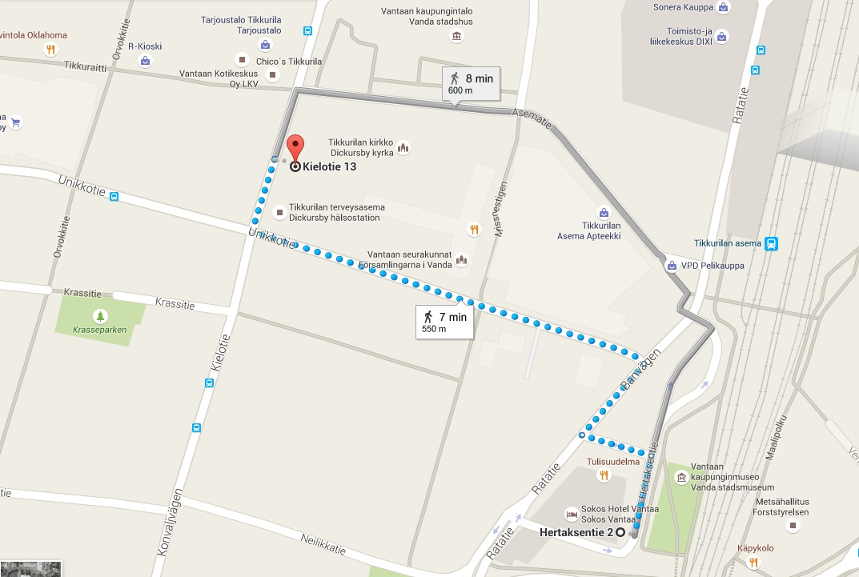

Friday 12 June

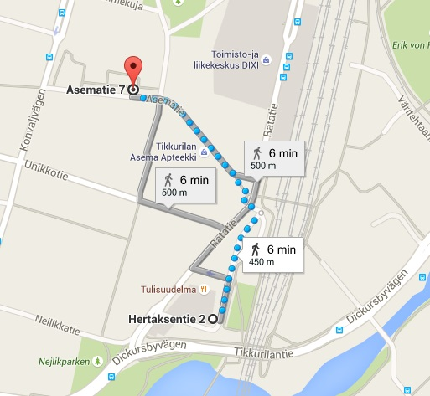
City Hall, Asematie 7, 01300 Vantaa - 450m walking distance from the hotel

Saturday 13 June

Helsinki Holiday Inn Hotel City Center (departure for the guided tour) – see Info Pack below

DINNER RESTAURANTS

Thursday 11 June

La Pasteria italiana, Ratatie 11 (Kauppakeskus Dixi, 3 krs.) – 220m walking distance from the hotel

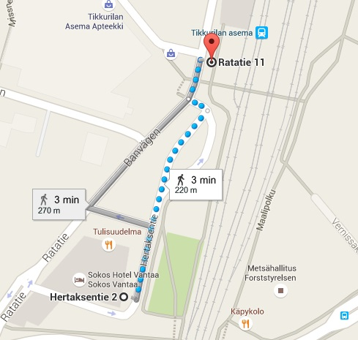

Friday 12 June

Hakunila international NGO – departure by bus from the reception venue

HOTEL SATURDAY 13th

Holiday Inn Hotel City Center
Elielinaukio 5, 00100 Helsinki
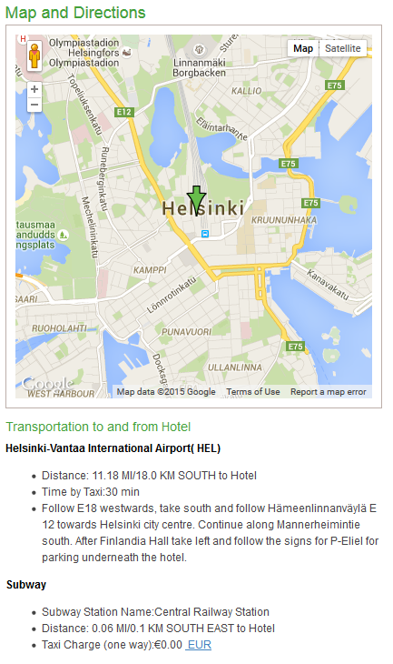+358 9 54255000

