MILE- Managing Migration and Integration at local Level-
cities and regions

MAPPING LOCAL ISSUES AND NEEDS

LOCAL MAPPING TEMPLATE

City | Torino
Department/ Organisation | City of Torino
Name of author | Hélène Monjarret
Date | 04/08/2007
Summarise the current situation and main issues related to migration in your city supported by figures and breakdowns by age, gender and ethnicity/nationality (1 to 3 pages maximum)
Piemonte Region is a historical region for arrival of migrants people: inside-migrants or immigrants. Now-a-days, inside-migrants are still arriving but obviously foreign immigrants are largely prevailing. Piedmont is an attractive region with relevant job opportunities, a region where activity increases and native population decreases. Recent immigration follows two main different trends: one of working immigration and one family reunion; which tends to mean that it is not a short-term immigration but a long-term one. This idea is reinforced by a few other elements: an increase of birth, a lower geographical mobility and a stronger integration at work.

The growth of this population is constant but goes through different phases of acceleration and slow down. Presently, the increase of the foreign population is slowing down.
At the end of 2006, there were 84.838 foreign residents in Torino which means 9,4% of the whole population, with a substantial parity between men and women. Between 1993 and 2001 the quote of young people (under 25) increased when the middle-age people (25-39) fell down and at the same time, the gap between gender component also reduced until arriving very near to parity. From then feminine component continued to grow up till reaching 49% of foreign presence in 2005. Minor component of the foreign resident population represent steadily in the years around a third of the whole.
Torino and the region follows more or less the same tendencies regard to immigrants’ origins. The first 15 nations of origin in Piemonte Region are the following ones in decreasing order: Romania, Morocco, Albania, China, Peru, Macedonia, Ukraine, Senegal, Tunisia, Moldavia, Philippines, Ecuador, Nigeria, Egypt and Brazil. The first three represent more than 60% of the foreign population in the region. Until a few years ago, the Moroccan community was the dominating one in the figures, but the part of Eastern European immigrants, particularly from Romania has constantly increase to become the most numerous one. In Torino, from 1995 to 2005 the Eastern European community grew from 13,2% of the foreign residents to 41%. As far as immigration phenomenon is becoming structural, entrepreneurship is a significant element to consider. In Torino and Piemonte Region, the foreign entrepreneurs and free-lance workers are in constant increase. The sectors of activity are mainly services and ethnic-based activity, but also building sector and the trend is diversification of the foreigner’s activities.

The City of Torino recently changes its approach of integration and defines three main guidelines for action planning: the first one concerns new comers and the will to create and organise a real specific service for them; the second axis is to guarantee equal access to ordinary services for all; and finally, a the most strategic aspect of Torino integration policy is the gamble on the second generation as the main asset for building the future.

Foreign residents from 1992 to 2005 – Torino
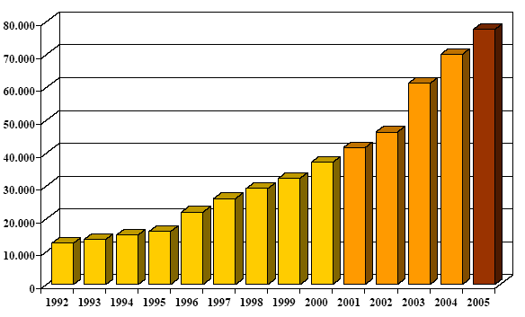

Repartition of foreign residents for continental origin - Torino 2006
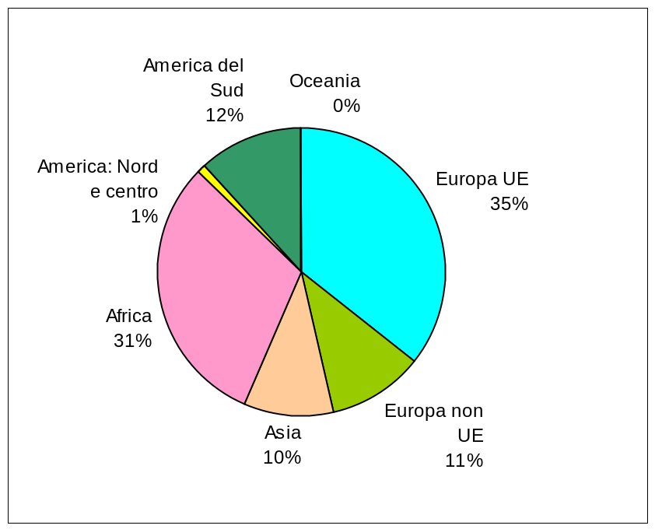
Source: Città di Torino

Age distribution of migrant population by gender in Piemonte– census 2001 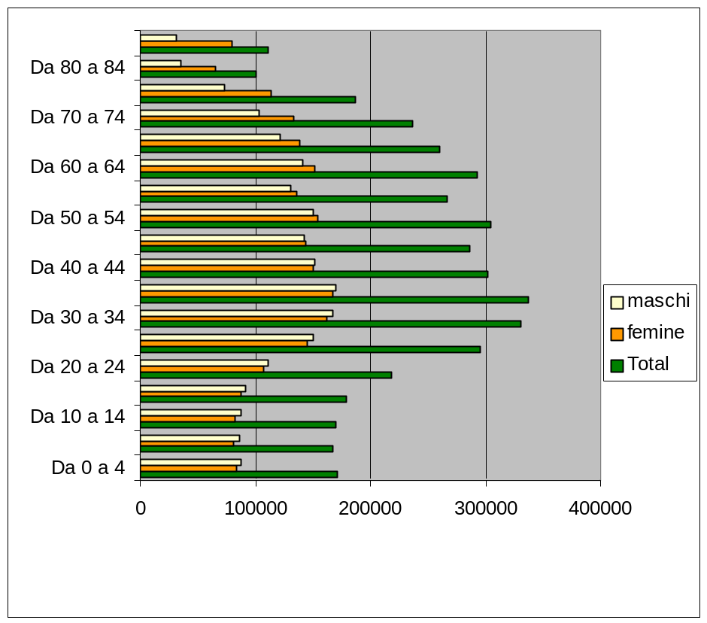
Source: Osservatorio sull’Immigrazione del Piemonte

Age distribution of migrants in Piemonte – census 2001
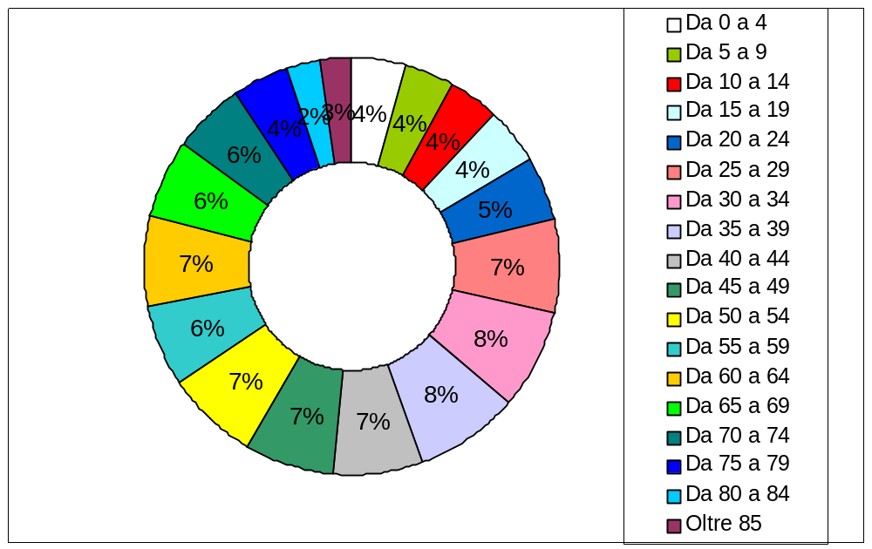
Source: Osservatorio sull’Immigrazione del Piemonte.

Foreign workers by professional position – Torino 2005
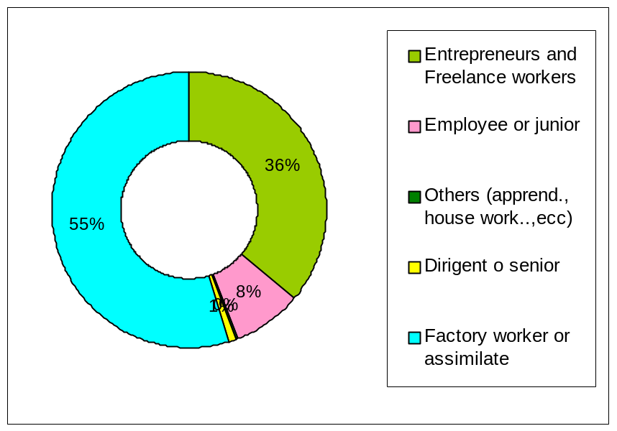
Source: Osservatorio interistituzionale sugli stranieri in provincia dei Torino.

Foreign entrepreneurs and freelance workers in Torino (2000-2005)
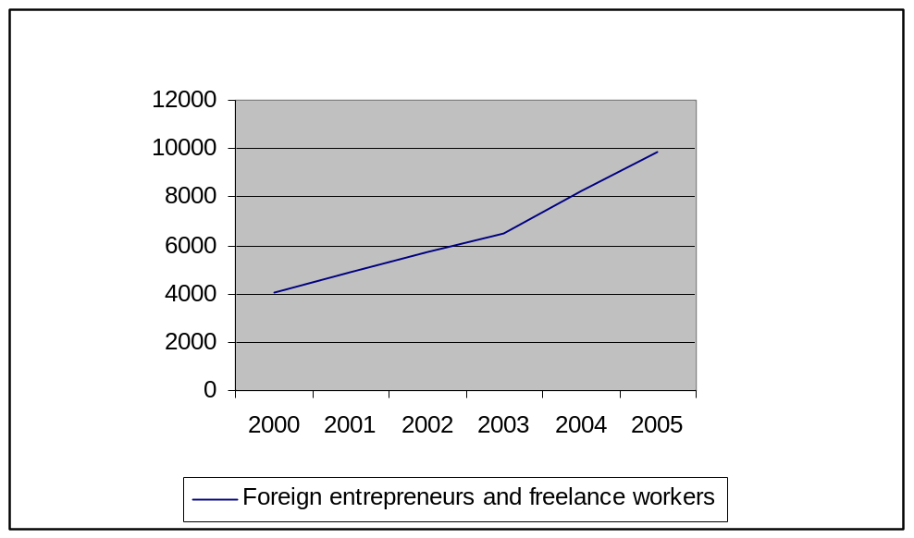
Source: Osservatorio interistituzionale sugli stranieri in provincia dei Torino.

Foreign entrepreneurs, by sectors of activity and by gender - Torino (2005)
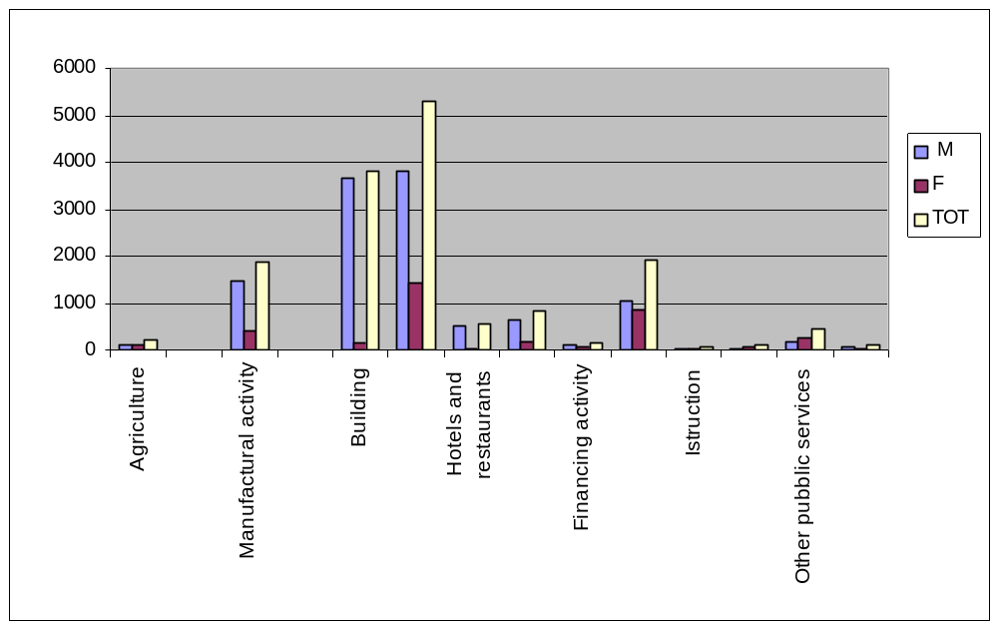
Source: Osservatorio interistituzionale sugli stranieri in provincia dei Torino.

Self-employed foreign workers by gender and origin - Piemonte Region (2005)
Source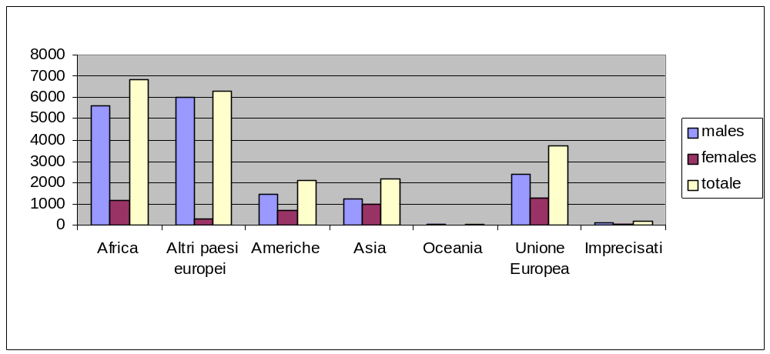: Osservatorio interistituzionale sugli stranieri in provincia dei Torino.

Percent of foreign students on whole students in each scholar level

Source: Osservatorio interistituzionale sugli stranieri in provincia dei Torino.
Scholar level | A.S. 2004 - 2005 | A.S. 2005 - 2006
Infance | 6,40 % | 7,08%
Primary | 7,81% | 9,25%
Secondary 1° grade | 6,77% | 8,14%
Secondary 2° grade | 4,02% | 5,40%
Medium percent | 6,24% | 7,52%

Roma people in Turin area, 200

Source: Settore Stranieri e Nomadi, Città di Torino.
Roma officially registered | 720
Estimation of effective Roma presence | 1000
under-18 Roma officially registered | unknown
Estimation of effective under-18 Roma presence | unknown
under-18 Roma at school | 220

Theme 1: Enterprise development for ethnic minorities
Business support (financial): in terms of the availability of credit for ethnic minorities and whether finance meets the varied needs in diverse client groups

What are the actions undertaken/services provided to meet migrants’ needs in relation to this theme and what are the results obtained so far?

There is no particular business support existing in terms of the availability of credit for ethnic minorities. However the measures in favour of entrepreneurship are accessible to foreign resident business-owners.
For example, some national laws encourage some categories of population like young entrepreneurs (under-25).
The City has also an action on incitation of commercial investments or business creation and offers regularly opportunities of micro-credits or financing on easy terms, arranged with partner banks. It exist one project of the City in partnership with professional associations, Mi.CRE.O witch aims to feminine self-employment through a program of micro-credit involving women participation in planning process.

A European Project of the Province CO.ME project, has an axis on micro-credit for self-employment in foreign population with the experimentation of a fund of alternative finance. In 2005, 5 projects of enterprise were financed and the project is continuing until 2009. The project schedules also the creation of an integrated system of specialized services. Limit: a very targeted project without a large scale action.

What are the priority needs not met by these services/actions?

The policy of the City is not to create programs of financial support for foreign immigrants so far as its approach is undifferentiated. What could be done are anti-discriminatory and anti-prejudice actions.

Theme 1: Enterprise development for ethnic minorities
Business support (non-financial): what kind of business support systems are available and if they meet the needs of ethnic minorities

What are the actions undertaken/services provided to meet migrants’ needs in relation to this theme and what are the results obtained so far?

The City in this case as on many other themes work in collaboration with the other services of the territory and do not repeat them.

In fact, the Chamber of commerce is, in Italy, the first reference for business support: it furnish assistance and information to every person that has a commercial activity or wants to start one. The Chamber organises also courses for future entrepreneurs. During the years it adapt to the increasing demand of foreigners and has developed instruments and studied targeted actions to support foreign citizens’ initiatives. No precise data on this. For example, a dictionary Words of Entrepreneurship was published and distribute for free in the Chamber. From the launch of the online services, most of the persons that avail from the desk service are foreigners so that they have a lower access to internet services and less instruments to understand it.

An other important support is furnished by the entrepreneurial associations which propose many services, including formation. There are no precise data on the participation of foreign entrepreneurs available.

As a complement, the Counter Service for Enterprise and Local Development of the City of Torino furnishes varied services:
- Information about procedures, authorizations;
- Orientation on training service for future entrepreneurs of Torino;
- Information about opportunities of financing on easy terms.
It exists also a Micro-enterprise division within the City services.
Some project in collaboration with the City works in favour of foreign entrepreneurship:
- C.N.A. DEDALO project, intercultural mediation for business creation and development for foreign citizens.
Another initiative of the City is the collaboration with the Compania di San Paolo, which is an important financer of the third sector in the region, to finance project of support to business creation which means mainly technical support and formation.

What are the priority needs not met by these services/actions?
Concerning this theme, the services existing are very numerous and it is not a priority increasing them.

Theme 1: Enterprise development for ethnic minorities
Measures to access wider markets: There is plenty of evidence that ethnic entrepreneurs tend to be “ghettoised” into narrow markets and thus they tend to remain small. What steps, if any, have been taken to help the promotion of such entrepreneurs to access wider markets?

What are the actions undertaken/services provided to meet migrants’ needs in relation to this theme and what are the results obtained so far?

Services for internationalization of businesses:
- Globus front office for business that already operates on foreign markets;
- Tender office of the chamber of Commerce, that help enterprises in their access to foreign projects of competitions;
- Desk abroad, support to enterprise of Torino in entering new strategic foreign markets (Bulgaria, Leetonia, Poland, Czech Republic, Romania, Russia, Hungary, Brazil, India, Morocco, Turkey).

What are the priority needs not met by these services/actions?
More than the widening of the access to market, the City is interested in favouring the diversification of the sectors of activities of the foreign entrepreneurs.

Theme 1: Enterprise development for ethnic minorities
Changing the enterprise culture: in terms of the importance of intervening at an early stage to create the “mindsets” and conditions required for opening up entrepreneurship to a wide public
What are the actions undertaken/services provided to meet these needs and what are the results obtained so far?

There may be already a widespread culture of entrepreneurship.
Furthermore, entrepreneurship is a good way - sometimes the best way - for immigrants to stay in Italy when their permit of stay is expiring.

What are the priority needs not met by these services/actions?
Remaining difficulties concerns women and young people entrepreneurship.

Theme 2: Active inclusion in the labour market
Active inclusion is a comprehensive approach combining three elements:
- a link to the labour market through job opportunities or vocational training;
- income support at a level that is sufficient for people to have a dignified life;
- better access to services that may help remove some of the hurdles encountered by some individuals and their families in entering mainstream society, supporting their re-insertion into employment (through, for instance, counselling, healthcare, housing, child-care, lifelong learning, ICT training, psychological and social rehabilitation)

For everybody: the Employment Center (of the Province of Torino) proposes professional formation for employed and unemployed persons. Participation of immigrants to these programs is in constant increase; with a predominant part for unemployed programs and apprenticeship programs; only a few concerns long-life formation. The main sectors of activity concerned are industry and services. The Piemonte Region furnishes services of vocational training and internship/fellowship opportunities. The City of Torino created a Work Center in witch are available information, orientation, internet access.

For immigrants: A network of Referents for Immigration was created to support the Employment centers, so that these center could usufruct from a service of cultural and linguistic mediators. The CO.ME project works on insertion in the labour market and prevention of illegal work. Apoliè - Sportello lavoro per Porta Palazzo, is a project focused on a quarter of Torino with highest density of foreign residents and was created to furnish a services of guidance and exhaustive following-up of working research and assistance on business creation.

Theme 2: Active inclusion in the labour market
New comers

What are the actions undertaken/services provided to meet these needs and what are the results obtained so far?

The Foreigner Office of the City of Torino receive the new comers but its action is not specific for them, every foreign resident can avail of its services.
This office furnish services regarding the following themes: labour and professional training; right to family unity; socio-sanitary and housing assistance; citizenship rights; assistance to discrimination victims; orientation to services. It also work on the Freedom project: programs of individual socio-educative assistance with Italian lessons and professional training.
The Counter Office for Immigration offers also a service of information regarding labour themes.

The public services existing are the Employment Centers, varied office of the City: Infromalavoro and Informagiovani (specifically addressed to young people) and are opened to everyone; but the private services such as agencies or charity offices are numerous.

Italian courses are also numerous: public and private ones, most of them free.

What are the priority needs not met by these services/actions?
Lack of real first assistance and first “lessons” on basic rights and duty, on principal rules in order to avoid exploitation of foreigner’s ignorance about working rules, housing rules, etc...

Theme 2: Active inclusion in the labour market
Early school leavers

What are the actions undertaken/services provided to meet migrants’ needs in relation to this theme and what are the results obtained so far?

Provaci ancora, Sam! has been carried out in the city of Turin (by voluntary associations, Educational Services, Social Services, schools) since 1989. The initiative’s objectives are: to contrast school truancy and dropping out, allow the young people to recover their studies courses, improve socialization in multicultural contexts. In the recent year it dealt mostly foreign student with social, educational and didactical difficulties at school.

Project se non ora quando? If not now when? which works on inclusion path for second generation youths and includes: parents, school, teachers and kids.

Conoscere l’italiano per studiare project: Knowing Italian in order to study in high schools to support foreign children – program of the Region with a EU financing.
Hypothesis: the importance of the role of the parents in continuing school after obligatory age. Analphabet parents or parents with difficulties in Italian are excluded from scholar process of the children; also lack of knowledge of Italian scholar system and assistance needed in orientation.

What are the priority needs not met by these services/actions?
Foreign school leavers are not from the same type as Italian school leavers which are often those abandoned by school because not learning as well as the others, no matter the reason. Often the foreign early school leaver do not leave for being unsuccessful at school but for necessity of working, of earning a salary, or for the lack of information about possibilities.
What can be notice is the lack of scholar support and mainly scholar guidance to pass from comprehensive school to high school and from high school to university.

Theme 2: Active inclusion in the labour market
Single parents

What are the actions undertaken/services provided to meet migrants’ needs in relation to this theme and what are the results obtained so far?

The City of Torino furnish a service of family mediation available to single parents also. The single parents have a facilitate access to kinder garden.

What are the priority needs not met by these services/actions?
Introducing linguistic and cultural mediation in these services.

Theme 2: Active inclusion in the labour market
Women migrants

What are the actions undertaken/services provided to meet migrants’ needs in relation to this theme and what are the results obtained so far?

Alma Mater is a historical association for women of Torino and it works in many ways with women and for women, with the support of the public administration.
WWW.PRO-DONNA.IT project considers the difficulties of the migrant and foreign women of the territory and in particular of South Torino and has the objective of coming over discrimination and favor women activity, through orientation and following-up.
Mi.CRE.O project.
Most attention on women does not concern working aspects.
The City works on targeted actions on women related to contingent necessity. For example, a project on Peruvian women which use to meet in a park of Torino in an abusive way: the idea has been to help them organizing themselves in cultural association and give them a specific place in the park to cook, eat, drink and be together in a formalized way.

What are the priority needs not met by these services/actions?
Importance of the services of kinder garden to enable women immigrants to be able to work. Encourage access of women to Italian courses. Start to recognize the specificity of the different cultural groups regarding integration (facilities and difficulties) and do not use a generalized approach. There is the need to work on specific nationality that keep the women closed and isolated from the society.

Theme 2: Active inclusion in the labour market
Roma community

What are the actions undertaken/services provided to meet migrants’ needs in relation to this theme and what are the results obtained so far?

The Nomads Office is an office dedicated to the management and support of Rom population which is divided in two main communities. The Rom from ex-Yugoslavia are an identified community, whether the Rom from Romania were in many cases clandestine and are now in a process of regularization.
This office works mainly on education and sanitary aspects. It deals also with programs of labour insertion.
EQUALROM, financed by Social Fund of the UE schedule a labour insertion program for Roma adults of Torino and Province with the following objectives: overtake the cultural barriers, give real opportunities of employment or self-employment, create formation services and support for employment and entrepreneurship.

What are the priority needs not met by these services/actions?
There is a normative problem regarding Rom in Italy. In Torino area only two camps are officially recognized by public authorities.
The first necessity is to work on prejudice and discrimination, and on stable housing condition.
There the need a strategic plan on the question.

Theme 3: Cultural diversity, economic development and social cohesion
Tourism and cultural diversity: the Autumn 2006 ESPON Report acknowledges that culture-based development might become a driver for territorial cohesion. EU countries are rich in cultural assets and the potential benefit of them is especially high in some regions where GDP currently is below average. Examples might be the construction of a creative cluster around the heritage, development of cultural tourism and raising the awareness and appreciation of the local population about the region’s cultural heritage.

What are the actions undertaken/services provided to meet migrants’ needs in relation to this theme and what are the results obtained so far?

What could be culture-based development:
Support to foreign associations.
Events:
Romeo and Juliet at Porta Palazzo: contemporary adaptation of Shakespeare’s piece, transposition in the market of Porta Palazzo.
San Salvario, multi-cultural identity of the quarter.
Green point events Identità e Differenza, Identity And Difference – Summer 2006, Intercultural Centre: concerts, meetings, courses.
Festival of contemporary African culture, Salsa festival Summer 2007.
Terra Madre, annual meeting of Slow Food.
What are the priority needs not met by these services/actions?
What interested more the City of Torino is more the diversity-based development: the lightening and the valorisation of the potential complementarities and competences of the varied cultures in terms of economic, cultural development and in terms of competitiveness. The City is working on how to connect the themes of internationalization of the city, of professional and university formation, and of local development.
As an example: the Politecnico University of Engineering of Torino implements a policy of attraction of Chinese students in agreement with the City. These students should became a driving example for the Chinese local community.
In the same prospective, the City of Torino opened civil service opportunities for foreign young residents, in order to give opportunities to those foreign students or workers that have real competence and will to do something for the community.

Theme 3: Cultural diversity, economic development and social cohesion
New media, new technology and cultural diversity: Increasingly, young adults from ethnic minority groups and others have begun to use new media and new technology in relation to promoting cultural diversity, eg through music , videos, etc.
What are the actions undertaken/services provided to meet migrants’ needs in relation to this theme and what are the results obtained so far?

The City website is available in Rumanian, Albanian, Arabic, Spanish, French and English.

Media in foreign languages:
Noua Communitae, bimestrial journal of the Rumanian and Moldavian communities, existing until 2006, bilingual Italian-Rumanian, joint Italian and Rumanian redaction.
Tropico Utopico, radio program hosted by Radio Flash once a week about Latin-American and Caribbean news and information, in Italian, Spanish and Portuguese, existing from 2006.
Vision Latina, radio program hosted by Radio Flash once a week about Latino-Americans in Torino and Italians from Torino in Latin-America, in Italian, Spanish and Portuguese, existing from 2003 and auto-financed from 2005.
Polide romanitate, radio program hosted by Radio Flash once a week, in Italian and Rumanian languages, existing from 2004.

What are the priority needs not met by these services/actions?
A strategic element for integration is foreigners image in the national and local media more than the existence of community media, which are important but do not need a specific public action. A need would be to give voice in the media to the immigrants’ vision, in particular to the young immigrants first or second generation. The action on media is fundamental to prepare cohabitation: working against stereotypes and discrimination.

Theme 3: Cultural diversity, economic development and social cohesion
Intercultural dialogue: How and in what way have mechanisms or events been organised to encourage mutual understanding and also challenge negative stereotypes of migrant groups.

What are the actions undertaken/services provided to meet migrants’ needs in relation to this theme and what are the results obtained so far?

Intercultural dialogue is one of the guidelines of the City’s policy and approach of managing immigration.
The Intercultural Center was create in 1996 by the City of Torino in order to offer to all the citizens a possibility of intercultural formation.
The Center for education to the identity and the culture and the Center “Torino and its culture” in Growing in town project, .
A service of intercultural mediation is available in municipal libraries.
Conoscersi e crescere insieme nell’intercultura, Knowing each other and growing up together in intercultural context, is a project of Alma Mater association financed by the City of Torino, Divisione Servizi Educativi : creation of a meeting point for families, where children from 0 to 6 years with the females of the family can interact in an intercultural communication, starting from individual stories, games, fairytales, music.
In schools: many projects were implemented but always for short term period because of the limited financing. The school problem is that it does not know how to deals with multiplicity of culture and origin.
From December 2007 will start a local campaign on integration theme, against discrimination and prejudices.
Melting box project will start in a few month and is a fair on equal rights and opportunities for all.

What are the priority needs not met by these services/actions?
Intercultural policy of the City has very few positive results, as it is centred only on diversity approach and not at all on normality approach.
The City approach at the moment is not to talk with community representatives.
There is a lack in promoting citizenship.

Theme 4: Access to services
Housing
What are the actions undertaken/services provided to meet migrants’ needs in relation to this theme and what are the results obtained so far?

No public services exist specifically for foreign people but there are a few service dealing with housing.
Public housing is open to foreign application but under condition and in a limited number. Requests of public housing from foreign resident however is increasing and assignations too.
Lo.ca.re project is an housing agency that furnishes guarantees to the owner and the tenant and under several conditions gives financial support to the tenant and fiscal advantage to the owner. It also works in favour of contracts of location with imposed conditions of prices (related to the zone in witch is the apartment). Many foreign citizens avoid from this service so far that public housing is harder to obtain for the restrictive application conditions. In 2004 50% of the contracts were with foreign renters. A limit of this service is the total lack of control existing.
The Counter Office of Social Information gives many information regarding housing.
The Counter office ImformaCasa furnishes information on supports existing for housing.
The City gives financial support to renters thanks to the National Fund for Rental.
The Piemonte Region launched this year a new Housing Program that schedule 10.000 public houses by 2012.

Specific foreign student housing in collaboration with the Politecnico University: a house for the first year in Torino for foreign students.

What are the priority needs not met by these services/actions?
Housing is a global problem that does not concern only foreign people, but foreign people are massively object of speculation and abuse concerning housing: a lot of them lives in very bad living condition nevertheless paying high rents.
Thinking public housing in term of social diversity.

Theme 4: Access to services
Education
What are the actions undertaken/services provided to meet migrants’ needs in relation to this theme and what are the results obtained so far?

Access to education is increasing. There are two level to consider: scholar education of children and education of adults.
Adults education means mainly learning Italian, but it also means lifelong professional training.
As far as scholar education is concerned the point is to favor and support inclusion of foreign children in Italian school at each age of arrival. The City of Turin offers a service of support and assistance in insertion of foreign minors in scholar structures.
A few project were financed by the City in order to support integration but no large scale programs exists. The School of Mums focused on the learning of Italian of the mothers as an instrument of involving them into school and scholar life of their child. The objective was to give them the means to communicate with the teachers, to be able to understand the communications and to inform themselves more easily. In one school, with 15 mums. Positive results.

The Regional Scholar office implements a program of intervention in favour of a better scholar insertion of non-Italian students.

What are the priority needs not met by these services/actions?
In Torino a child over 3 coming to life has a foreign parent, and one over 4 has both foreign parents. More than 50% of the new post in kinder garden goes to children with at least a foreign parent. The lack of post in public kinder garden is a large scale problem.
In elementary school, the course of Italian as 2d language tends to disappear for ministerial budget restriction.
The main limit to work on is access to secondary school and then to university.

Theme 4: Access to services
Health
What are the actions undertaken/services provided to meet migrants’ needs in relation to this theme and what are the results obtained so far?

Immigrants in regular condition, with work and residence, have access to medical public services. The problem of access to public health services is not specific for immigrants but it is a global problem of the national health services.
The ISI, created to furnish medical care also to foreign people in temporary stay in Italy, became a facilitating element for access to health services also for foreign residents. The presence of cultural mediator is one of the crucial element of success.
A campaign on pregnancy and secret birth has been launched by the province through a prevention guide.

What are the priority needs not met by these services/actions?
Limit: women and pregnancy. Only 75% of foreign women is visited during the first three months against 96% of Italian women. There is also a higher rate of premature birth, of reanimation and of dead-birth. Foreign women also present high rate of multiple volunteer abortion (3 times more than Italian women).
Campaigns promoting responsible procreation needs educational intervention and prevention to be culturally respectful and acceptable for women targeted – the approach should be different for the different cultures.
BUT it exist a specific Observatory that focuses on women’s health and that is in charge of policy planning.

Other comments

Torino social town planning will start with 6 working tables, one of which on immigration and integration, that will focus on housing, labour, health and free time.

Initiatives for a better access to services:
- Guide “Live in Piemonte”: information on services to foreign citizens, available in 9 languages (Piemonte Region).
- Atlante Immigration project, a free database on the internet, with information and research on immigration (Torino province).
- a misura di cittadino, services and possibilities for young people, migrants and workers In Torino, Osservatorio sulle Politiche degli Enti Territoriali.
- Torino è, Guida pratica del cittadino 2006, citizen practical guide.

Sources?

Please list (if possible) the materials you used to write this report

Rapporto 2005, Osservatorio interistituzionale dell’immigrazione della Provincia di Torino, 2006.
Immigrazione in Piemonte Rapporto 2006, IRES Piemonte, Osservatorio sull’immigrazione della Regione Piemonte, 2007.
L’immigrazione straniera: indicatori e misure di integrazione. La situazione in Italia e alcuni elementi per il Piemonte e Torino, FIERI-Forum internazionale ed europeo di ricerche sull'immigrazione con il Dipartimento di Scienze demografiche dell’Università “La Sapienza” di Roma, 2004.
Progetto Atlante www.atlante.it
Città di Torino www.comune.torino.it
Osservatorio dell’Immigrazione del Piemonte
Osservatorio Istruzione Piemonte
Osservatorio sulla formazione professionale
Osservatorio culturale del Piemonte
Osservatorio sulle politiche degli enti territoriali

