EN
 | COMMISSION OF THE EUROPEAN COMMUNITIES
Brussels, 5.7.2005
COM(2005) 299 final

COMMUNICATION FROM THE COMMISSION
Cohesion Policy in Support of Growth and Jobs:
Community Strategic Guidelines, 2007-2013
{SEC(2005) 904}
TABLE OF CONTENTS
1. INTRODUCTION 4
2. COHESION, GROWTH, JOBS 5
2.1. The renewed Lisbon agenda 5
2.2. The contribution of cohesion policy to growth and jobs 6
3. THE FRAMEWORK FOR COHESION POLICY 2007-2013 8
3.1. Concentration 8
3.2. Convergence 8
3.3. Regional competitiveness and employment 9
3.4. European territorial cooperation 10
3.5. Governance 10
4. GUIDELINES FOR COHESION POLICY, 2007-2013 12
4.1. Guideline: Making Europe and its regions more attractive places to invest and work 13
4.1.1. Expand and improve transport infrastructures 13
4.1.2. To strengthen the synergies between environmental protection and growth 15
4.1.3. Address Europe’s intensive use of traditional energy sources 16
4.2. GUIDELINE: Improving knowledge and innovation for growth 17
4.2.1. Increase and improve investment in RTD 18
4.2.2. Facilitate innovation and promote entrepreneurship 19
4.2.3. Promote the information society for all 21
4.2.4. Improve access to finance 22
4.3. GUIDELINE : More and better jobs 23
4.3.1. Attract and retain more people in employment and modernise social protection systems 23
4.3.2. Improve adaptability of workers and enterprises and the flexibility of the labour market 25
4.3.3. Increase investment in human capital through better education and skills 26
4.3.4. Administrative Capacity 27
4.3.5. Help maintain a healthy labour force 28
5. TAKING ACCOUNT OF THE TERRITORIAL DIMENSION OF COHESION POLICY 29
5.1. The contribution of cities to growth and jobs 29
5.2. Supporting the economic diversification of rural areas 30
5.3. Cooperation 31
5.4. Cross-border cooperation 31
5.5. Transnational cooperation 31
5.6. Interregional cooperation 32
6. NEXT STEPS 32
ANNEX 34
COMMUNICATION FROM THE COMMISSION
Cohesion Policy in Support of Growth and Jobs:
Community Strategic Guidelines, 2007-2013
“Europe must renew the basis of its competitiveness, increase its growth potential and its productivity and strengthen social cohesion, placing the main emphasis on knowledge, innovation and the optimisation of human capital.
To achieve these objectives, the Union must mobilise all appropriate national and Community resources – including the cohesion policy – in the Strategy’s three dimensions (economic, social and environmental) so as better to tap into their synergies in a general context of sustainable development”.

1. INTRODUCTION
The recent enlargement to 25 Member States, with Bulgaria and Romania also set to join the Union in 2007, has dramatically increased disparity levels across the EU.
The recently published Third Interim Report on Cohesion confirmed that the enlargement of the Union to 25 Member States, later to 27 or more, presents an unprecedented challenge for the competitiveness and internal cohesion of the Union. At the same time, the report noted that some of the poorest parts of the new Member States have some of the highest growth rates in the Union (see map in annex).
In meeting the objectives set out in the Treaty, and in particular that of fostering real convergence, the actions supported with the limited resources available to cohesion policy should be concentrated on promoting sustainable growth, competitiveness and employment as set out in the renewed Lisbon strategy. Clearly, macroeconomic stability and structural reforms are a precondition for the success of cohesion policy along with a range of other conditions which favour investment (including effective implementation of the Single Market, administrative reforms, good governance, a business-friendly climate, and the availability of a highly skilled workforce).
These are the principles governing the proposals for the reform of cohesion policy for the period 2007-2013 presented by the Commission in the Third Cohesion Report of February 2004 and in budgetary and legislative form in July 2004.
The Commission’s proposals seek improvements in two main areas. First, the strategic dimension of cohesion policy is strengthened to ensure that Community priorities are better integrated into national and regional development programmes. Second, efforts are made to ensure greater ownership of cohesion policy on the ground. This is reflected in a reinforced dialogue in the partnerships between the Commission, the Member States and the regions and in a clearer and more decentralised sharing of responsibilities in areas such as financial management and control. The proposals also create a clearer division of responsibilities between the Commission, Member States and the Parliament.
In accordance with Article 23 of the draft Council Regulation (EC) laying down general provisions for the European Regional Development Funds (ERDF), the European Social Fund (ESF) and the Cohesion Fund, it is for the Council to establish, after the adoption of the regulations and on the basis of a Commission proposal, Community strategic guidelines for cohesion policy to “give effect to the priorities of the Community with a view to promote balanced, harmonious and sustainable development”.
The Community Strategic Guidelines sketched out in this Communication have the following main characteristics:
- the financial instruments at the disposal of Cohesion policy are the Structural Funds (the ERDF and the ESF) and the Cohesion Fund. In the guidelines that follow, there is deliberately no analysis by Fund. The question of the appropriate instrument under each heading is a matter for the programming phase and depends on the nature of the planned expenditures (infrastructure, productive investment, human resource development, etc);
- the key objective is to identify Community priorities for support under cohesion policy with a view to strengthening synergies with, and helping to deliver, the Lisbon strategy as defined by the integrated guidelines for growth and jobs;
- they concern only the part of national and regional investments co-financed by the Structural Funds and the Cohesion fund;
- they need to be read alongside the legislative proposals. The latter define the purpose and the scope of assistance of each Fund, while the Community Strategic Guidelines seek to identify within that scope those areas where the cohesion policy can most effectively contribute to the realisation of Community priorities, particularly those of the renewed Lisbon strategy;
- they reflect discussion with the Member States and within the different Commission services.
Once adopted by the Council, the Guidelines will form the basis for preparing national strategic reference frameworks and the resulting operational programmes.

2. COHESION, GROWTH, JOBS

2.1. The renewed Lisbon agenda
The conclusions of the March 2000 European Council in Lisbon – the basic text defining the Lisbon strategy – set out a strategy and a broad range of objectives and policy tools with the aim of making the European Union more dynamic and competitive. The 2001 European Council in Göteborg incorporated an environmental dimension to these objectives.
The mid-term review of the process concluded that results so far were mixed. After a promising start in 2000, employment growth slowed sharply, while productivity growth has been disappointing throughout, owing partly to the failure to take full advantage of the knowledge economy and information and communication technologies (ICTs). Although the poor economic performance is partly due to the slowdown in the world economy, more needs to be done to raise growth potential and employment in Europe.
In February 2005, the Commission proposed a new Partnership for Growth and Jobs to the European Council of March 2005. The Council confirmed its objectives and underlined the need to re-launch the Lisbon Strategy.
This renewed effort requires that “the Union must mobilise all appropriate national and Community resources – including cohesion policy”. In addition, it concluded that greater ownership of the Lisbon objectives on the ground was necessary, involving regional and local actors and social partners. This is of particular importance in areas where proximity matters, such as in innovation and the knowledge economy, employment, human capital, entrepreneurship, support for small and medium-sized enterprises (SMEs) or access to risk capital financing. Moreover, national policies should also consistently address the same strategic objectives in order to mobilise the largest amount of resources and avoid conflicting actions on the ground.
In the period since the March 2005 European Council, the Commission has adopted integrated guidelines for the growth and jobs agenda in order to assist Member States in developing national reform programmes. In parallel, the Commission will prepare a Lisbon Community Programme.

2.2. The contribution of cohesion policy to growth and jobs
Cohesion policy already contributes to the Lisbon strategy. Independent evaluations show that the policy has had a substantial macro-economic impact, especially in the less-developed regions, with multiplier effects on the EU as a whole. By mobilising the potential for growth that exists in all regions, cohesion policy improves the geographical balance of economic development and raises the potential rate of growth in the Union as a whole. If the EU is to achieve its Lisbon targets, all regions – especially those where the potential for higher productivity and employment is greatest – have their part to play.
Moreover, cohesion policy contributes to strengthening economic and political integration through, for example, developing infrastructure networks and access to services of general interest, raising the skills of the Community’s citizens, enhancing the accessibility of remote regions and promoting cooperation.
There are several ways in which cohesion policy can continue to make a significant contribution to the Lisbon priorities by:
- Investing in areas of high growth potential. High returns are available on investments in regions with the potential to catch up rapidly with the rest of the EU, but where domestic funds may be insufficient to pursue all available opportunities.
- Investing in the drivers of growth and employment. Cohesion policy is focused on investments in human and physical capital that are critical to growth and employment potential, including physical and ICT infrastructure, research capacity and innovation, education and training and adaptability of workers.
- Supporting the implementation of coherent strategies over the medium to longer term. Cohesion policy is the only policy to provide a stable seven-year framework of investment.
- Developing synergies and complementarities with other Community policies. Cohesion policy acts as a powerful lever for the implementation of other Community policies. For example, Trans European Network projects are financed directly by the Cohesion Fund in the cohesion countries, leading to substantial gains in accessibility to the rest of Europe; compliance with the environmental acquis and with the broader aims of sustainable development is strongly supported by cohesion policy; RTD policy and its concerns with, in particular, research infrastructures and the development of human resources in research is also supported by cohesion policy, as are Community innovation and SME policies.
- Mobilising additional resources. Activities co-financed by cohesion policy secure a high degree of additionality for EU funds, in particular by shifting resources for investment to areas where expenditure can have the greatest impact and added value. They leverage additional national resources, both public and private, for use in coherent national and regional development strategies. Each euro spent at the EU level by cohesion policy leads to further expenditure, averaging 0.9 euros, in less developed regions (current Objective 1) and 3 euros in regions undergoing restructuring (current Objective 2).
- Improving governance. The unique delivery system for cohesion programmes favours improvements in institutional capabilities in policy design and implementation; the dissemination of an evaluation culture; public–private partnership arrangements; transparency; regional and cross-border cooperation; and the exchange of best practices. It also contributes to better governance at all levels by improving responsibility and ownership of the Lisbon strategy at sub-national level.
- Promoting an integrated approach to territorial cohesion. Cohesion policy can help to create sustainable communities, by ensuring that economic, social and environmental issues are tackled through integrated strategies for renewal, regeneration and development in both urban and rural areas
In the light of the different ways in which cohesion policy can contribute to the Lisbon agenda, the following section sets out the key aspects of the new framework for cohesion policy, 2007-2013.

3. THE FRAMEWORK FOR COHESION POLICY 2007-2013

3.1. Concentration
In this section, the new framework for cohesion policy is discussed in relation to the need for thematic and geographical concentration. Since the concentration of resources is also a process issue, the governance dimension is also discussed.
Growth in economic output is essentially composed of two drivers: employment and productivity growth. They are intimately related and must be boosted simultaneously to achieve maximum impact. In order to promote under the national and regional development programmes, 2007-2013, a sustainable development path and strengthen competitiveness in the knowledge-based economy, it is essential to concentrate resources on basic infrastructures, human capital, and research and innovation, including access to and strategic use of information and communication technologies (ICTs). Both tangible and intangible assets are required.
The policy mix in order for a Member State or region to achieve an appropriate combination of investments for growth depends on its specific characteristics, the structure of its economic activity and the nature and extent of its structural deficits, and its potential areas of comparative advantage. The policy mix inevitably evolves over time, bringing a change in the type of policies and instruments used. Each Member State and region has to find the right policy mix for its own development path in the light of its particular economic, social, environmental, cultural and institutional conditions.
However, while the mix may vary according to context, concentration will be ensured at the level of programmes and projects by including only those elements that can contribute to the growth and jobs agenda. This will be the governing principle which the Commission will bring to bear when negotiating the different national and regional programmes.
Timing is also an issue with regard to cohesion policy in Member States where transfers from the Union take on a macroeconomic dimension. In the short-term, these transfers will create pressure on inflation, for example, in the construction sector while placing additional pressure on the current account (as a result of imports of capital equipment, etc.) and on the budget (due to co-financing arrangements). It is therefore important that Member States and regions organise their investment programmes in such a way as to address the supply-side bottlenecks and increase productivity in order to offset the demand-side pressures on the nominal economy.
Account also needs to be taken of other Community policy priorities, first because of their potential to contribute to growth and jobs within the framework of cohesion policy programmes and, second, in order to foster synergies with other EU policies on the ground.

3.2. Convergence
For regions and Member States eligible for cohesion policy support under the new Convergence objective, the key objective will be to stimulate growth potential to maintain and achieve high growth rates. This objective should be seen in the light of the unprecedented increase in disparities within the enlarged Union, the long-term nature of the efforts that will be needed to reduce them and the contribution to the competitiveness of the whole Union.
Their strategies therefore will focus on the investments and collective services which are required to increase long-term competitiveness, job creation and sustainable development. Basic infrastructures and services will need to be created, upgraded and expanded in order to open up regional and local economies, set up a proper business support framework and exploit the opportunities afforded by the Single Market. Moreover, substantial efforts are required to expand investment in human capital; increase access to employment; strengthen social inclusion; and introduce and implement reform in education and training systems.
Along with efforts directed at basic infrastructure, action is required to modernise and restructure the productive capacity of regions by providing services to enterprises, particularly SMEs; by improving access to finance; by promoting RTD and innovation; by developing human resources; and by promoting the penetration, dissemination and take-up of ICTs.
The strengthening of institutional capacities and the institutional order is essential to design and deliver effective policies.

3.3. Regional competitiveness and employment
The need for concentration on a limited number of key priorities, and in particular on research, innovation, accessibility and job creation, is compelling under this objective in order to ensure best use of limited financial resources. To ensure a smooth adaptation following economic change and restructuring, investment in human capital can play an important role.
The aim of the new regional competitiveness and employment objective is to anticipate and promote economic change by improving the competitiveness and attractiveness of EU regions through investments in the knowledge economy, entrepreneurship, research, university-enterprise cooperation and innovation; access to transport and telecommunication infrastructure, energy, and health; environment and risk prevention; supporting the adaptability of workers and enterprises; reinforcing participation in the labour market; and promoting social inclusion and sustainable communities.
Industrial regions take different forms. Many are characterised by the presence of large manufacturing firms, high population densities and high economic growth rates while others combine modern industry, especially SMEs, and a relatively rapidly growing service sector. Both types of region may, however, be confronted by pockets of deep-seated urban decline and poverty, by congestion, environmental pressure and ill-health, having to respond to the challenges of globalisation and the need to adapt to accelerating economic change. At the other end of the scale, many industrial regions are only just beginning to adapt to change, and the run-down of the industrial base has not been offset to a sufficient degree by new activities.
Meanwhile, in areas characterised by low population density, economic development is often driven by small firms, but the challenges facing them are similar. The low population density makes it more difficult to respond to the challenges and the socio-economic situation has therefore not changed over the past decade.
There is a wide variation in the economic situation of rural areas. Some have good links to urban centres and, with agriculture continuing to play a significant role, are experiencing increasing economic diversification and the growth of activities in the service sector, for example tourism. Other more remote rural areas have to contend with a highly dispersed and ageing population, poor technical and social infrastructures, inadequate services, and weak links with the rest of the economy.
Addressing this diversity of problems, and helping regions to restructure and generate new activities in accordance with the renewed Lisbon agenda, is the challenge for the new generation of regional competitiveness and employment programmes.

3.4. European territorial cooperation
The aim of the new cooperation objective is to promote stronger integration of the territory of the Union in all its dimensions. In so doing, cohesion policy supports the balanced and sustainable development of the territory of the Union at the level of its macro-regions and reduces the “barrier effects” through cross-border cooperation and the exchange of best practices.
These actions are based on shared development strategies of the territories concerned (national, regional, local) and on the networking of the key stakeholders. As such, they have an obvious European value added which increases even more in the enlarged and more diversified Union.

3.5. Governance
In the context of cohesion policy, the issue of governance has different dimensions.
The first concerns a set of characteristics of public organisations related to the performance and the success of public policies. For countries and regions, in particular those eligible under the Convergence objective, the quality and productivity of the public sector are essential in order to embrace reforms and good governance, especially in the economic, employment, social, educational, environmental and judicial fields. This will help not only to improve the implementation of EU cohesion policy, but also to raise economic performance overall.
Strengthening institutional capacities and governance where they are considered to be weak should be a key priority in less developed regions. Economic competitiveness and a stronger civil society depend not only on effective infrastructure networks, but also on the non-discriminatory, predictable and transparent enforcement of the law; the assignment and enforcement of tradable property rights, including intellectual property rights; an open public procurement system; and an administration which minimises the administrative burden on economic operators.
Thus, when developing their national strategies, Member States should systematically analyse to what extent a more efficient, accountable and transparent public administration can help raise productivity levels. Capacity building for public administrations at national, regional and local level, to improve the administrative framework for economic activity, good policy design and implementation, including better lawmaking, evaluation and impact analysis of policy proposals, and regular screening of delivery mechanisms, should therefore be supported by the Structural Funds.
The second dimension refers to measures and actions that are specifically needed in order to improve the capacity of Member States in managing and implementing the cohesion policy. Sound and efficient management of the Funds requires appropriate, effective and transparent structures in central and regional administrations which are able to perform the tasks related to the implementation of the Funds, such as public procurement, financial control, monitoring, evaluation, and preventing and combating fraud and corruption. The effective use of the Funds is also influenced by the capacities of project holders to develop and implement high-quality projects. Where resources are used in an efficient and transparent manner, their visibility in itself encourages private entrepreneurs and social partners, and creates the environment for the former to take their own investment decisions. Therefore, action is needed in this field too, and should be backed up by technical assistance.
A related, and highly important, factor determining the effectiveness of cohesion policy is the quality of the partnership between all stakeholders, including those at regional and local level, in the preparation and implementation of programmes. In addition, a strong partnership between the Commission and the Member States is the basis for determining cohesion strategy and its ultimate implementation through the operational programme.
Developing innovative projects based on partnership, promoting civil participation in the formulation and implementation of public policies, as well as improving interaction between and within the communities can contribute to the creation of human and social capital, leading to sustainable employment, growth, competitiveness and social cohesion. In this context, it is important for the key stakeholders at national, regional and local level to rally behind the reform agenda so that resources are genuinely concentrated on the growth and jobs agenda, and put in place the necessary partnership networks to that effect.
Regions are encouraged to develop regional sustainable development strategies, building consensus on the objectives to be achieved through regular and systematic dialogue with key stakeholders. Partnership is essential to the elaboration and the implementation of development strategies, and relies on consultation and participation of stakeholders, such as competent authorities, economic and social partners, and representatives of civil society including non-governmental organisations. Partnership provides a basis for openness and transparency in the preparation and implementation of programmes.
Public-Private Partnerships
Public-Private Partnership (PPP) may be an appropriate method of financing investment when there is significant scope for involving the private sector, especially in areas where it is not feasible or appropriate to move away from public ownership or market provision. Apart from the financial leverage it provides, public-private partnership at project level also improves the quality of the implementation and subsequent management of projects. Member States are therefore encouraged to opt for such partnerships where they are available. The principal benefits of such PPP schemes are that:
• the public sector gains access to a range of private sector skills that should enable it to provide a more efficient and cost-effective service
• the private sector takes on a range of risks that under traditional public procurement would be borne by the public sector
• greater efficiency can be generated where a single party is responsible for design, construction, management and financing as a part of an integrated package.
In considering whether to undertake a particular project as a PPP, it is important that certain conditions are met before contracting out the provision of goods and services, in particular the putting in place of an appropriate legal framework.
PPP arrangements work best where there is an explicit policy commitment by national governments to involve the private sector in public sector projects. Clear and specific frameworks are needed for PPP in different policy areas; these will vary, for example, according to how far costs can be recovered through user charges and the extent of social objectives.
The EU will support these PPPs by providing finance, via the Structural and Cohesion funds, where the projects meet all the necessary criteria. For larger projects the Commission will encourage MS to include assessment of its suitability for a PPP scheme. The EIB and the EIF could provide valuable input in this regard.

4. GUIDELINES FOR COHESION POLICY, 2007-2013
In light of the above and of the renewed Lisbon strategy for growth and jobs, programmes co-financed through the cohesion policy should seek to target resources on the following three priorities:
- improving the attractiveness of Member States, regions and cities by improving accessibility, ensuring adequate quality and level of services, and preserving their environmental potential;
- encouraging innovation, entrepreneurship and the growth of the knowledge economy by research and innovation capacities, including new information and communication technologies; and
- creating more and better jobs by attracting more people into employment or entrepreneurial activity, improving adaptability of workers and enterprises and increasing investment in human capital.
In the following sections, key aspects of each of these broad areas are examined with specific guidelines under each heading. Naturally, not all of these more detailed guidelines will be relevant to all regions. The most appropriate mix of investments ultimately depends on the analysis of the strengths and weaknesses of each Member State and region. The guidelines rather represent a single framework which Member States and regions are invited to use when developing national and regional programmes, in particular with a view to assessing their contribution to the objectives of the Union in terms of cohesion, growth and jobs. The Guidelines are a necessary condition, but not the only condition for achieving the right level of concentration on key priorities for each Member State and region in accordance with the renewed Lisbon agenda.
In line with the re-launch of the Lisbon Strategy for Growth and Jobs, cohesion policy should focus to a greater extent on knowledge, research and innovation, and human capital. Accordingly, the overall financial effort in support of these fields of action should be significantly increased. In addition, Member States should be inspired by best practice where this has delivered visibly positive results in terms of growth and jobs.
Member States and regions should pursue the objective of equality between men and women at all stages of the preparation and implementation of programmes and projects. This may be done through specific actions to promote equality or to combat discrimination, as well as by taking careful account of how other projects and the management of the funds may affect women and men.

4.1. GUIDELINE: Making Europe and its regions more attractive places to invest and work
One of the preconditions for growth and jobs is to ensure that the necessary infrastructure (e.g. transport, environment, energy) is available to businesses. A modern infrastructure is an important factor in the performance of many enterprises, affecting the economic and social attractiveness of regions. Infrastructure investment in regions that are lagging behind, especially in the new Member States, will encourage growth and thus reinforce convergence with the rest of the Union. Resources should come not just from grants but also from loans, for example from the European Investment Bank (EIB). Member States will have an opportunity to make greater use of EIB expertise to prepare suitable projects for European funding.

4.1.1. Expand and improve transport infrastructures
The provision of efficient, flexible and safe transport infrastructure can be regarded as a necessary precondition for economic development as it boosts productivity and thus, the development prospects of the regions concerned by facilitating the movement of people and goods. Transport networks boost opportunities for trade, while increasing efficiency. Furthermore, the development of Europe-wide transport infrastructures (notably the relevant parts of the thirty priority projects for Trans-European Transport Networks), with a particular focus on cross-border projects, is essential to achieving greater integration of national markets, especially within the context of an expanded Union.
Infrastructure investment needs to be adapted to the specific needs and level of economic development of the regions and countries concerned. Typically, infrastructure investments (as with other investments) show diminishing rates of return above a certain level of funding. The economic returns on such investments are high when infrastructure is scarce and basic networks have not been completed, but they are likely to decrease once a certain level has been reached.
The level of regional economic development and the existence of large infrastructure endowments should thus be taken into account. In the least developed regions and countries, international and interregional connections may offer higher returns over the longer term in the form of increased business competitiveness and also facilitate labour mobility. On the other hand, for regions with a dispersed, small-scale economic base and a settlement pattern based on small towns, the construction of a regional transport infrastructure may be more appropriate. In convergence regions, and to a lesser extent in phasing out regions, with inadequate road networks, funding should also be available to build economically vital road links.
In order to maximise the benefits deriving from transport investments, assistance from the Funds must be based on a number of principles.
First, objective criteria should be used to determine the level and nature of the infrastructure investment to be undertaken. For instance, potential rates of return should be measured by the level of economic development and the nature of economic activities of the regions concerned, the prevailing density of infrastructures or the degree of congestion. When determining the social rates of return, due account must also be taken of environmental and social implications of prospective infrastructure projects.
Second, the principle of environmental sustainability should be respected to the greatest possible extent, in accordance with the White Paper. Balancing the dominance of road transport in Europe by promoting alternative modes and combined transport should be a key concern.
Third, particular attention should be paid in the Convergence regions to modernising the railway system by carefully selecting the priority sections, ensuring their interoperability within the framework of the European Rail Transport Management System (ERTMS).
Fourth, investments in transport infrastructure should be accompanied by proper traffic management, with particular attention to safety, in accordance with national and Community standards. National or regional strategies should take into account the need to achieve a balanced (and clean) modal split that serves both economic and environmental needs. Strategies should include, for example, intelligent transport systems, multi-modal platforms and, in particular, technology used for the ERTMS and SESAME (for a more uniform air traffic management system in Europe).
Based on the above principles, the guidelines for action are as follows:
- Member States should give priority to the 30 projects of European interest, located in Member States and regions eligible under the Convergence objective. Other TEN projects should be supported where this is a strong case in terms of their contribution to growth and competitiveness. Within this group of projects, cross-border links and those overseen by the specially designated European co-ordinators in the Member States merit special attention. Member States should make use of the co-ordinators as a means of shortening the time that elapses between designation of the planning of the network and the physical construction
- Complementary investment in secondary connections will also be important in the context of an integrated regional transport and communications strategy covering urban and rural areas, in order to ensure that the regions benefit from the opportunities created by the major networks.
- Support for rail infrastructure should seek to ensure greater access. Track fees should facilitate access for independent operators. They should also enhance the creation of an EU-wide interoperable network. Compliance and applications of the interoperability and the fitting of ERTMS on board and on track should be part of all projects financed.
- Promoting environmentally sustainable transport networks. This includes public transport facilities (including park-and-ride infrastructures), mobility plans, ring roads, increasing safety at road junctions, soft traffic (cycle lanes, pedestrian tracks). It also includes actions providing for accessibility to common public transport services for certain target groups (the elderly, disabled persons) and providing distribution networks for alternative vehicle fuels.
- In order to guarantee the optimum efficiency of transport infrastructures for promoting regional development, attention should be paid to improving the connectivity of landlocked territories to the Trans-European network (TEN-T) (see map in the annex). In this respect, the development of secondary links, with a focus on inter-modality and sustainable transport, should be promoted. In particular, harbours and airports should be connected to their hinterland.
- More attention should be paid to developing the “motorways of the sea” and to short-sea shipping as a viable alternative to long-distance road and rail transport.
Where Member States receive support from both the Cohesion Fund and the Structural Funds, a distinction should be made in the programmes between the types of actions funded by each of the Funds, with the Cohesion Fund playing the key role in support of Trans-European transport networks.
In turn, the Structural Funds should generally focus on the development of infrastructure linked to measures to stimulate economic growth (such as tourism development, improvements to increase the attractiveness of industrial sites, etc.). With regard to road infrastructure, investments shall also fit the overall goal of road safety.
Co-financing from the Cohesion Fund and the Structural Funds should be complementary to grants from the budget for Trans-European Networks. Member States will need to determine in advance the instrument most suited to the planned projects. Cohesion policy funding can be combined with the loan guarantee part of the TEN instruments.

4.1.2. To strengthen the synergies between environmental protection and growth
Environmental investments can contribute to the economy in three ways: they can ensure the long-term sustainability of economic growth, they decrease external environmental costs to the economy (e.g. health costs, clean-up costs or damage recovery) and they stimulate innovation and job creation. Future cohesion programmes should seek to strengthen potential synergies between environmental protection and growth. The provision of environmental services such as waste and waste-water treatment infrastructures, management of natural resources, the decontamination of land to prepare it for new economic activities, and protection against certain environmental risks, should all have high priority in this context.
In order to maximise economic benefits and minimise the costs, priority should be given to tackling environmental pollution at its sources. In the waste management sector, this implies focusing on waste prevention, recycling and biodegradation of waste which are cheaper and provide more jobs in comparison with landfill and incineration, the least favourable end-of-pipe solutions.
Development strategies should be based on a prior evaluation of needs and specific issues faced by regions, where possible using appropriate indicators. Efforts should be made to promote the internalisation of external environmental costs, with support for the setting up and development of market-based instruments (see, for example, instruments proposed in the Environmental Technologies Action Plan).
Accordingly, the recommended guidelines for action are the following:
- Addressing the significant needs for investment in infrastructure, particularly in the Convergence regions, particularly in the new Member States, to comply with environmental legislation in the fields of water, waste, air, and nature and species protection.
- Ensuring that attractive conditions exist for businesses and their highly-skilled staff. This can be ensured by promoting land-use planning which reduces urban sprawl, and by rehabilitating the physical environment, including natural and cultural assets. Investments in this area should be clearly linked to the development of innovative and job-creating businesses on the sites concerned.
- Promoting, in addition to the investments in sustainable energy and transport covered elsewhere, investments that contribute to the EU Kyoto commitments.
- Undertaking risk prevention measures through improved management of natural resources, more targeted research and better use of ICTs, and more innovative public management policies (see map in annex).
Where Member States receive support from both the Cohesion Fund and the Structural Funds, a distinction must be made in the programmes between the types of actions funded by each of the Funds. The Cohesion Fund should in general focus on infrastructure investments in water, waste and air pollution, while the Structural Funds should in general focus on the promotion of environmental management systems, on the dissemination of clean technologies in SMEs and the rehabilitation of contaminated sites.

4.1.3. Address Europe’s intensive use of traditional energy sources
A related priority is the need to reduce traditional energy dependency through improvements in energy efficiency and renewable energies. Investments in these fields contribute to security of energy supply for long-term growth, while acting as a source of innovation and providing opportunities for exports.
Investment in traditional sources of energy is also needed, so as to ensure security of supply. In particular, the Funds should concentrate – where there is evidence of market failure and where it does not go against the liberalisation of the market – on the completion of interconnections, with special emphasis on the Trans-European networks, the improvement of electricity grids and the completion and improvement of gas transmission and distribution networks.
Guidelines for action under this heading are the following:
- Supporting projects to improve energy efficiency, and dissemination of low energy intensity development models.
- Supporting the development of renewable and alternative technologies (wind, solar, biomass) which can give the EU a leading edge and thus strengthen its competitive position. Such investments also contribute to the Lisbon objective of ensuring that, by 2010, 21% of electricity is generated from renewable sources.
- Concentrating investment in traditional energy sources to develop the networks where there is evidence of market failure. These investments mostly concern the Convergence regions.

4.2. GUIDELINE: Improving knowledge and innovation for growth
The Union’s aims of growth and job creation will require a structural shift in the economy towards knowledge-based activities. This calls for action on a number of fronts: to address low levels of Research and Technological Development (RTD), especially in the private sector; to promote innovation through new or improved products, processes and services which can withstand international competition; to increase regional capacity to generate and absorb new technologies (ICTs in particular); and to provide more support for risk-taking.
RTD expenditure as a percentage of GDP has been increasing, but only marginally and, at 1.9% of GDP, remains well short of the Lisbon target of 3%. It is estimated that an increase in the share of RTD expenditure from 1.9% to 3% of GDP (in order to reach the Lisbon target by 2010) will result in an increase of 1.7% in the level of GDP by 2010. While the shortfall in business investment in RTD remains significant, there are signs that public investment in this field is also coming under pressure. The RTD and innovation gap within and between countries, particularly in relation to business expenditure on RTD, is much bigger than the income gap. While a combination of national and Community initiatives have been undertaken, more action is needed to match business needs with RTD supply from public and private RTD institutions.
Europe’s innovation gap is widening: the European Innovation Scoreboard shows that Europe lags behind the US in 9 out of 11 Innovation indicators. Also within Europe, the innovation gap persists, as the Union too often fails to transform technological development into commercial products and processes. Cohesion policy can help to address the main problems behind Europe’s underperformance in innovation, including ineffective innovation systems, insufficient entrepreneurial dynamism or slow business adoption of ICT.
In this context, it is necessary to enhance national and regional RTD capacities, to support investment in ICT infrastructure, and to disseminate technology and knowledge through appropriate technology transfer and knowledge exchange mechanisms. Better use of existing RTD potential could be encouraged by regional ‘foresight’ and other regional strategic planning methods, involving regular and systematic dialogue with key stakeholders. It is also important to enhance the RTD absorption capacity of firms, particularly SMEs, to encourage the creation and exploitation of a larger pool of high-quality research talent in Europe; to increase private and public investment in RTD and innovation; and to encourage RTD partnerships across the different regions of the Union.
While direct grants remain important, notably in Convergence regions, there is a need to focus on the provision of collective business and technology services to groups of firms, in order to help them improve their innovative activity. Direct grants to individual firms should be targeted at improving the RTD and innovation capacity of the firm, rather than at a temporary reduction of its production costs generating high deadweight effects. This is particularly important in traditional sectors, particularly those exposed to global competition which need additional efforts in order to remain competitive, as well as in SMEs which often represent the highest source of employment at the regional level. Most importantly, these policies need to be adapted to the particular conditions of each region, and in particular to the needs of SMEs. National and regional strategies must be based on a comprehensive analysis of RTD investment opportunities.
Knowledge and innovation are at the centre of the Union’s efforts to promote faster growth and more jobs. Two related framework programmes are proposed at Union level: the Seventh Framework programme for RTD and the Framework Competitiveness and Innovation Programme (CIP). Synergy between cohesion policy and these instruments is vital and national and regional development strategies must show how this will be achieved. Cohesion policy can help all regions to build up research and innovation capacity, thus contributing to the effective participation of those regions in the European Research Area and research and innovation activities of the Union in general. In particular, it has two important roles to play. The first is in helping regions to implement regional innovation strategies and action plans which potentially can have a significant impact on competitiveness, both at regional level and in the Union as a whole; the second is in contributing to raising the research and innovation capacity in the region up to a level where it can participate in transnational projects for research.
Regional strategies should thus concentrate on investing in RTD, innovation and entrepreneurship; ensuring that these investments respond to the economic development needs of the region and are transformed into product, process and service innovation; enhancing technology transfer and knowledge exchange; promoting the development, dissemination and uptake of ICTs within firms, and ensuring that enterprises willing to invest in high added value goods and services have access to finance.

4.2.1. Increase and improve investment in RTD
The competitiveness of European enterprises crucially depends on their ability to bring new knowledge to the market as quickly as possible. This ability is strengthened by public support for RTD, including support to companies where economic and market conditions justify it. In addition, issues of ownership of research results and the need to achieve critical mass in certain research sectors provide justification for government support for RTD.
The specific nature of RTD must be considered when implementing regional policy. In particular, RTD requires close interaction between the players to encourage the formation of poles of excellence which are needed to reach critical mass. Geographical proximity through the existence of clusters of SMEs and innovation poles around public research institutions for instance, must play a key role. As a result, RTD activities necessarily have to be spatially concentrated while the absorptive capacity of low RTD-intensive areas is fostered.
RTD in the less developed Member States and regions should be developed around existing poles of excellence and avoid the excessive spatial dispersion of resources. Investments should also complement European priorities set out in the Seventh Framework Programme and support the objectives of the renewed Lisbon agenda. Priority should be given to the development of new and marketable products, services and skills.
Actions in RTD should be aligned with EU RTD policy and the needs of regions in question. In terms of method, these need be based on a sound analytical approach, such as foresight; as well as use of indicators, such as patents; human resources in RTD; location of private and public research institutions; and on the existence of clusters of innovative businesses.
The guidelines for action in the field of RTD can be identified as follows:
- Strengthening co-operation among businesses and between businesses and public research/higher education institutions by supporting the creation of regional and trans-regional clusters of excellence.
- Supporting RTD activities in SMEs and enabling SMEs to access RTD services in publicly-funded research institutions.
- Support for regional cross-border and transnational initiatives aimed at strengthening research collaboration and capacity building in priority areas of EU research policy.
- Strengthen R&D capacity building, including ICT, research infrastructure and human capital in areas with significant growth potential.
In the regions eligible under the Convergence objective, programmes can contribute to developing RTD and education infrastructure (including regional high-speed data networks between and within research establishments), equipment and instrumentation in both publicly funded research institutions and businesses, provided that these investments are directly linked to regional economic development objectives. This may include research infrastructure for which the feasibility studies have been financed from earlier Framework Programmes. Support for Seventh Framework Programme priorities should seek to develop the full potential of emerging and existing centres of excellence and to step up investment in human capital, particularly by training researchers at national level and by creating conditions to attract researchers trained abroad.

4.2.2. Facilitate innovation and promote entrepreneurship
Innovation is the result of complex and interactive processes, including the ability of enterprises to connect to complementary knowledge from other market players, organisations and institutions.
Investments in innovation represent an overarching priority for cohesion policy throughout the Union. Their co-financing should be the main priority in the regions covered under the new Regional competitiveness and employment objective, where limited financial resources need to be concentrated so as to reach critical mass and generate a leverage effect.
The main objective should be to promote a business climate which promotes the production, dissemination and use of new knowledge by firms. In order to create efficient regional innovation systems, economic, social and political actors need to be brought into contact with the leading edge of technology and business practice in the world, beyond the national or local levels. To this respect, co-operation should be also sought with the Innovation Relay centres and the Euro-Info-Centres which are financed under the CIP programme, especially in the field of trans-national technology and diffusion of information.
Start-up companies, particularly those linked to RTD, need to be supported with the aim of developing partnerships with research institutions based on a longer-term vision and clear market orientation. Cohesion policy should seek to compensate for market failure that hampers innovation and entrepreneurship. Actions should seek to build on existing poles of activity in order to exploit regional potential for RTD and to foster networking and technological cooperation within and between regions.
Public authorities should ensure that research institutions, the private sector and the public sector exploit to the full the potential synergies between them.
In terms of method, economic development strategies could be informed by the collection of data on existing innovative activities in the regions concerned, for example, on private patenting or on the nature, scope and development potential of existing clusters of innovative activities, including those which involve both private and public research institutions. The Community Innovation Surveys and the European Innovation Scoreboard are also helpful in this regard.
The guidelines for action under this heading are the following:
- Making regional RTD innovation and education supply more efficient and accessible to firms, in particular SMEs, for example by establishing poles of excellence, bringing together high technology SMEs around research and technological institutions, or by developing and creating regional clusters around large companies.
- Providing business support services to enable enterprises, and in particular SMEs, to increase competitiveness and to internationalise, in particular by seizing the opportunities created by the Internal Market. Business services should prioritise the exploitation of synergies (e.g. technology transfer, science parks, ICT communication centres, incubators and related services, co-operation with clusters) and give more traditional support in the areas of management, marketing, technical support, recruitment, and other professional and commercial services.
- Ensuring full exploitation of European strengths in the area of eco-innovations. Eco-innovations should be promoted, together with the improvement of SME practices through the introduction of environmental management systems. By investing in this area now, EU businesses will be in a strong position in the near future when other regions appreciate the necessity of such technologies. This is an area with a clear link to the Framework Programme for Competitiveness and Innovation.
- Promoting entrepreneurship, facilitating the creation and development of new firms, and promoting spin-out and spin-off companies from research institutions or firms using a variety of techniques (for example, awareness raising; prototyping; tutoring and the provision of managerial and technological support to entrepreneurs-to-be).
It is important to ensure that companies, including SMEs, can make commercial use of research results.
Business services should preferably be delivered by the private sector or by mixed public-private organisations. The services should be top-class, readily available, easy to access and responsive to the needs of SMEs. The quality of the services should be defined and monitored and there should be coherence between service providers, e.g. by establishing public-private partnerships and one-stop shops.
Administrative procedures are often too complex. Information and initial support should be available from a network of one-stop shops, which could provide the interface between the public sector and the grant applicant; this should include the various actions cofinanced by Cohesion Policy. These providers should have competence for the full range of state aids - independently of national or regional responsibilities - and targets for the efficiency of their operation which are monitored regularly.
Whenever the circumstances are appropriate, tailored support should be made available to specific categories of business (e.g. start-ups or recently transferred companies) or entrepreneurs (e.g. young people, women, older workers or those from ethnic minority communities). Entrepreneurship education should also be encouraged in schools.

4.2.3. Promote the information society for all
The dissemination of ICT across the Union’s economy represents a major lever for improving both productivity levels and the competitiveness of regions. The dissemination of ICT also encourages the re-organisation of production methods and the emergence of new business and private services. The efficient and effective delivery of public services - in particular e-government and e-health – has a significant potential for economic growth and for enabling new services. Technology dissemination can contribute to regional development by favouring the creation and growth of poles of excellence in ICT activities and developing connectivity and networking among enterprises and SMEs in particular. Measures should encourage the development of products and services with a view to facilitating and stimulating private investment in ICT while guaranteeing competition in the ICT sector.
Policy measures should therefore focus on improving innovation support services for SMEs with the particular objective of boosting technology transfer between research institutions and enterprises. Cohesion policy should also be used to develop skills needed in the knowledge economy and to develop content through the delivery of applications and services (such as e-government, e-business, e-learning, e-health), which provide interesting alternatives to other, often more costly, service delivery models. This is particularly relevant for remote and sparsely-populated areas. Clearly the use and development of products and content-based services can only work if the appropriate infrastructure is available and capable of supporting broadband services. It is therefore important that an appropriate broadband communication infrastructure is available across the Union at an accessible cost.
As a general rule, investment in ICT infrastructure should take into account rapid technological development, respect for the principles of technological neutrality and open access. Compliance with competition rules and with the implementation of the regulatory framework for electronic communications is essential.
Actions need to be based on context indicators related to the existing economic structure (including industrial specialisation; level of economic development; quality of connectivity to ICTs and potential synergies between regional poles of economic activity). The identification of regional needs should take into account existing Union initiatives in favour of ICTs, in particular the i2010 – a European Information Society for growth and employment.
Given that ICTs cut across all sectors of economy and society, it is imperative that Member States and regions develop compatible information society strategies which ensure coherence and integration among sectors, by balancing supply and demand measures on the basis of local requirements, stakeholders’ participation, and strong public political support.
The guidelines for action are as follow:
- Ensuring uptake of ICTs by firms and households and promoting development through the balanced support for the supply and demand of ICT products and both public and private services, as well as through increased investment in human capital. These actions should increase productivity, promote an open and competitive digital economy and an inclusive society (for example, improving accessibility for disabled and elderly people), and thus boost growth and jobs.
- Ensuring availability of ICT infrastructure where the market fails to provide it at an affordable cost and to an adequate level to support the required services, especially in remote and rural areas and in new Member States.

4.2.4. Improve access to finance
Another key ingredient for the promotion of knowledge and innovation is to facilitate access to finance. For the purpose of fostering growth and job creation, it must once again be made more rewarding for entrepreneurs and enterprises to invest in the development and production of goods and services than to focus efforts, for example, on rent-seeking activities.
Access to finance in this context is often difficult, thus creating an obstacle to growth and job-creation. Improving access to capital both for RTD activities and for start-ups is important. risk capital markets related to innovation activities need to be developed in conjunction with a better regulatory environment that makes entrepreneurship easier.
These programmes could be undertaken in close cooperation with the European Investment Fund (EIF) in order to develop financial resources in areas where entrepreneurship is hampered by market failures owing to the high risks associated with RTD activities. Due account must also be taken of the impact of government support for business creation, in order to avoid the crowding-out of private investment and measures that are damaging to competition.
Private equity and venture capital, and rotating funds for innovative start-ups should play the essential role as an engine for entrepreneurship, innovation and job creation; public sector institutions are not always best suited to risk-taking. The priority should be to create or expand specialised providers of risk capital and bank guarantees, where there is market failure. Typically, they will be more effective if they provide an integrated package of support, starting with training prior to the business start-up or expansion.
Based on these principles, the guidelines for action are:
- Supporting non-grant instruments such as loans, secured debt financing for subordinate debt, convertible instruments (mezzanine debt) and risk capital (e.g. seed capital and venture capital). Grants should be used to build and maintain infrastructures that facilitate access to finance (e.g. technology transfer offices, incubators, “business angels” networks, investment readiness programmes). Guarantee and mutual guarantee mechanisms should also be supported, in particular to facilitate access to micro-credit by SMEs. The EIB and the EIF could provide valuable input in this regard.
- Outreaching to specific groups, such as young or female entrepreneurs or those from disadvantaged groups, including ethnic minorities.
It is particularly important to work closely with the EIF in view of the expertise it has developed over a number of years, in order to give SMEs the required support, while developing the European risk capital market at the same time.

4.3. GUIDELINE : More and better jobs
In relaunching the Lisbon strategy, the European Council endorsed a single set of Guidelines bringing together the Broad Economic Policy Guidelines and the Guidelines of the European Employment Strategy, thereby integrating macro-economic, micro-economic and employment policies for growth and jobs. In accordance with the draft Fund regulations, in the sphere of employment and human resources the priorities of the Community Strategic Guidelines on cohesion shall be those of the European Employment Strategy. In addition, the EU Employment Recommendations highlight country-specific challenges and priorities.
The drive for full employment and higher productivity depends on a wide variety of actions, including those already discussed above. Investment in infrastructure, business development and research improve job opportunities, both in the short run as a result of first round effects and in the longer run as a result of their positive effect on competitiveness. To maximise employment from these investments, human capital must be further developed and enhanced.
In terms of human capital development, the Employment Guidelines highlight three priorities for action for Member States' policies:
- attract and retain more people in employment and modernise social protection systems;
- improve adaptability of workers and enterprises and the flexibility of the labour markets;
- increase investment in human capital through better education and skills.
In line with these priorities, appropriate attention should be given to investments to improve efficiency in public administration, as well as to education and health infrastructures.
Cohesion policy should focus on addressing the specific challenges of the European Employment Strategy in each Member State, by supporting actions under the convergence and the regional competitiveness and employment objectives. The range of eligible actions and financial resources is greater for the former objective. For the latter, EU resources will need to be much more focused to achieve a significant impact.
Employment and human resource development programmes should take into account the country-specific challenges and priorities, as highlighted in the Employment Recommendations, and can be managed at national or regional level. In order to effectively address regional disparities, national programmes should have a regional dimension, if no specific regional programmes are in place.

4.3.1. Attract and retain more people in employment and modernise social protection systems
Widening the base of economic activity, raising employment levels and reducing unemployment are vital to sustain economic growth, promote socially inclusive societies and combat poverty. Increasing participation in employment is all the more necessary because of the expected decline in the working age population. In the framework of the Employment Guidelines, Member States are called upon to:
- Implement employment policies aimed at achieving full employment, improving quality and productivity at work, and strengthening social and territorial cohesion
- Promote a life-cycle approach to work
- Ensure inclusive labour markets, enhance work attractiveness, and make work pay for job-seekers, including disadvantaged people, and the inactive.
- Improve matching of labour market needs.
Actions must be based on prior identification of needs by, for instance, using relevant national and/or regional indicators such as unemployment and participation rates, long-term unemployment rates, population at risk of poverty rates and level of income.
The presence of efficient and effective labour market institutions, notably employment services that can respond to the challenges of rapid economic and social restructuring and demographic ageing is essential in order to support service delivery to job seekers, the unemployed and disadvantaged people and could be supported by the Structural Funds. These institutions have a pivotal role to play in implementing Active Labour Market Policies and providing services on a personalised basis with a view to promoting occupational and geographical mobility and matching labour supply and demand, including at local level. They should help to anticipate shortages and bottlenecks in the labour market and occupational and skills requirements. Positive management of economic migration would also be assisted as a result. Easy access to and transparency of the services on offer are crucial. The EURES network is central to increasing occupational and geographic mobility, both at European level and nationally.
An important priority should be to strengthen active and preventive labour market measures to overcome obstacles to entering or remaining in the labour market and to promote mobility for job seekers, the unemployed and inactive, older workers as well as those at risk of becoming unemployed. Action should focus on the provision of personalised services, including job search assistance, training and job placement. The potential for self-employment and business creation, ICT skills and digital literacy should be fully taken into account. Special attention should be paid to:
- implementing the European Youth Pact, by facilitating access to employment for young people, by easing the transition from education to work, including through career guidance, assistance in completing education, access to appropriate training and apprenticeships;
- specific action to increase women’s participation in employment, to reduce occupational segregation and address gender pay gaps and gender stereotyping and to promote more family-friendly working environments, and the reconciliation of professional and private life. Facilitating access to childcare and care services for dependent persons is crucial, alongside gender mainstreaming in policies and measures, awareness-raising and dialogue among stakeholders;
- specific action to strengthen access of migrants to the labour market and facilitate their social integration, through training and validation of competences acquired abroad, personalised guidance, language training, appropriate support for entrepreneurship and awareness raising among employers and migrant workers about their rights and obligations, and strengthening the enforcement of anti-discrimination rules.
Another important priority should be to ensure inclusive labour markets for people at a disadvantage or at risk of social exclusion, such as early school-leavers, the long-term unemployed, minorities and people with disabilities. This calls for an even broader range of support to build pathways to integration and combat discrimination. The aim should be to:
- improve their employability by enhancing participation in vocational education and training, rehabilitation and appropriate incentives and working arrangements, as well as the necessary social support and care services, including through the development of the social economy;
- combat discrimination and promote the acceptance of diversity in the workplace through diversity training and awareness-raising campaigns, in which local communities and enterprises would be fully involved.

4.3.2. Improve adaptability of workers and enterprises and the flexibility of the labour market
In the light of increasing pressures from globalisation, including sudden and unexpected trade shocks, and the continual introduction of new technologies, Europe must increase its capacity to anticipate, trigger and absorb economic and social change. In the framework of the Employment Guidelines, Member States are called upon to:
- Promote flexibility combined with employment security, and reduce labour market segmentation, having due regard to the role of the social partners.
- Ensure employment-friendly labour cost developments and wage-setting mechanisms.
The main focus should be on actions to promote investment in human resources by enterprises, especially SMEs, and workers through the provision of lifelong learning strategies and systems which equips employees, in particular low-skilled and older workers, with the necessary skills to adapt to the knowledge economy and to prolong their working life. Attention should be given in particular to:
- the development of lifelong learning strategies and systems including mechanisms such as regional and sector funds, with the aim of increasing investment by enterprises and participation of workers in training;
- Implementation of such strategies by contributing to the funding of schemes and training activities. Priority should be given to SMEs, including facilitating their access to external sources of competence and training solutions –with emphasis being placed on ICT and management skills- and to increasing the participation of the low-skilled and older workers in training and re-training.
Better anticipation and positive management of economic restructuring, especially as a result of changes linked to the opening-up of trade, are particularly important. Consideration should be given to creating monitoring systems involving the social partners, enterprises and local communities, to scrutinising socio-economic changes at national, regional and local level, and assessing future economic and labour market trends. Support for the programmes aimed at modernisation of labour markets and anticipation of gradual changes throughout the Union in sectors such as agriculture, textiles and automobiles needs to be put in place, alongside active measures to reinforce the economic well-being of regions. There is also a role for specific employment, training and support services for workers in the context of company and sector restructuring, such as rapid response schemes in the case of collective lay-offs.
Attention should also be given to developing and disseminating knowledge on innovative and adaptable forms of work organisation to take advantage of new technologies - including teleworking, improving health and safety at work, increasing productivity and promoting better reconciliation of work and family life. This may also include raising awareness of corporate social responsibility and of ways to transform undeclared work into regular employment.

4.3.3. Increase investment in human capital through better education and skills
Europe needs to invest more in human capital. Too many people do not enter or remain in the labour market, because of lack of skills, or due to skills mismatches. To enhance access to employment for all ages and to raise productivity levels and quality at work, there is a need to step up investment in human capital and to develop and implement effective national lifelong learning strategies for the benefit of individuals, enterprises, the economy and society. In the framework of the Employment Guidelines, Member States are called upon to:
- Expand and improve investment in human capital
- Adapt education and training systems in response to new competence requirements.
Reforms in labour market training to attract more people into employment and increase adaptability of workers and enterprises need to be coupled with reforms in education and training systems -using where relevant common European references and principles. In previous programming periods, the Structural Funds have invested substantially in education and training systems. In the next programming period, the investment in human capital must be reinforced by focusing on the Lisbon objectives in line with the integrated guidelines for growth and employment. The following general priorities should be addressed:
- expanding and improving investment in human capital including the development of appropriate incentives and cost-sharing mechanisms for enterprises, public authorities and individuals;
- supporting coherent and comprehensive lifelong learning strategies, with particular attention given to addressing the skill needs of the knowledge economy, including support to the establishment of partnerships between regions and cities in terms of education and training to facilitate the exchange of experience and good practice. Particular attention should be given to addressing the needs of disadvantaged groups;
- supporting the development and introduction of reforms in education and training systems using where relevant common European references and principles;
- strengthening the links between universities, research and technological centres and enterprises, in particular through networking activities and joint actions.
Under the "Convergence" objective, many Member States and regions are faced with very significant education and training challenges. Financial resources should also be used for the implementation of reforms, which should address the following specific priorities:
- ensuring an adequate supply of attractive, accessible and high quality education and training provision at all levels, including flexible learning pathways, a significant decline in early school-leaving and higher completion rates of upper secondary education;
- supporting the modernisation of higher education and the development of human potential in research and innovation, through post-graduate studies, further training of researchers, and attracting more young people into scientific and technical studies;
- promoting the quality and attractiveness of vocational education and training, including apprenticeships and entrepreneurship education;
- ensuring, where appropriate, greater mobility at regional, national or transnational level, and promoting frameworks and systems to support the transparency and recognition of qualifications and the validation of non-formal and informal learning;
- investment in education and training infrastructure including ICTs, where such investments are necessary for the implementation of reform and/or where they can significantly contribute to increasing the quality and effectiveness of the education and training system.

4.3.4. Administrative Capacity
In previous programming periods, the Funds have, through technical assistance, reinforced the management capacity of Member States and managing authorities in implementing the regulations. This will also apply for the period 2007 to 2013.
Above and beyond the management of the Funds, effective administrative capacity of public administrations and public services i.e. smart administration, is a fundamental requirement for economic growth and jobs. Thus in line with the revised Lisbon Strategy which calls for better legislation, policy design and delivery to create the conditions for economic growth and job creation, the Funds will support investment in the human capital of administrative and public services at all territorial levels.
For countries and regions under the Convergence objective, increasing productivity and quality at work in the public sector - especially in the economic, employment, social, educational, health, environmental and judicial areas, is essential to pursue and accelerate reforms, to raise productivity and growth in the wider economy and to promote social and territorial cohesion and sustainable development. The Structural Funds can play an important role in supporting effective policy design and implementation, which involves all relevant stakeholders, in a broad range of fields.
Therefore, under the Convergence Objective, Member States are called upon to build up public administrations and public services at national, regional and local level. Actions in this field should take into account the specific situation of each Member State. Thus, in line with the principle of concentration, Member States are invited to conduct a comprehensive analysis to identify the policy areas requiring the most support for administrative capacity. Investment should concentrate on those policy areas where there are the greatest obstacles to socio-economic development and on the key elements of administrative reforms.
Member States should ensure that the need to increase efficiency and transparency in public administrations and to modernise public services is adequately addressed. In particular, they should consider action to:
- Support good policy and programme design, monitoring, evaluation and impact assessment, through studies, statistics, expertise, and foresight, support for interdepartmental coordination and dialogue between relevant public and private bodies;
- Enhance capacity building in the delivery of policies and programmes, including with regard to the crime proofing and enforcement of legislation, especially through mapping of training needs, career development review, evaluation, social audit procedures, implementation of open government principles, managerial and staff training and specific support to key services, inspectorates and socio-economic actors.

4.3.5. Help maintain a healthy labour force
In the light of the EU’s demographic structure, and ageing population and a likely decline in the labour force, it is essential that the Union takes steps to increase the number of healthy years of work for members of its workforce. Investment in health promotion and disease prevention will help to maintain active participation in society for as many workers as possible, thus maintaining their economic contribution and reducing dependency levels. This has a direct effect on productivity and competitiveness.
There are major differences in health status and access to health care between European regions. It is therefore important for cohesion policy to contribute to health care facilities, thereby helping to increase the number of healthy years of work. Community-based health improvement and preventive action have an important role to play in reducing health inequalities. Good health care translates into greater participation in the labour market, longer working life, higher productivity and lower healthcare and social costs.
It is important for cohesion policy, especially in regions lagging behind, to contribute to the improvement of long-term care facilities and invest in the improvement of health infrastructure, in particular when their absence or insufficient development represent a major barrier to economic development. Member States should ensure that the need to increase efficiency in health care systems is addressed through investment in ICT, knowledge and innovation. In particular, Member States are called upon to pay attention to:
- Preventing health risks by means of generic health information campaigns and by ensuring a transfer of knowledge and technology and ensure that health services have the necessary skills, products and equipment to prevent risks and minimise their potential damage.
- Filling the gaps in health infrastructure and promoting efficient provision of services where the economic development of regions eligible under the Convergence objective is being affected. This action must be based on a thorough analysis of the optimal level of services provision and appropriate technology, such as telemedicine and the cost-saving potential of e-health services.

5. TAKING ACCOUNT OF THE TERRITORIAL DIMENSION OF COHESION POLICY
One of the determining features of cohesion policy - by contrast with sectoral policies - is its capacity to adapt to the particular needs and characteristics of specific geographical challenges and opportunities. Accordingly, when developing their programmes and concentrating resources on the priorities presented in the preceding sections, Member States and regions should pay particular attention to these specific needs in order to prevent uneven regional development from hampering growth potential.
The territorial dimension is of particular importance for urban and rural areas respectively. Cohesion policy can also play a central role in improving the situation of cross border and broader transnational areas as well as regions suffering from other handicaps due to their insularity, remoteness (such as the outermost or Arctic regions), sparse population or mountain character by promoting better accessibility, notably in the case of services of general economic interest, by sustaining economic activity and by promoting economic diversification on the basis of their endogenous capacities and natural endowments.
The concept of territorial cohesion extends beyond the notion of economic and social cohesion, its objective being to help achieve a more balanced development, to build sustainable communities in urban and rural areas and to seek greater consistency with other sectoral policies which have a spatial impact. This also involves improving territorial integration and encouraging cooperation between and within regions.
Improving territorial cohesion is a matter both of method – i.e. determining whether a multi-disciplinary or integrated approach is needed – and of recognising the particular problems presented by different geographical circumstances. Success in the area of territorial cohesion therefore depends on a comprehensive strategy which sets the framework within which specific objectives and actions are pursued.

5.1. The contribution of cities to growth and jobs
In urban areas, the focus should be on improving competitiveness (through clustering and networking) and achieving more balanced development between the economically strongest cities and the rest of the urban network.
Account must be taken of specific problems of the urban areas such as social exclusion, high and rising crime rates, and the general worsening of the quality of life in deprived urban areas. In general, support should focus on the development of participative and integrated strategies capable of tackling the high concentration of economic, environmental and social problems affecting urban agglomerations.
Actions supported include measures to promote entrepreneurship, local employment and community development, as well as the provision of services to the population, taking account of changing demographic structures. Attracting very highly skilled personnel is also important (with measures relating to accessibility, high quality education, the supply of cultural services, and opportunities for RTD and innovation).
Also important are measures to rehabilitate the physical environment, redevelop brownfield sites, and preserve and develop the historical and cultural heritage. The regeneration of public spaces and industrial sites can play an important role in helping to create the infrastructures necessary for sustainable economic development.
In the light of the often deep-seated problems of social cohesion, it is important that actions should strengthen security, promote economic, social and cultural integration of the least favoured, combat discrimination, and improve the availability of, and access to, key services.
The key partners in the cities and local authorities have an important role to play in achieving these objectives. The preparation of a medium- to long-term development plan for urban regeneration is generally a precondition for success as it ensures the coherence of investments and of their environmental quality. This will also help to secure the commitment and participation of the private sector in urban renewal.

5.2. Supporting the economic diversification of rural areas
Cohesion policy can also play a key role in support of the economic regeneration of rural areas, complementing the actions supported by the new rural development fund (European Agricultural Fund for Rural Development).
The synergy between structural, employment and rural development policies needs to be encouraged. In this context, Member States should ensure complementarity and coherence between actions to be financed by the ERDF, Cohesion Fund, ESF, EFF and EAFRD on a given territory and in a given field of activity. The main guiding principles as regards the demarcation line and the coordination mechanisms between actions supported by the different Funds should be defined at the level of national strategic reference framework/national strategy plan.
For cohesion policy, action in favour of rural areas should contribute to ensuring a minimum level of access to services of general economic interest with a view to improving conditions in rural areas that is needed in order to attract firms and qualified personnel and to limit out-migration. Connectivity to the main national and European networks is also necessary. In addition, cohesion policy should support the endogenous capacity of rural territories by promoting, for example, product marketing at national and global level, and favouring process and product innovation in existing economic activities.
Many rural regions depend heavily on tourism. These regions require an integrated approach dedicated to quality, focusing on consumer satisfaction and based on the economic, social and environmental dimensions of sustainable development. Actions should take advantage of, and seek to preserve natural and cultural assets which can have important positive spin-offs by protecting habitats and supporting biodiversity. The integrated approach should aim to have a positive impact on the tourism sector, the local economy, the people working in the tourism sector, visitors and the local population, as well as the natural and cultural heritage.
It is also important to recognise the potential constraints of an integrated approach. Achieving the necessary critical mass to deliver services efficiently - including services for a healthy workforce referred to above - is a particular challenge. Ensuring universal access to all services, particularly in very sparsely populated areas, may be achieved by investing in development poles in rural areas (for example in small and medium-sized towns) and by developing economic clusters based on local assets combined with the use of new information technologies.

5.3. Cooperation
Measures to promote cross-border, transnational, and interregional cooperation should complement the three priorities indicated above. As a consequence, closer cooperation across EU regions should help speed up economic development and the achievement of higher growth. National borders are often an obstacle to the development of European territory as a whole, and can restrict its potential for full competitiveness. In the cross-border and transnational context, transport, water management and environment protection are clear examples of challenges requiring a focused and integrated approach that goes beyond national boundaries.

5.4. Cross-border cooperation
The ultimate objective of cross-border cooperation in Europe is to integrate areas divided by national borders that face common problems requiring common solutions. Such challenges are faced by all border regions in the Union and they are generally related to fragmentation of markets, the labour force, investment patterns, infrastructure, fiscal resources, institutions and including services of general interest.
Though cooperation programmes should be tailored according to the particular situation faced by each border region, it is important that an effort is made to concentrate the assistance on the main priorities in support of growth and job creation.
Generally applicable recommendations for future cross-border cooperation are not always relevant owing to the large diversity of situations. At the same time, in view of the obstacles created by borders, a useful starting point is the improvement of existing transport and communication infrastructure and the development, where necessary, of new links. These are pre-conditions for establishing or developing cross-border contacts.
Cross-border cooperation should focus on strengthening the competitiveness of the border regions. In addition, it should contribute to economic and social integration, especially where there are wide economic disparities on either side. Actions include promoting knowledge and know-how transfer, the development of cross-border business activities, cross-border education/training and healthcare potential and integrating the cross-border labour market; and joint management of the environment and common threats. Where the basic conditions for cross-border cooperation are already in place, cohesion policy should focus assistance on actions that bring added value to cross-border activities: e.g. increasing cross-border competitiveness through innovation and research and development; connecting intangible networks (services) or physical networks (transport) to strengthen cross-border identity as a feature of European citizenship; the promotion of cross-border labour market integration; cross-border water management and flood control.

5.5. Transnational cooperation
Transnational areas are macro-regions where there is a need to increase economic and social integration and cohesion. Transnational cooperation programmes seek to increase cooperation across Member States on matters of strategic importance.
Support should therefore be given to actions which seek to improve the physical interconnection of territories (e.g. investments in sustainable transport) as well as intangible connections (networks, exchanges between regions and between the parties involved).
The actions envisaged include the creation of European transport corridors (particularly cross-border sections) for the prevention of natural hazards, water management at river basin level, integrated maritime cooperation and R&D/innovation networks.
The map of the current zones for transnational cooperation needs to be re-examined. The delineation of future macro-regions will have to ensure that they create the conditions for implementing basic structural actions. They therefore need to be drawn up taking account of territorial coherence and functional criteria of a geographical nature, for example, sharing the same river basin or coastal zone, belonging to the same mountainous area, being crossed by a major transport corridor. Other criteria, such as history or institutional structures, or existing cooperation or Conventions, are also pertinent.
Finally, the successful experience of the EQUAL Community Initiative, which promotes an inclusive society by combating discrimination and exclusion, is mainstreamed across all actions to further build on partnership, empowerment, innovation and transnational cooperation, allowing Member States to share good practices and develop new ways to combat problems they are facing in the above mentioned areas.

5.6. Interregional cooperation
Interregional cooperation programmes should focus on the Growth and Jobs Agenda: strengthening innovation, SMEs and entrepreneurship, the environment and risk prevention. In addition, exchange of experiences and best practices regarding urban development, modernisation of public sector services (such as health and government using ICT) and the implementation of cooperation programmes as well as studies and data collection will be encouraged. Interregional cooperation will also be supported within programmes for convergence and regional competitiveness and employment. In addition, exchange of experiences and best practices regarding urban development, social inclusion, relationship between cities and rural areas, and the implementation of cooperation programmes will be encouraged.

6. NEXT STEPS
Following an agreement on the Financial Perspectives (2007-2013), the negotiations on the regulations for the Structural and Cohesion Funds need to be concluded as soon as possible in order to allow maximum preparation time for the new programmes. At that point, the Commission will provide the final version of the Community Strategic Guidelines for Cohesion to the Council for approval in accordance with Article 24 of the draft General Regulation.
The Strategic Guidelines are the basis for the National Strategic Reference Frameworks, which in turn determine the priorities set out in the Operational Programmes in accordance with Article 25 of the draft General Regulation.
It is essential, therefore, to abide by the timetable for the adoption of the regulations for the Structural and Cohesion Funds 2007-2013 in order to allow sufficient time for the programming phase in 2006.
Finally, the Commission will launch a public consultation at the time of adoption of this document in preparation for the final version of the Strategic Guidelines.
Bearing in mind the limited resources available for cohesion policy programmes in the Member States and regions, the consultation is intended to help find a response to the following questions:
- To what extent should cohesion policy support the growth and jobs agenda and the Lisbon process?
- What new elements might be included in order to address this agenda?
- Which aspects do you consider to be less relevant to this agenda?
The results of the consultation exercise will help to shape the final version of the Guidelines to be communicated by the Commission to the Council. The Commission therefore invites all relevant stakeholders to participate in this consultation exercise and would welcome comments before 30 September 2005. Comments can be posted on:
http://europa.eu.int/comm/regional_policy/consultation/index_en.htm
ANNEX
LIST OF MAPS
Map 1 GDP growth, 1995-2002
Map 2 Thematical regional classification of Europe - Competitiveness
Map 3 Potential accessibility, multimodal, 2001
Map 4 Thematical regional classification for Europe: Hazards
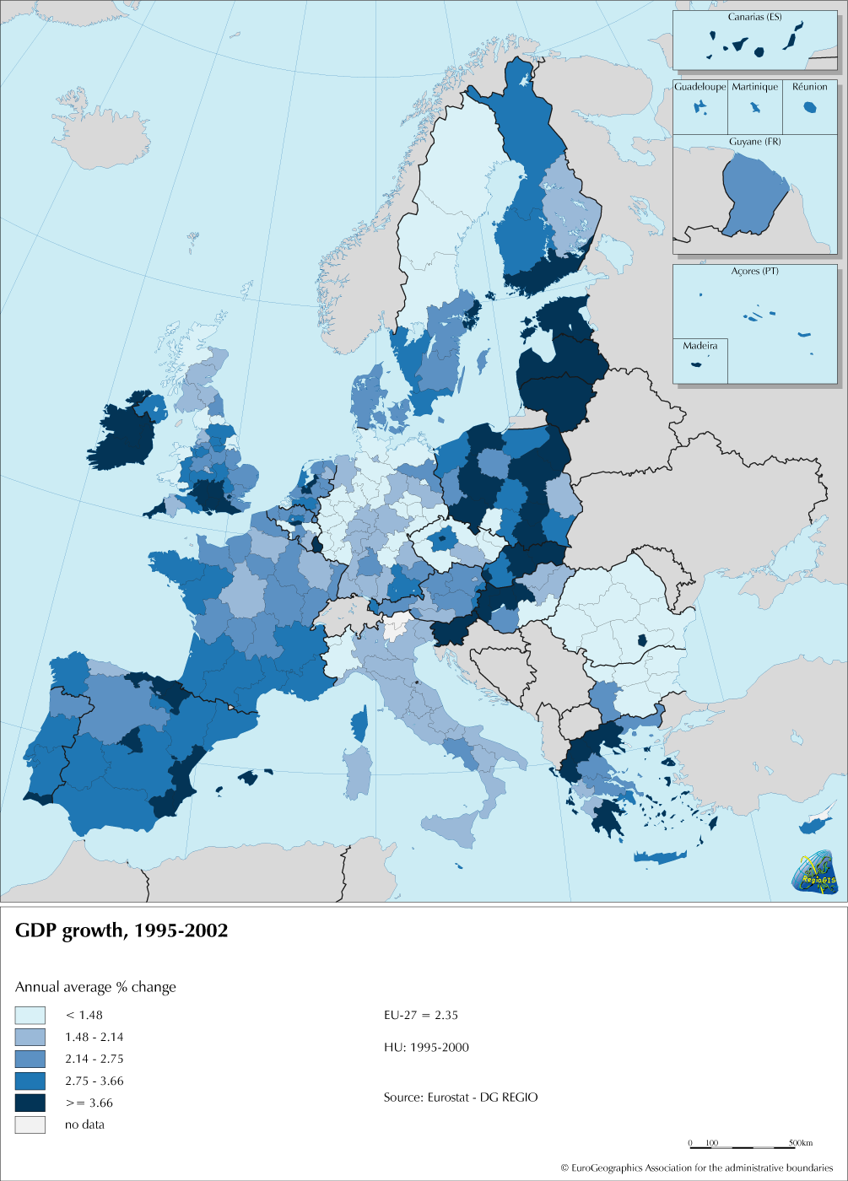
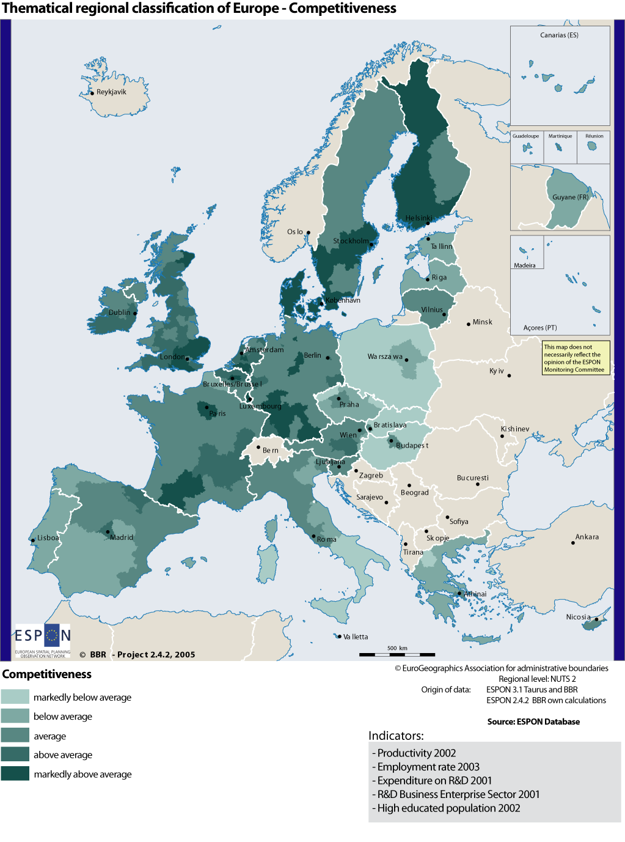
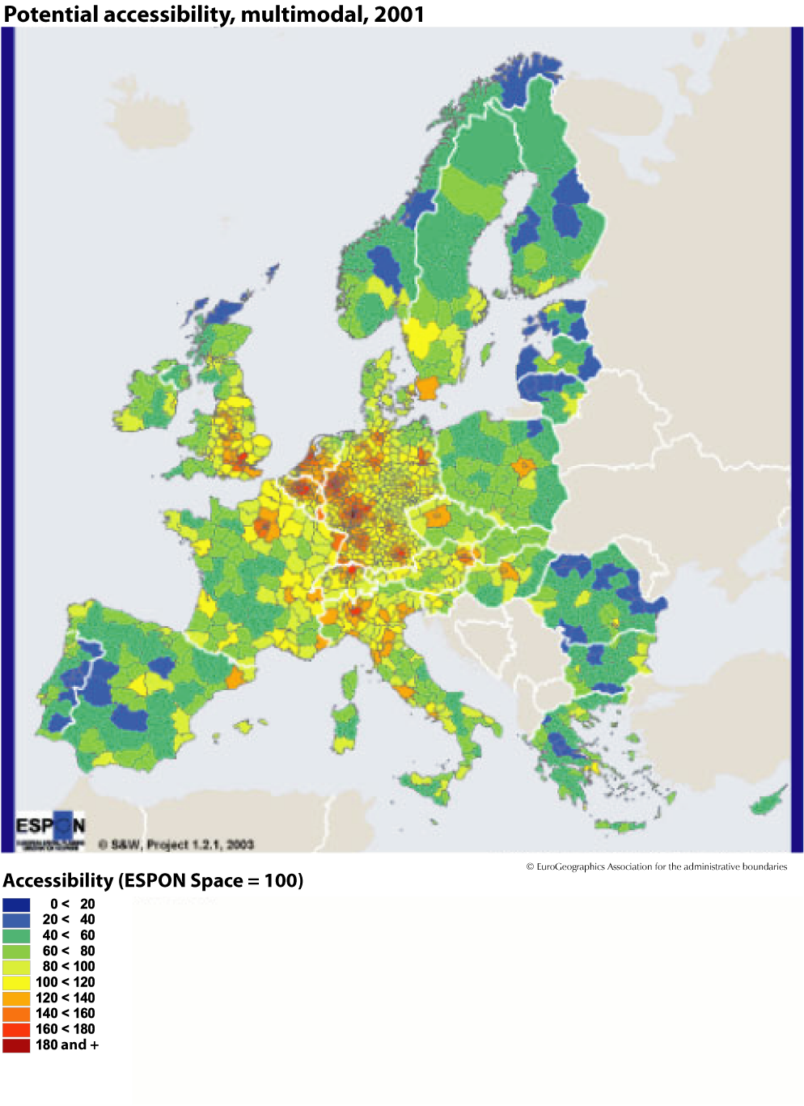
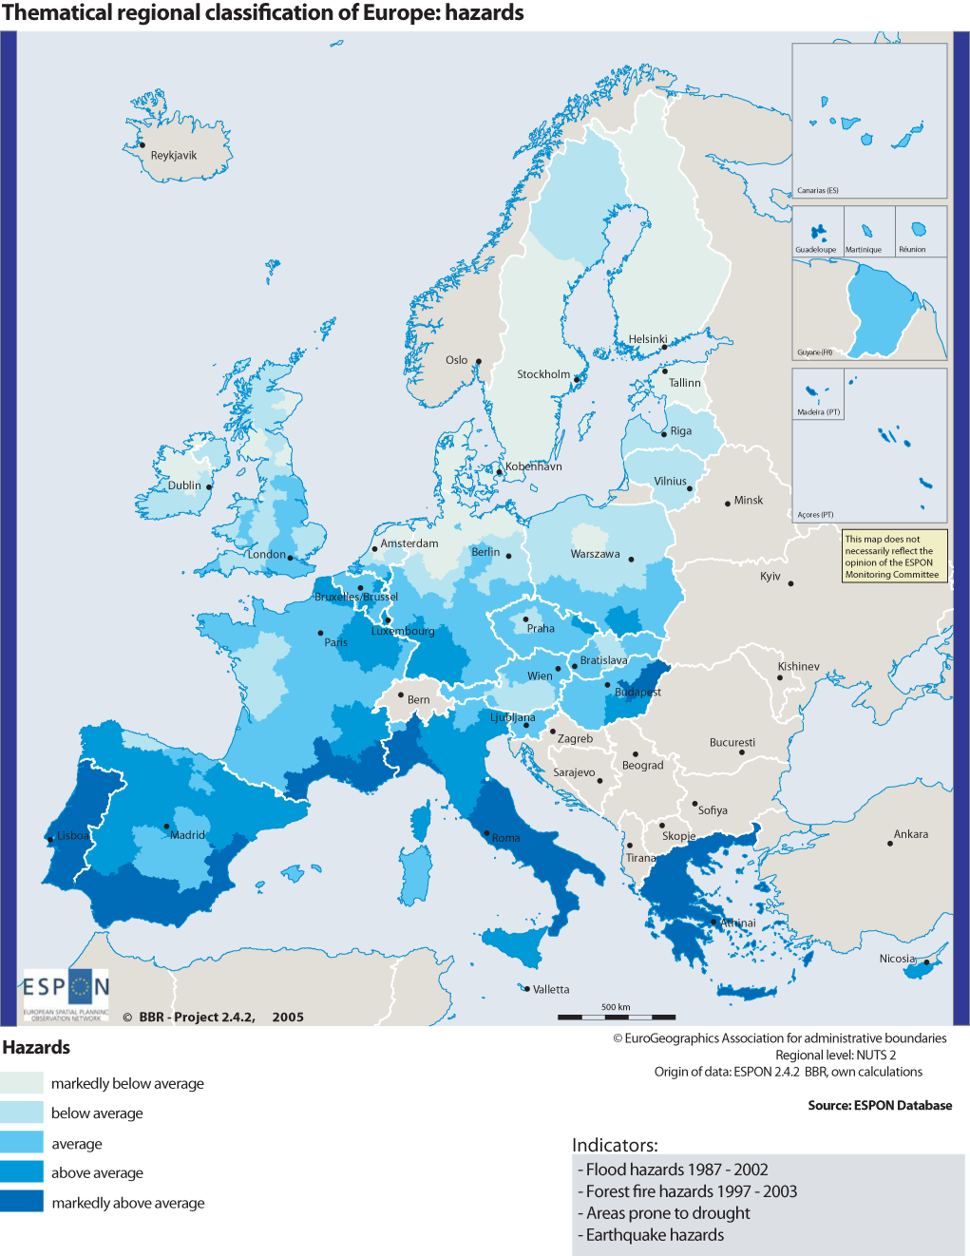

Presidency conclusions, European Council, March 2005.
Article 158 of the Treaty states that, in order to strengthen its economic and social cohesion, the Community shall aim at reducing disparities between the levels of development of the various regions and the backwardness of the least favoured regions or islands, including rural areas.
In line with the Göteborg Strategy adopted by the European Council in 2001.
“The EU Economy: 2004 Review” - COM(2004) 723, 26.10.2004.
COM(2004) 492, 14.7.2004. In the rest of the paper, “Funds” is used in relation to the three Funds and “Structural Funds” when reference is made to the ERDF and ESF only.
COM(2004) 492, Article 23.
Presidency Conclusions, Lisbon European Council, 23 and 24 March 2000.
Communication to the Spring European Council “Working Together for growth and jobs – a new start for the Lisbon Strategy” - COM(2005) 24, 2.2.2005.
Presidency conclusions, European Council, March 2005.
COM(2005) 141.
See Third Cohesion Report, p. 149.
Communication to the Spring European Council “Working Together for growth and jobs – a new start for the Lisbon Strategy” - COM(2005) 24, 2.2.2005.
“European transport policy for 2010 : time to decide” - COM(2001) 370.
Decision No 884/2004/EC of the European Parliament and of the Council, 29 April 2004.
“Investing in research: an action plan for Europe” - COM(2003) 226, 30.4.2003.
“The economic costs of non-Lisbon” - SEC(2005) 385, 15.3.2005.
SEC(2004) 1475.
COM(2005) 229.
Article 99 of the Treaty for the Broad Economic Policy Guidelines and Article 128 for the Employment Guidelines.
Article 23 of the draft Council Regulation (EC) laying down general provisions for the European Regional Development Funds (ERDF), the European Social Fund (ESF) and the Cohesion Fund.
COM(2005) 141,12.4.2005

