In this edition you will find information on the following issues:

MEMBER NEWS
Feature Article
Network Developments
Upcoming Events

PROJECT NEWS
EU NEWS AND PUBLICATIONS
News
Publications

CONTACT INFORMATION

Current Projects Update
Projects development

Did you know?
You can click on the blue titles in the overview. It will take you directly to the section!

MEMBER NEWS
Feature Article
Cities and the crisis
Cities and local authorities in the EU are increasingly feeling the impacts of the financial banking crisis that started in autumn last year as a result of US housing market problem which subsequently developed into one of the severest global financial and economic crisis experienced in several generations.
We can see a number of key trends emerging across Europe:
- Growing unemployment is set to increase the strain on social service providers – most often cities – and affect the volume of tax revenues across Europe. Apart from immediate effect on the revenues, a mid- or long-term impact is expected upon local and regional authorities.
- In several EU member states local governments suffered a substantial loss, due to their high investment share in banks that have been hit by the crisis. This means that many regions and cities are unable to access the EU funds allocated to them, as they are unable to meet the co-financing criteria. This creates a downward spiral, where the regions hit hardest by the crisis are also the ones that are struggling the most to set up EU-funded projects.
- The global financial crisis and financial difficulties in the banking sector affect the availability of credits. Even if the municipal sector has generally high ratings as borrower, the requested volumes of credits are not available, or are available only at high cost, due to liquidity shortage on the market. It should be noted, that in some countries especially banks, which traditionally provided loans to the municipal sector, have been affected by the crisis (e.g. Kommunalkredit in Austria, Kommunekreditt in Norway, Dexia in Belgium, France and Luxembourg).

- The credit crisis is affecting ongoing investments in infrastructure and development projects. The reduce rate of investments by both the private and the public sectors will result in a general slow-down of local and regional development.

The EU’s response to the crisis
The European Commission presented on 26 November a plan to drive Europe's recovery from the current economic crisis. The Recovery Plan is based on two mutually reinforcing main elements. Firstly, short-term measures to boost demand, save jobs and help restore confidence. Secondly "smart investment" to yield higher growth and sustainable prosperity in the longer-term.
The Plan calls for a timely, targeted and temporary fiscal stimulus of around EUR 200 billion or 1.5% of EU GDP, within both national budgets (around EUR 170 billion, 1.2% of GDP) and EU and European Investment Bank budgets (around EUR 30 billion, 0.3% of GDP). The Plan proposed to accelerate payments of up to € 6.3 billion under the structural and social funds. The European Central Bank and other central banks have considerably reduced their interest rates to support non-inflationary growth. (ECB from 4.25 % in September 2008 through 2 % in January 2009 to 1.5 % in March 2009).
Every EU Member State is called upon to take major measures good for its own citizens and good for the rest of Europe. The Recovery Plan includes extensive action at national and EU level to help households and industry and concentrate support on the most vulnerable. It puts forward concrete steps to promote entrepreneurship, research and innovation, including in the car and construction industries. The Recovery Plan aims to boost efforts to tackle climate change while creating much-needed jobs at the same time, through for example strategic investment in energy efficient buildings and technologies. Go to Recovery Plan>>
EU Structural Funds
On 22 July, as the real impact of the financial crisis on the labour market was already being felt far and wide, the European Commission presented a second package of measures aimed at adapting the Structural Funds. The idea is to accelerate the flow of finance to beneficiaries. The message has not changed since the start of the crisis: implementation of cohesion programmes must not be delayed by the difficult environment. On the contrary, mobilisation of available funds – €347 billion for 2007-2013 – can help combat the crisis by assuring the continuity of investments in the ‘real economy’. The keywords are therefore flexibility and simplification.
The key feature of the proposal is the elimination, in 2009 and 2010, of the obligation of state co-financing of projects receiving support from the European Social Fund (ESF). This means that the countries may have their projects financed in full by the ESF, without putting up the national counterpart usually required for all projects aided by the Structural Funds. Negotiations are under way between the Parliament, the Council of Ministers and the Commission to put this possibility into action.

Network Developments
OPEN DAYS OFF 2009
On 6 October 2009 QEC-ERAN scheduled, in conjunction with the Lisbon Region, its second edition of the OPEN DAYS OFF, an occasion for participants and actors operating in Urban regeneration projects to meet each other and exchanging views and opinions on topic like citizens and crisis and what the European Parliament can do to face one of the worst economic crisis of the last century.
The event was opened by Luisa Avedano on behalf of Ilda Curti (Deputy Mayor of Torino and President of the QEC-RAN Network) and Haroon Saad, Director of QEC-ERAN.
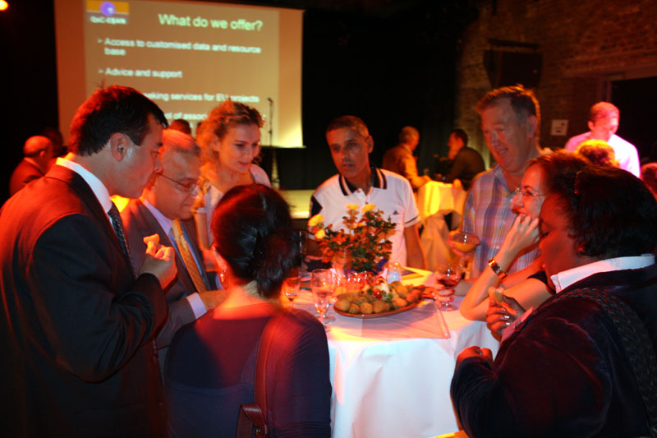During the evening several topics where discussed following a method called “Instigate and Debate”: participants were split in 7 tables of discussion and after a chat of around 25 minutes one spokesperson from each table asked a question to a panel of speakers.
The Panel consisted of Brian Field Senior Economist and Bank’s Urban Specialist at the European Investment Bank, Karima Delli MEP from Greens Party and Peter Ramsden Thematic Pole Manager in the framework of the Urbact Program.
The themes discussed were diversified as, for example, inequalities in the labour market, participation in representative democracy, the crisis of the housing market or social inclusion of migrants and so on.
After the debates the night continued and the participants enjoyed a reception offered by the Lisbon Region and music in the artistic settings of the Beursshouwburg in Brussels. For more information please visit our website>>
Staff developments
Following the summer break we have now several new staff working for QEC ERNAN.

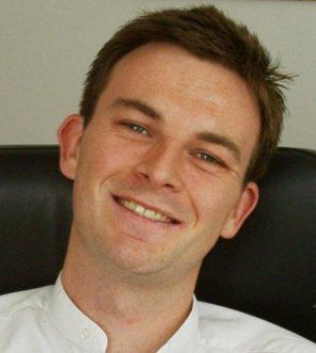
Nicolas Hauw has started in October 2009 as a project assistant to support the communication activities of the Fundamental Rights project and our network.
Delia Giorgianni has joined Qec-ERAN in September 2009. She works as Communications and Project Assistant to 2 URBACT projects.
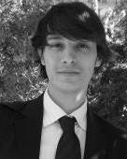
Pierre-Jean Verrando has joined Qec_ERAN in September 2009 He works as a project assistant for the "Fundamental Rights and Citizenship" Project.
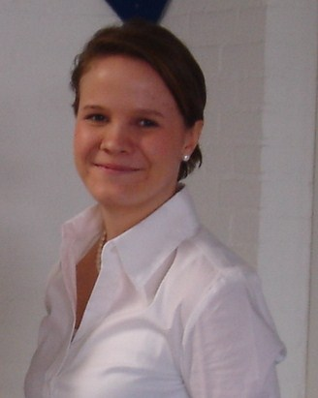
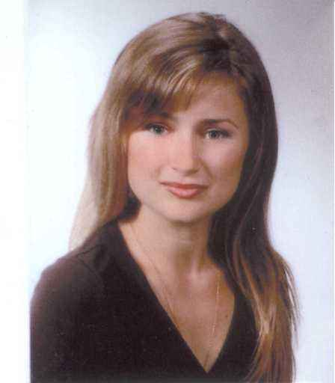
Stella Ruissalo, has joined Qec_ERAN in September 2009 for a one-year student work placement. She studies European Business and International Business Management as a double degree between Metropolia University of Helsinki and Inholland University in the Netherlands. She will be assisting in diverse projects.
Anna Maria Pitrowska joined Qec-ERAN in October 2009 for a 10 months internship within the Grundtvig Programme. Anna gained her professional experience in the fields of adult education and EFS projects.
back to: table of contents

Upcoming Events

26-30 October: University of Gloucestershire, Grundtvig Learner workshop on adult lifelong learners from disadvantaged communities. Get more information and register mjackson@glos.ac.uk
27 October: The European local inclusion and social action network (ELISAN) conference-debate on the "social dimension of the territorial cohesion ", Brussels.
2-3 Nov: Global Forum on Migration and Development Civil Society Days, Athens.
9-10 Nov: GIP SPSI (French Public Interest Group for Health and Social Protection in the International arena) Annual Colloquium on Social Development and Fighting Poverty , Paris.
15 Nov: ELENA course on the Common European Asylum System , Vienna.
24 Nov: Irish national Organisation of the Unemployed (INOU), A Fairer Ireland: Equality and Rights at the Heart of Recovery. Please contact Rachel@eracampaign.org
2-4 Dec: Department of Sociology of the Uppsala University (Sweden), International conference ’Gendering Violence - Feminist Interventions in Contemporary Research’ , Uppsala, Sweden.
7-8 Dec: Conference on “Interacting in diversity for social cohesion: frameworks and references to adapt the organisation and competences of social services to the demands of a pluralist society ”, Strasburg, France.
10-11 Dec: Polis conference, First announcement and call for papers 2009 Annual Polis Conference, Unlocking the economic and environmental potential of innovation in urban and regional mobility , Brussels. Deadline for submission of abstracts: 17 July 2009.
12 Dec: AIDE Fédération conference on cultural and political: state of play, challenges and perspectives, Paris. Contact: el-hakkaoui@aide-federation.org

back to: table of contents
PROJECT NEWS
Current Project Update
WEED
The first Transnational Exchange Workshop and the second Steering Group Meeting of the WEED project took place in Celje (Slovenia) on the 3rd - 4th September 2009.
The workshop involved over 30 participants most of whom were directly involved in WEED Local Action Groups. The workshop was focused on best practice in developing strategies for promoting female entrepreneurship and in enabling the participants to further discuss the evolving Local Action Plans and refine objectives for their local and regional strategies.

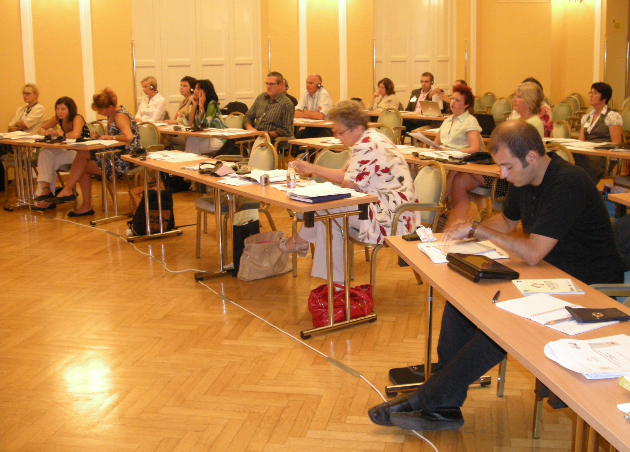
For more information please contact Annachiar Pecchini or visit the project website.
ESIP
ESIP participated in the final workshop of the Laps and Raps II workshop which took place from 16-18 September 2009 in Celje, Slovenia.

The theme of the workshop was on child poverty including several case study presentations from project partners, presentations from the European Commission and the European Cities Against Child poverty network. The following workshop sessions focused on introducing and training participants on how to use the framework and methodology for local/regional action planning for social inclusion that were developed during the Laps and Raps I project. The workshop was preceded by an ESIP Steering Board meeting that took place on 17 September.
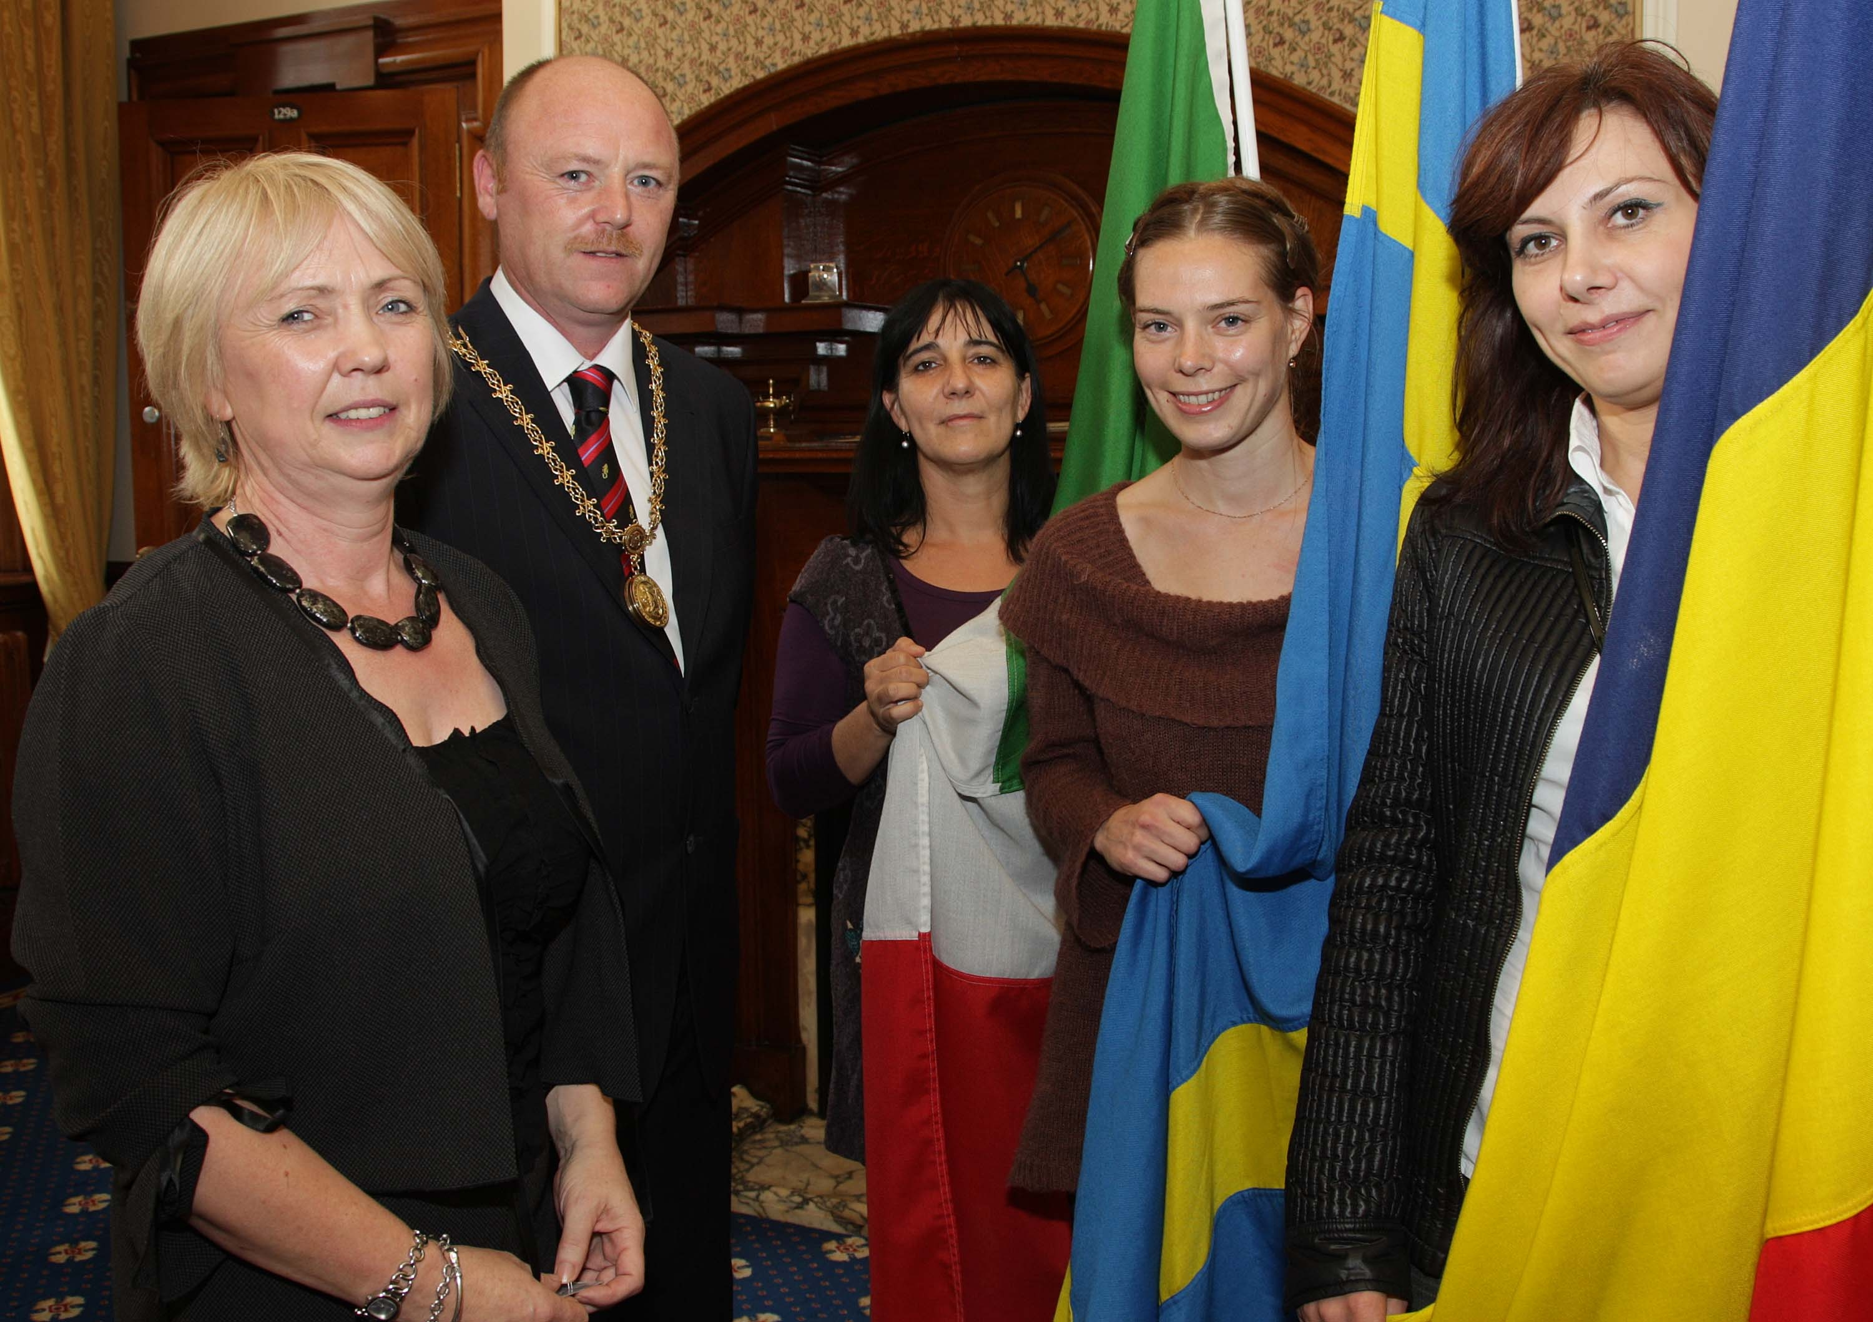

The fourth issue of the ESIP newsletter will be published in October and will be available on the ESIP website.
For more information please contact Isabella Haaf or visit the
ESIP website
Building Healthy Communities - Urbact
Belfast, who is a partner city in the BHC network, organised a multi-lateral workshop from the 28-30 September 2009.
The purpose of the workshop was to give partner cities an understanding of the concept and process of Health Impact Assessment (HIA) and to see how it has been applied in Belfast. The training involved HIA theory but had a practical focus including HIA case-studies of the Regeneration Strategy of the Lower Shankill and site visits to the Shankill and East Belfast.
The second BHC newsletter was published prior to the Belfast workshop and can be download here.

For more information please contact Isabella Haaf or visit the project website

Active A.G.E. – Urbact network
After the first Transnational Exchange Workshop in Wolverhampton around the sub-theme « Age and the Economy » in June, a follow-up online programme for the Local Support Groups will start in October. Online consultations and teleconference will give support to the LSG to produce the first draft of the Local Action Plan, which will be done by all partners by the end of November.
Partners will also choose the next ALS group for the second sub-theme for the second Transnational Exchange Workshop on February 2010 that will be hosted by the city of Maribor, Slovenia.
For more information please contact Maria Elena Bragalia or visit the project website
Intercultural Youth Panels Project
Within the Framework of the Intercultural Youth Panels project, a Transnational Exchange took place on the 27th- 30th of September 2009 in Brussels with the aim of bringing together youngsters from different European cities in order to discuss and share their concerns about Cultural Diversity in their communities.
The objective was to facilitate the exchange and capacity-building through a participative and informal workshop programme, that was composed by discussions, presentations, exhibitions, performances and visits to some of the European institutions.
There were 50 participants from several European cities. Each of the groups presented their Activity Programmes implemented at the local level, including awareness-raising campaigns and other type of activities. At the same time there were some contribution from DG Education and Culture on Youth Policy and the Youth in Action Programme, by Mr. Artur Payer and Ms Veronika Remisova respectively.
For more information please contact Tamara Hodas or visit our website.

Projects in the pipeline
The QeC ERAN secretariat has developed the following project proposals that were submitted in September 2009:

- Active-Ageing - Social Experimentation in relation to active inclusion of older people (Community Action Programme)
- Social Innovation in relation to active inclusion of disadvantaged groups (ESF Transnational Learning Exchange)

- Changing mindsets (Roma Integration)
- SI-AI - Social Innovation in relation to Active Inclusion measures that support/empower disadvantaged groups to access the labour market (URBACT II Programme)
- Spatial Cohesion - Public Spaces: Integrated approaches to spatial cohesion in deprived areas (URBACT II Programme)
- Roma-net – Integration of Roma population, Green Shoots - the role of Social Economy and Microfinance in promoting entrepreneurship and job creation in the context of the financial crisis (URBACT II Programme)
back to: table of contents

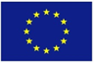
EU NEWS
MEPs elect Barroso to a second term as Commission President
The President of the European Commission, José Manuel Barroso was re-elected by MEPs for a new five year mandate on 16th September. He won the absolute majority and his uncontested election opens the way for the appointment of the college of commissioners after the Irish vote on 2nd October. Read more . However, his speech did not convince his detractors…read more .
EU set to get a Commissioner for Human Rights
During discussions between President Barroso and liberal deputies in the European Parliament last week, it emerged that Barroso, if reappointed as President of the Commission, would create a commissioner post responsible for fundamental rights and civil liberties. Currently the Commission has a justice, freedom and security commissioner, but it has long been argued that such a portfolio is too broad to give enough attention to issues such as data protection, immigration and the rights of migrants in Member States – a very pressing issue following certain Member States' recent controversial handling of Roma and immigrants from Africa. Read more .
Services of general interest and sustainable development
Two communications were published by the European Commission this summer. The first entitled “Mainstreaming sustainable development into EU policies: 2009 Review of the European Union Strategy for Sustainable Development ” does not mention services of general interest. The second communication, dated 20 August 2009, entitled “The GDP and Beyond: Measuring progress in a changing world ” (COM (2009) 433) mentions “public services” in the environmental and social indicators to be added to GDP. Further, an exploratory opinion of the European Economic and Social Committee on the future of the development strategy is slated for this fall.
Lisbon Treaty: state of play
On 18 September, the Bundesrat, the upper chamber of the German parliament, adopted the legislative changes demanded by the Federal Constitutional Court before the ratification of the Lisbon Treaty by Berlin. These modifications were approved ten days ago by the lower chamber, the Bundestag. After the vote by the upper chamber German President Horst Köhler will sign the Lisbon Treaty that notably aims to improve decision making processes within the Union. Read more .
… in Ireland
The vote on 2 October was yes for the treaty, albeit with several exemption clauses for Ireland.
The Crisis: state of play
Council seeks a “sustainable recovery” out of the crisis
On 17 September, the 27 Heads of State and Government of the EU discussed the common European position to adopt so that they stand united at the G20 summit in Pittsburgh. They insisted on the continued work to provide in view of re-establishing the world economy that is sorely affected by the crisis, and on the vital coordination of strategies to emerge from the crisis on the part of the Member States. Emphasis was placed on the need to promote access to employment and social cohesion. Read more .
EU spending cuts 'just a matter of time'
Economists say some European countries will follow the UK's example of making tough choices on public spending sooner or later. Read more .
ILO: anti-crisis measures taken by G20 governments will save up to 11 million jobs in 2009
The ILO also forecasts that continued labour market deterioration around the world in 2009 would produce an estimated increase in global unemployment of between 39 and 61 million workers relative to 2007, which could result in global unemployment ranging from 219 to 241 million - the highest level ever on record. Read more
Swedish government announced more income tax reductions
On 19 September, the Swedish government announced more income tax reductions totalling 10 billion SEK (990 million euros) the aim being to stimulate the employment market. In real terms every Swedish worker will have 200 to 250 SEK more to spend each month (19.80€-24.75€). This measure is the fourth part of a plan to reduce taxes launched in January 2007 designed to encourage the Swedes to return to work rather than live on benefits which are often as high as the net salary. Read more .
Eurostat publishes the last inflation rates and external trade figures
According to statistics published on 16 September by Eurostat, the annual inflation rate in the euro area lay at 0.2% in August 2009 in comparison with -0.7% in July. The monthly inflation rate lay at 0.3% in August 2009. The annual inflation rate in the EU lay at 0.6% in August 2009 in comparison with 0.2% in July. The monthly inflation rate lay at 0.3% in August 2009. Read more . As to external trade, Eurostat recorded a surplus of 12.6 billion euros with the rest of the world in comparison with -3 billion in July 2008. In comparison with the month of June 2009 exports increased by 4.1% whilst imports decreased by 0.3%. With regard to the EU the surplus is said to be 0.7 billion euros, in comparison with -22.4 billion in July 2008. In July 2009 compared with June 2009 exports progressed by 3.3% whilst imports declined by 0.6%. Read more.
Commission proposes to increase parental leave
The European Commission has on July 30, 2009 adopted a proposal to increase the existing right to take parental leave from three to four months per parent and apply it to all employees, regardless of their type of contract. The proposal complements the Commission's recent package of measures to improve work-life balance for Europeans. Read more.
Social security coordination: revised EU rules
The Council of Ministers and European Parliament have approved a legislative package on social security coordination in the EU. These new rules will pave the way for a modernisation of the system for coordinating national social security regimes in the EU as from March 2010. The following groups stand to benefit from the new arrangements: tourists, mobile workers, job seekers, pensioners. Read more.
Europe still deep in recession, but unemployment rising less sharply
Over the last quarter (1 April 2009 to 30 June 2009), Eurofound’s European Restructuring Monitor (ERM) recorded some 125,000 job losses and 31,000 job creations across the European Union. In many EU Member States, the pace at which jobs are being lost appears to have slowed compared with the previous two quarters. Read more.
Stark differences in working time across Europe
Eurofound publishes its annual report on working time developments across the European Union. In 2008, the average collectively agreed weekly working time in the European Union remained unchanged at 38.6 hours, according to the annual update on working time developments from Eurofound, the Dublin-based EU Agency. The report, which looks at working time agreements set by collective bargaining, also found that the average paid annual leave entitlement for workers in Europe was 25.2 days across the EU in 2008. Read more.
Measuring flexicurity The EU's Employment Committee (EMCO) approved on 24 June 2009 a report showing how flexicurity policies can be monitored. The report highlights a series of indicators that provide a basis for analysing flexicurity policies in each Member State. Read more.
Public procurement to drive economic recovery
Public procurement should become the driver of new technology developments and the main vehicle for economic recovery, Malcolm Harbour MEP, the new head of the European Parliament's internal market committee, told EurActiv in an interview. Read more.
FRA opinion on the Stockholm Programme for justice and home affairs
Morten Kjaerum, Director of the European Union Agency for Fundamental Rights, addressed the Ministers of Justice and the Ministers of Interior at an Informal Council meeting in Stockholm in July. He underlined the relevance and possible implications the Stockholm Programme has in the area of fundamental rights. The FRA has also published its opinion on the programme entitled: "The Stockholm Programme: A chance to put fundamental rights protection right in the centre of the European Agenda". Read more.
back to: table of contents

PUBLICATIONS
Eurostat Yearbook “Europe in figures”
On 18 September, Eurostat published its 2009 Yearbook 'Europe in Figures' . This yearbook contains a selection of over 500 pages of statistics held on record by Eurostat together with explanatory texts. It is an introductory text to the EU's statistics and is also a guide covering a wide range of free data on the internet. The yearbook offers an overview of the development in key trends in the EU, the euro area, the Member States, candidate countries, EFTA, the USA and Japan when they are available.
European Policy Centre report on briefing on the financial crisis
The EPC has issued a report of the 21 September Sixty-Minute Briefing on The financial crisis - a need for better regulation. To get the report, contact M.Bartholome@epc.eu.
ECDN: new issues of Money Matters Two new issues of ECDN's publication series Money Matters are now available for download on ECDN's website . "Money Matters" 6 deals with "Reference Budgets for Social Inclusion". Number 7 contains a summary of ten European countries concerning "Over-indebtedness and Data Collection". Printed examples can be ordered at office@ecdn.eu (against coverage of postage costs).
European Committee of Social Rights (ECSR) has issued its 1st newsletter
The ECSR has issued its 1st newsletter (Sept. 2009). The mission of the European Committee of Social Rights (ECSR) is to judge that States party are in conformity in law and in practice with the provisions of the European Social Charter. In respect of national reports, the Committee adopts conclusions , in respect of collective complaints, it adopts decisions .
World's wealth has declined
According to the ninth world report on wealth by the Boston Consulting Group, the world's wealth declined for the first time since 2001. After decreasing by 11.7% to 92 trillion euros it is due to recover growth in 2010 but this will be progressive. Read more .
New report: EU gender legislation has helped tackle workplace discrimination
EU legislation has benefited workers through broader protection against discrimination based on gender, and clearer definitions of discrimination, says a European Commission report adopted at the end of July.However while implementation of Directive 2002/73/EC has generally been satisfactory, not all countries have yet brought their rules into line with EU requirements. The report identifies both the challenges and good practices in implementing the Directive. The Directive aims to promote equal treatment for men and women in access to employment, vocational training and promotion, and working conditions. Read more on the transposition of EU gender equality legislation into national law:
ENAR has published its 2008 national Shadow Reports on racism
ENAR has published its 2008 national Shadow Reports on racism. These reports bring an NGO perspective on the realities of racism in the EU member states, and deal with the many faces of racism and discrimination at both legislative and local level, from policy to practice. A European shadow report, identifying trends on the phenomenon of racism across the EU and drawing on the national shadow reports, will be published in November. Read more .
Report on “Understanding irregular migration in Northern Europe”
PICUM, Migrants Rights Network and Compas have recently published the report of an international workshop entitled “Understanding Irregular Migration in Northern Europe”. This report highlights key points of the discussion of a wide range of actors who attended a workshop within the “Clandestino” project. Nearly 150 representatives of NGOs and trade unions, researchers, local authorities, policy makers, journalists, and other professionals came together at the workshop to discuss policies and responses to irregular migration in the United Kingdom, France, the Netherlands, Germany and Austria. Read more .
CEPS working document on the “EU Passenger Name Record System and Human Rights: Transferring Passenger Data or Passenger Freedom?”
The European Commission presented the ‘EU Passenger Name Record (PNR) system’ in 2007 as a tool in the fight against terrorism and organised crime. One of the proposed instruments of this system is the Framework Decision on the use of PNR, which provides for the storage and exchange of passenger data between EU member states and between member states and non-EU countries. Current Council proposals make clear that the passenger data may also be used to investigate other crimes or to prevent illegal immigration, which raises both practical and legal concerns. This Working Document published by the Centre of European Policy Studies (CEPS) looks at the legal rights implications of the EU PNR system, focusing in particular on international human rights standards. Read more .
Eurochild publication: Children Without Parental Care - National Surveys
The latest Eurochild publication is a compilation of national surveys on the situation of children without parental care across the European Union. It represents a snapshot of the situation in 19 of the 27 EU member states plus Moldova. A second edition with the missing EU member states will be published in Autumn 2009.
Babelgium: initiative by two members of ENAR Belgium Two members of ENAR Belgium, Coordination et initiatives pour réfugiés et étrangers (CIRE) and the Centre bruxellois d’action interculturelle (CBAI), have launched a series of humoristic videos on how to debunk prejudices on intercultural relations. Read more (in French).
OSCE rights office and Lithuanian education ministry launch anti-Semitism teaching tools
The OSCE Office for Democratic Institutions and Human Rights (ODIHR) and Lithuania's Ministry of Education and Science recently launched a Lithuanian-language version of teaching materials on combating anti-Semitism designed for use in secondary schools. Lithuania is the third country to adopt the ODIHR teaching materials, after Germany and Poland. Read more.
Council of Europe publication on policies and practices for teaching sociocultural diversity
This publication raises discussion about how teacher education, particularly in-service training, can prepare student teachers to become reflective professionals responsive to diversity in schools and classrooms. It addresses the urgent need to develop courses and practical training which stimulate the competence and reflection necessary to enhance inclusive environments where children and young people can learn to live together respecting differences. Read more.
ERIO newsletter
The European Roma Information Office (ERIO) has published the latest issue of its Newsletter. It focuses on ERIO’s recent conferences on Roma political participation and on the European dimension of Roma migration, and presents ERIO’s recommendations to the Swedish Presidency of the EU. Read more.
European Web Site on Integration
DG Justice, Freedom and Security launched The European Integration Forum on 20-21 April 2009 and, more recently, the European Web Site on Integration www.integration.eu where you can find the documents relating to the inaugural meeting of the Forum under the section "The EU and integration – the European Integration Forum". The second meeting of the Forum will take place on 12-13 November 2009.
back to: table of contents

CONTACT INFORMATION
QeC-ERAN
Quartiers en Crise -European Regeneration Areas Network,
Rue Vieux Marchè aux Grains 48, B-1000 Brussels
Tel: +32 (0)2 524 45 45, Fax: +32 (0)2 524 44 31,
E-mail: info@qec-eran.org
www.qec-eran.org
Executive Bureau:
President Ilda Curti segreteria.assessorecurti@comune.torino.it
President supported by Luisa Avedano Luisa.Avedano@comune.torino.it
Vice –President Lionel Martjin lb.martijn@charlois.rotterdam.nl
Honorary Secretary Jude Kehla- Wirnkar
Treasurer Cllr William Humphrey
supported by Deidre Ferguson fergusond@belfastcity.gov.uk
Member Luana Zanella assessore.murer@comune.venezia.it
Member Bernad Dallons
Supported by Eric Dosimont dosimonteric@cpascharleroi.be
QeC-ERAN Office:
Director Haroon Saad hsaad@qec-eran.org
Assistant Director, WEED Annachiara Pecchini apecchini@qec-eran.org
Financial and Administrative Manager Daniel Casares dcasares@qec-eran.org
Active Age Maria Elena Bragaglia mebragaglia@qec-eran.org
Information and Communication Manager Isabella Haaf isabellahaaf@qec-eran.org
Building Healthy Communities Isabella Haaf
Information and Communication Assistant Delia Giorgianni d.giorgianni@qec-eran.org
Intercultural Youth Panels Tamara Hodas García thodasgarcia@qec-eran.org
Project Assistant Nicholas Hauw n.hauw@qec-eran.org
Project Assistant Jean Pierre Verrando jp.verrando@qec-eran.org
Project Assistant Stella Ruissalo s.ruissalo@qec-eran.org

