“Women in local development”

Local Mapping Report

Rome, 2007

Summary of contents

Introduction..........................................................................................................................p. 3

The contribution of the Digital World Foundation..............................................................p. 6

Mainstreaming in Italy, legislative context of reference ....................................................p. 8

The Digital World Foundation action oriented.plan for equal opportunities....................p. 11

Concrete actions towards local deveolpment of women in Rome.....................................p. 21

Appendix 1.........................................................................................................................p. 50

Bibliography and internet links..........................................................................................p. 57

Introduction

The Digital World Foundation (www.mondodigitale.org), is partner of the project “Getting Engaged: Women in local development” funded by the European commissio: DG Imployment, social affairs and equal opportunity.
Infact, the priority theme of the 2006 call was the promotion of the gender equality in local development encouraging balanced partecipation of women and men in local developmnet and analysing wich policies implemented at local level can develop the promotion of gender equality.
The overall aim of this project is to bring about an exchange of experience and transfer of learning between partners seeking to strengthen their approach and commitment to an 'inclusive' approach to local development which incorporates a gender equality dimension. In so doing the project will also aim to:
- Disseminate research and information relating to gender and local development initiatives.
- Identify and disseminate good practice where it does exist.
- Promote positive action to address gender equality within local social and economic development.
To realise this overall aim, this project has the following specific objectives:
- Undertake three transnational local development peer review workshops. The workshops would focus on the following three specific sub-areas directly linked to the two overarching themes of the project:
  - Strategies, priorities and monitoring issues in relation to local development and gender equality
  - Patterns of involvement and consultation issues in relation to gender equality
  - Methodologies for assessing women’s needs and relationship to service provision issues
This project has a number of expected results and outputs:
- The establishment of 8 Local Action Groups which would act as the catalyst for local/regional change. Each LAG would be cross-sectoral and have a minimum of 12 members
- 3 Transnational peer review workshops which would focus on:
  - Strategies, priorities and monitoring issues in local development
  - Patterns of involvement and consultation issues;
  - Methodologies for assessing women's needs and relationship to service provision issues
- Each workshop would bring together 3 delegates from each of the LAG's plus external experts and invited delegates from organisations/networks active in the related area.
- 3 peer review workshop reports. These would incorporate an overview (state of the art) of the sub theme; linked good practice case studies and links to relevant publications and websites
- 8 Local dissemination workshops which would disseminate the outcomes locally/regionally
- The creation of an online policy and good practice exchange which would have the following elements:
  - Case studies of practice relating to the three areas of focus
  - Links to relevant websites and publications
  - Profiles of LAG members in order to facilitate networking across LAGs .
- 8 Local action plans which would seek to incorporate good practice identified through the transnational exchange programme
- Disseminate the results transnationally via existing networks and websites and thus promote the importance of gender equality in local development.
- Evaluation/ Final overarching report which would act as the "portal" for non-project partners to access the project effectively and thus seek to maximise the transfer of learning.

The contribution of the Digital World Foundation
The aim of this document is to realize a local mapping report to identify what measures has been taken to promote the participation of women in the Italian context, with the focus on the situation of Rome.
In the last decade it has been diffused, also in Italy, the opinion that women can carry knowlwdge and competences in the various ambles of their professional capability for having a greater development of the society and the economy.
This, with other stathegy of sensitiveness, is one of the reasons that have allowed to discover and to contrast the discriminations and segregations that the women have been, and are, victims. Too much often the steps completed don’t translate themselves in obvious and stable results above all in the decisional positions. Too much often the same ones aren’t revealed in definitive conquests. The gender mainstreaming, that is, in its wider meaning, the insertion of one perspective of gender in the political choices and in the actions of national and local government, is a strategy employed to international level in order to realize the parity between woman and man in all ambles of the political life and has like objective the possibility to give, to all the levels, the women and the equal men benefits. Systematic integration of females and male requirements in the various situations in order to obtain the full equality, holding account of the various impact and approach that women and men have in the working atmosphere, can be a strategic dimension of continuous improvement which the public organizations can stretch through the complex of the actions that daily place in being. In this optical it appears obvious as it is necessary to concentrate itself on the role, the tasks, the spaces that the various subjects, men and women, they have and they express inside of the organizations.
The documents and the studies of the European Union and the international organisms, as the OCSE, speed up a clear choice, from the Countries, because they support processes of innovation of the leadership in ecological and integrated terms. They necessity to increase the quality and the spread of the leadership with characteristics of positive sensibilisation of the organizations and in the decisional processes that, on the other hand, would have to be managed from a management adequately formed to the managing diversity. To European level, in fact, it puts into effect it them legislative period and normative it coincides with the introduction of a new method of job between the States, of flexible and differentiated type that it would have to constitute the alternative to the method of the funtional harmonization based on the adoption of standard uniform minimums and on norms of binding character. It’s a put off center process, carefully controlled to the center, where various models and national political are coordinated through the adoption of lines of common guideline. The resource to the soft law, that is one technical not binding norm (line-guide, recommendations, etc), used in increasing way in all the fields of European integration, is typical of this method of integration. The women, still more in the near future, will have in hands, differently from previous generations, all capabilities to approach decisional places. She comes, moreover, emphasized the necessity to adopt organizational modalities apt to favor the participation of the women, concurring the conciliation between professional life and familiar life. What would have to be “natural” from the moment that the women constitute the majority of the citizens (and approximately the half of the dependent in the public administrations), but in Italy it still too much assumes often the tones of the exceptionality, of the challenge, bringing to light how much the changes of mentality are discs of a valve regarding the transformations of the society. An example of application of soft law is the recent declaration, of the European Commission, that it has instituted 2007 like European Year of the Equal Opportunities. The European Year of the Equal Opportunities has been inaugurated on the 30/31 January 2007 to Berlin in occasion of the first apex on the equality.

Mainstreaming in Italy, legislative context of reference
In Italy, practics of gender mainstreaming is articulated with the following lines guides and recommendations, carried out on the three levels of European, national and local development.

Some examples of the Italian legislative context are :
1. The Table of march for the equal opportunities between the women and men (2006-2010) introduced from the European Parliament on the 13 March 2007.

2. The introduction, also to the national level, of the Communication of the Commission to the European Parliament and to the Council on the 8 Maggio 2007 titled “Parity between women and men and female emancipation in the cooperation to the development” (Brussels, 8.3.2007).

3. The Italian National Plan based on the promotion of one full integration between 15 actions and levels of central and local governance on training and best practises.
The objectives of the Italian National Plan reflect the specific objectives of the European Year of the Equal Opportunities:
    - Rights - increasing the knowledge on the equality rights and not discrimination
    - Representation - to increase the participation of subjects exposed to discrimination’s actions.
    - Acknowledgment - to recognize the contribution of the diversities for a right society
    - Respect - to promote the mutual respect.

4. The official publication (Gazzetta Ufficiale of the 31.5.2006, n. 125) of the legislative decree of the 11 Aprile 2006, n. 198 that has instituted the Code of the equal opportunities between man and woman, in compliance with article 6 of the law n. 246, 28 November 2005.

5. The directive for the equal opportunities in Public Administration has been signed on the 23 Maggio 2006.

6. The Municipality of Rome has instituted a Department dedicated to the Equal opportunities verifying the existing conditions and valuing the proposals that came from he activis of the civil society in order to improve the quality of life of women and, in general terms, Roman citizens. The Department offers the solution for the problems of the Roman women that are in conditions of discomfort promoving employment and a good quality of the feminine work through innovative entrepreneurial experiences.
Most of departments of the Municipality of Rome (mobility, school, human resources, commerce, environment, social policies) and in particular the Department for equal opportunities, have created a plan that opens the services to the citizenship with the perspective of an harmonisation between working time inside the administration and bureaucracy times: this plan is named Office Times and Timetables.

7. In July 2003, an agreement was signed by the Municipality of Rome and the Unione degli Industriali di Roma. This agreement provided the framework for the start of activities leading to the formulation of the Programme Women and New Technologies aimed at promoting the presence and development of women in Roman enterprises. This was followed by the creation of a network of mentors with female personalities from the world of enterprise, government, culture and finance. Members of this network could give testimony of their successful careers, complementing the work-placement opportunities to be provided by UIR company members. A seminar on Women and New Technology took place in March 2004 and in November 2004 the first pilot course kicked off with the participation of 20 young women from scientific, humanistic and economic disciplines. A second course followed in 2006 involving 28 graduates. In 2005, the thematic blog “donneict” (www.donneict.it) also started with the aim of stimulating the formation of a community with the participants to the course. More recently, with the sponsorship of the training company Challenge SpA, a course grant on “Development of Managerial Competence” (Sviluppo delle Competenze Manageriali) has been instituted in memory of the late Raffaella Alibrandi, who led the start of the programme on the side of the Unione degli Industriali di Roma. The grant will be given to the best participant in the course “Women and New Technology.”

The Digital Worl Foundation action oriented plan for equal opportunities
The Digital World Foundation has oriented its local mapping into two main fields:
      - The analysis of the Local Development of the women in the ICT (Information and Communication Technology) companies
      - The analysis of the Local Development of the women in Public Administration.

1) Local Development of the women in the ICT(Information and Communication Technology) companies
The present society is characterised by inequality of opportunities for men and women and the fear is that these will remain in the knowledge society. Table 01 shows data from ISTAT and the UNDP Human Development report 2005 for Italy. The female population is in the majority with 30,085,571 (51.5%) as compared with 28,376,804 (48.5%). They also have a longer life expectancy: 83.1 years as compared with 77.3
for men. Socially, however, the status of women is visibly less advantageous that that of men. Thus, economically, women’s earned income is estimated roughly at less than half that of men (0.46), while female economic activity is 60% that of male economic activity. In terms of professional and technical workers, women fare a bit better with 45% of the total. Politically, the situation of inequality was very strong in 2005 – only 10.4% of the seats in Parliament were held by women; only 21% of legislators, senior officials and managers were women; and only 8.3% of women made it to the ministerial level of government.

Table 01. Various Indicators Relevant to Gender Equality in Italy
Indicator | Year | Female | Male
Population (1) | 2005 (1st January) | 30,085,571 | 28,376,804
Population (1) | 2005 (1st January) | Total: 58,462,375
Life expectancy at birth (1) | 2003-2004 | 83.1 | 77.3
Estimated earned income (PPP US$) | 2003 | 17,176 | 37,670
Ratio of estimated female to male earned income | 2003 | 0.46
Rate of female economic activity (2) (over 15 years old) | 2003 | 39.0% | -
Female economic activity as % of male rate | 2003 | 60
Female professional and technical workers (% of total) | 2003 | 45 | 55
Seats in parliament held by women (% of total) | 2005 | 10.4 | 89.6
Female legislators, senior officials and managers (% of total) | 2003 | 21 | 79
Women in government at ministerial level (% of total) | 2005 | 8.3 | 91.7
Source. Based on UNDP (2005), ISTAT, Italy in Figures 2005, ISTAT, Demografia in Cifre 2005, Molina (2006)
1) Data from ISTAT. All other data is from UNDP (2005).
2) Rate of female economic activity is defined as the “share of the female population ages 15 and above who supply, or are available to supply, labour for the production of goods and services.” (UNDP, 2005, p.355)

This picture is confirmed by the Women’s Empowerment Ranking of countries of the World Economic Forum. Overall, it ranks Italy in 45th place. More specifically Italy is ranked in 51st place in women’s “economic participation,” 49th place in women’s
“economic opportunity,” 48th place in women’s “political empowerment,” 41st place in women’s “educational attainment” and 11th place in women’s “health and well-being.” Commenting the low result in “women’s empowerment” in Italy, the WEF report sees it as

“a clear reflection of the shortcomings of these so-called “advanced” nations in implementing gender equality … As is to be expected of countries notorious for their patriarchal culture, Italy and Greece each perform particularly poorly on the economic participation and economic opportunity dimensions.”

This inequality or “gender-gap” finds its own manifestation in the evolution towards the knowledge society, for instance, in the use of ICTs such as the PC and Internet. Thus, early reports on the digital divide showed a significant gap between men and women in the use of these technologies. Table 30 shows how in 1995, the proportion of women who used the PC amounted to one-third of the number of men who used it, while for the Internet this proportion fell to less than 10%. Table 02 however also shows that over the years there has been a marked reduction of the gap between women and men in the use of the PC and the Internet. In fact, by 2004, the proportion of women who used the PC had increased to almost three-quarter of the number of men who used it (72%), while for the Internet this proportion had gone up to 67%%.

Table 02. Women’s Catching Up in Italy (women as % of men who use PC and Internet at home) - 1995-2004
 | 1995 | 2000 | 2002 | 2004
PC | 33 | 52 | 64 | 72
Internet | 9 | 41 | 59 | 67
Source. Lizzeri (2005) in Molina (2006).

Tables 03 and 04 provide a more detailed picture of the use of the PC and Internet by gender and class of age for the year 2005. The results come from an ISTAT survey involving 20,000 families with a total of 55,000 persons. The tables show that the largest disparities begin at the age bracket 35-44 years of age and become particularly accentuated beginning at the age bracket 60-64 years of age. Instead, between the ages of 6 and 34 the proportion of PC user is not much different and roughly the same if one considers both male and females between 6 and 24 years of age. The pattern regarding the use of the Internet is very similar.

Table 03. PC Users by Gender and Class of Age in Italy – 2005
(per 100 persons of the same sex and age class)

Age | Male |  | Female
 | Use the PC | Don’t Use It | Use the PC | Don’t Use It
3-5 | 19.6 | 74.9 | 14.2 | 81.6
6-10 | 51.9 | 46.0 | 54.5 | 43.9
11-14 | 75.4 | 23.5 | 72.0 | 27.4
15-17 | 80.9 | 18.5 | 79.4 | 19.3
18-19 | 75.8 | 21.7 | 76.1 | 21.9
20-24 | 69.0 | 27.6 | 69.2 | 27.4
25-34 | 59.8 | 37.3 | 54.3 | 42.8
35-44 | 57.7 | 40.3 | 46.2 | 52.4
45-54 | 48.0 | 50.3 | 33.4 | 64.3
55-59 | 33.7 | 63.4 | 16.2 | 81.2
60-64 | 20.0 | 77.5 | 7.9 | 89.8
65-74 | 9.7 | 87.8 | 2.0 | 94.3
Over 75 | 2.8 | 94.1 | 0.6 | 96.5
Total 3 years and over | 45.3 | 52.3 | 34.7 | 62.8
Source. Based on ISTAT – Le tecnologie dell’informazione e della comunicazione: disponibilità nelle famiglie e utilizzo degli individui, 2005. Multiscope survey conducted by the ISTAST involving 20,000 families for a total of 55,000 persons, in Molina (2006).

Table 04. Internet Users by Gender and Class of Age in Italy – 2005
(per 100 persons of the same sex and age class)
Age | Male |  | Female
 | Use the Internet | Don’t Use It | Use the Internet | Don’t Use It
3-5 | - | - | - | -
6-10 | 12.7 | 84.0 | 13.3 | 84.8
11-14 | 47.0 | 52.7 | 41.2 | 57.9
15-17 | 64.2 | 34.6 | 62.8 | 35.5
18-19 | 66.9 | 30.3 | 68.1 | 29.8
20-24 | 63.7 | 32.9 | 62.6 | 33.9
25-34 | 53.9 | 43.1 | 47.5 | 49.4
35-44 | 49.5 | 48.2 | 36.8 | 61.4
45-54 | 40.0 | 58.1 | 25.1 | 71.9
55-59 | 27.3 | 69.3 | 11.4 | 84.4
60-64 | 15.9 | 80.9 | 6.1 | 91.0
65-74 | 7.2 | 90.0 | 1.3 | 94.6
Over 75 | 2.1 | 93.8 | 0.3 | 96.4
Total 6 years and over | 37.1 | 60.2 | 26.9 | 70.2
Source. Based on ISTAT – Le tecnologie dell’informazione e della comunicazione: disponibilità nelle famiglie e utilizzo degli individui, 2005. Multiscope survey conducted by the ISTAST involving 20,000 families for a total of 55,000 persons in Milona (2006).

The same ISTAT survey also looked at the use of the PC and Internet by females and males but this time in relation to their “condition and professional position.” The results are shown in Table 05 and reveal a substantial parity in the categories of “employed,” “directors, entrepreneurs and free-lance professionals,” “managers, cadre, employees,” “self-employed workers and assistants,” “searching for first job,” and “students.” Notable differences are shown in favour of men in the categories of “workers and apprentices,” “retired” and “other,” and in favour of women in the categories of “searching for new jobs” and by default “housewives.” However, only 8.8% of housewives use the PC and an even lower 5.7% use the Internet. Considering that housewives constitute 40% of the adult feminine population, this is an important sector of Italian society at risk of exclusion from the benefits of the knowledge society.

Table 05. PC and Internet Users over 15 years old by Sex, Condition and Professional Position – 2005 (per 100 persons of the same characteristics)

Condition and Professional Position | Use of PC |  | Use of Internet
 | Male | Female | Male | Female
Employed | 55.1 | 58.4 | 47.5 | 48.7
Directors, entrepreneurs and free lance professionals | 72.1 | 72.4 | 67.3 | 65.6
Managers, cadre, employees | 78.9 | 77.8 | 71.0 | 66.3
Workers, apprentices | 34.2 | 25.5 | 25.3 | 17.3
Self-employed workers and assistants | 39.8 | 37.7 | 33.3 | 30.6
Searching for new job | 29.7 | 38.2 | 24.7 | 29.9
Searching for first job | 44.9 | 42.0 | 36.9 | 34.6
Students | 87.2 | 85.9 | 77.5 | 75.7
Housewives | - | 8.8 | - | 5.7
Retired | 10.6 | 4.6 | 8.1 | 3.0
Other condition | 21.9 | 7.9 | 18.1 | 6.1
Total | 44.3 | 32.8 | 38.1 | 26.9
Source. Based on ISTAT – Le tecnologie dell’informazione e della comunicazione: disponibilità nelle famiglie e utilizzo degli individui, 2005. Multiscope survey conducted by the ISTAST involving 20,000 families for a total of 55,000 persons in Molina (2006).

A problem of “digital gender gap” therefore exists above all at the older ages and regarding the female population playing the role of housewives. In the categories of directors, entrepreneurs, managers, free-lance professionals, the proportion of men and women using the PC and Internet are not distinguishable. The problem of “gender gap” is rather in the different proportions of women and men who exercise these types of jobs. Table 01 above has shown that female professional and technical workers constitute 45% of the total. This percentage diminishes significantly if one considers the proportion of women exercising the functions of high-level decision making in industry, for instance, directors, managers, entrepreneurs. Table 06 shows that in Italy the percentage of women with management responsibility in companies reaches barely one fifth of the total, while women occupying directorship positions in various types of companies and banks at the most reach 14.5% in joint stock companies and as low as 4% in listed companies (excluding banks)

Table 06. Number and Percentage of Women with Management and Directorship Responsibility in Italian Companies
Type of Decision-Making responsibility and Organization | Total Number | Number of Women | % Women
Management in companies (Spa, Srl, other) | 1,54 million | 318,000 (management) | 20,5%
Directorship in joint stock companies (Spa) | 145,431 | 20.,783 | 14,3%
Directorship in listed banks | 563 | 9 | 1,6%
Directorship in listed companies  (excluding banks) | 2,452 | 100 | 4%
Directorship in family-owned listed companies | 1,090 | 73 | 6,7%
Source: Il Sole-24Ore, 21 November 2005 based on research conducted by Cerved, in Molina (2006).

A Newsweek (2006) article looks at the record of various countries regarding women in decision-making positions (legislators, senior officials and managers) and shows that Italy comes last with 19%, compared with US (45%), UK (33%) Sweden (29%) Germany (27% and the Netherlands (24%). In fact, Italy is well below the world average of 27%.

In this context, it is encouraging to see that the trends on growth of women enterprises in Rome and Lazio for the period 2003-2005 show a higher degree of dynamism as compared with the growth of total number of active enterprises. As shown in Table 07, in Rome and Lazio, women enterprises grew 6.7% and 5.1% respectively, a rate significantly higher that the 3.8% growth in Italy as a whole, although this 3.8% was also higher than the 2.5% growth shown by the total of active enterprises in the country. The gender gap at decision-making levels is huge however. Suffice to note that in 2005, women enterprises reached just about one-quarter of the total active enterprises. Thus, there is a long way to go before the achievement of real equality of opportunities at higher-levels of decision-making in Italian society.

Table 07. Growth of Women Enterprises in Rome and Lazio (2003-2005)
Place | Total Number of Women Enterprises in 2005 | Difference  2003-2005 | Growth Rate (%)  2003-2005
Rome | 56,876 | 3,562 | 6.7
Lazio | 96,219 | 4,680 | 5.1
Italy | 1,219,112 | 44,569 | 3.8

Total of Active Enterprises
Rome | 230,464 | 9,334 | 4.2
Lazio | 362,806 | 11,743 | 3.3
Italy | 5,118,498 | 122,760 | 2.5
Source. Censis (2006a), in Molina (2006).

Concrete actions towards local deveolpment of women in Rome

1) The project “Women and New Tecnologies” by the Fondazione Mondo Digitale

In 2003, the Digital Youth Consortium began addressing the problem of gender disparity in industry’s decision-making structure through the creation and implementation of an educational programme on Women and New Technology run together with UIR Femminile Plurale, the women department of the Unione degli Industriali di Roma (UIR), the Roman industrial confederation. This programme was born out of a stimulus from the Department of Policy for Equal Opportunities of the Municipality of Rome and is targeted exclusively to young female graduates (under 28 years old) or with brief working experience. It aims to enhance female graduates’ knowledge of the challenges they face in their future careers and the role new technologies play in enhancing opportunities and entrepreneurship potential in the knowledge society. It also aims at facilitating work placement opportunities for female graduates in the companies that are members of UIR. More long-term, it aims at promoting, in the companies of Rome and Lazio, a culture of meritocracy and equal opportunities that fully recognises women’s potential and talent to serve at all organizational levels.

In July 2003, an agreement was signed by the Municipality of Rome and the Unione degli Industriali di Roma. This agreement provided the framework for the start of activities leading to the formulation of the Programme Women and New Technologies aimed at promoting the presence and development of women in Roman enterprises. This was followed by the creation of a network of mentors with female personalities from the world of enterprise, government, culture and finance. Members of this network could give testimony of their successful careers, complementing the work-placement opportunities to be provided by UIR company members. A seminar on Women and New Technology took place in March 2004 and in November 2004 the first pilot course kicked off with the participation of 20 young women from scientific, humanistic and economic disciplines. A second course followed in 2006 involving 28 graduates. In 2005, the thematic blog “donneict” (www.donneict.it) also started with the aim of stimulating the formation of a community with the participants to the course. More recently, with the sponsorship of the training company Challenge SpA, a course grant on “Development of Managerial Competence” (Sviluppo delle Competenze Manageriali) has been instituted in memory of the late Raffaella Alibrandi, who led the start of the programme on the side of the Unione degli Industriali di Roma. The grant will be given to the best participant in the course “Women and New Technology.”
At the same time, but in a separated field of action, inside of the Center of formation “Educational City” of Rome (via of the Quadraro) it started another plan of action. It has been attempted to explain to roman teachers that participates to encounter specific, weeklies magazine (plan Thematic Weeks: www.cittaeducativa.roma.it), that feminine intelligence is not only “expressive”, but also scientific and analytics like that one of the men. This, because it has been found that the first nearly unconscious barriers, that pushes the young women to make different choices regarding the course of studies in the technological field, derive from attitudes and contexts in which the first years of the school (Zajczyk and others have grown since, 2004).

Figure 12 illustrates the synergistic relationship and value flows between organizations, people and resources, created by project Women and New Technology. On the left-hand side of Figure 12, the box DYC shows the contribution of the Consortium to the project and its results. This DYC’s contribution is also listed in Table 36.

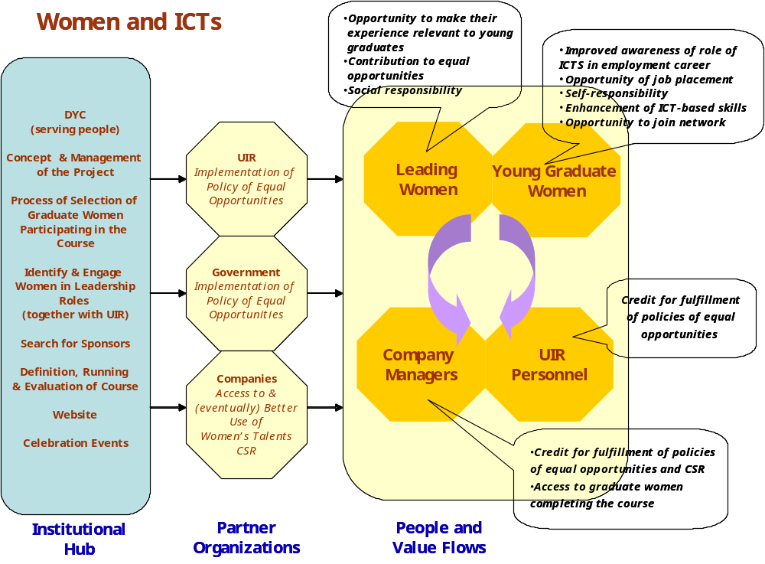

Figure 12. Project Women and New Technology – Organizations, People and Value Flows

DWF’s Activities in Project Women and New Technology
- Concept and management of the project
- Process of selection of graduate women participating in the course
- Identify and engage women in leadership roles in government and industry (together with UIR)
- Identifying and engage potential sponsors
- Definition and running of courses for young graduate women
- Monitoring and evaluation
- Website for the project www.donneict.it
- Organization of celebration events

Moving to the right of Figure 12, the three octagons show the different organizations involved in the realization of Project Women and New Technology, and the overall benefit they obtain from this involvement. Table 37 provides greater details about the contribution and overall benefit of each organization.

Roles and Overall Benefit to Partner Organizations from Their Participation in Women and New Technology
Organization | Contribution or Role | Overall Benefit
Digital Youth Consortium | Organiser, promoter and responsible for the concept and activities involved in project Women and New Technology | Fulfilment of the vision and mission of the consortium
UIR | Promotion of programme inside industrial membership, identifying companies offering job placement opportunities, and helping identify women in leadership positions | Fulfilment of policy of equal gender opportunity inside industry
Companies | Provision of placement opportunities for the women graduates attending and performing well in the course | Fulfillment of policies of equal gender opportunities and CSR and access to graduate women completing the course.  Eventually, the intention is that companies also benefit from better awareness and use of their women’s talents.
Local and Regional Government | Support through policy of equal gender opportunities | Practical fulfilment of policies on equal gender opportunities

Moving further to the right-hand side of the diagram, the box “people and value flows” shows the direct participants in, and beneficiaries of, the activities of project Women and New Technology. These are graduate women, women in leadership positions, UIR personnel, and company managers. The callouts list the benefits or value reaching each of these groups. These are reproduced in Table 38.

Benefits to Different Groups of People Involved in Women and New Technology
Graduate Women | Leading Women | UIR Personnel | Company Managers
- Improved awareness of role of ICTS in employment career  - Opportunity of job placement  - Self-responsibility  - Enhancement of ICT-based skills  Opportunity to join network of peers | - Opportunity to make their experience or success relevant to young graduates  - Contribution to equal gender opportunities  - Social responsibility | Credit for fulfillment of policies of equal gender opportunities | - Credit for fulfillment of policies of equal opportunities and CSR  - Access to graduate women completing the course

Evaluation of Course Women and New Technology 2006

The DYC run an evaluation questionnaire with the participants to the 2006 course session. Figures 13a, 13b, 13c and 13d show the result of the assessment given by 20 respondents in relation to the value of the course for (a) enriched knowledge to face better the labour market, (b) opportunity of contacts with the world of enterprise, (c) opportunity to learn about policy on equal opportunities and (d) improved possibilities of finding work. Close to three-quarters of the respondents found the course good (57%) or excellent (16%) in relation to contacts with the world of enterprise (Figure 13a) and knowledge to face better the labour market (Figure 13b); and similar three-quarters found it good (53%) or excellent (53%) in terms of learning about policy for equal opportunities (Figure 13c).

When it came to improved possibilities of finding work (Figure 13d), 58% of respondents found it good but 21% found the course had given them little (16%) or nothing (5%). This more moderately positive result is related to the greater difficulty of securing work as a direct result of the course. This is also confirmed by the fact that about 10 participants of the course have found placements as a direct result of the course. This is about one-quarter of those who completed the two courses that have taken place. This is clearly and area for improvement and further investment of resources. The small-scale action implemented by the DYC in collaboration with UIR, however, has laid the foundations for a better and more extensive action in the future.

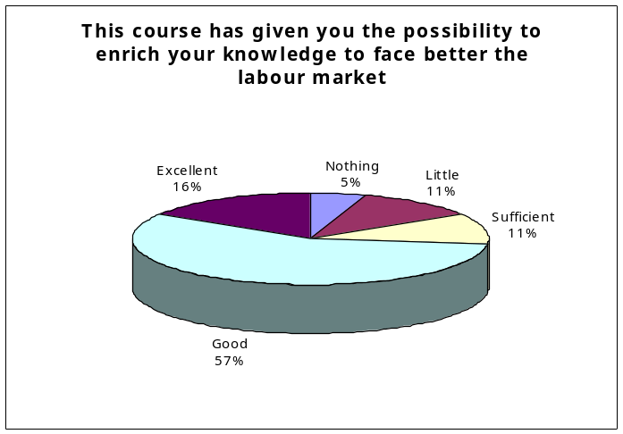

Figure 13a. Assessment of Value Regarding Enriched
Knowledge for Facing Labour Market

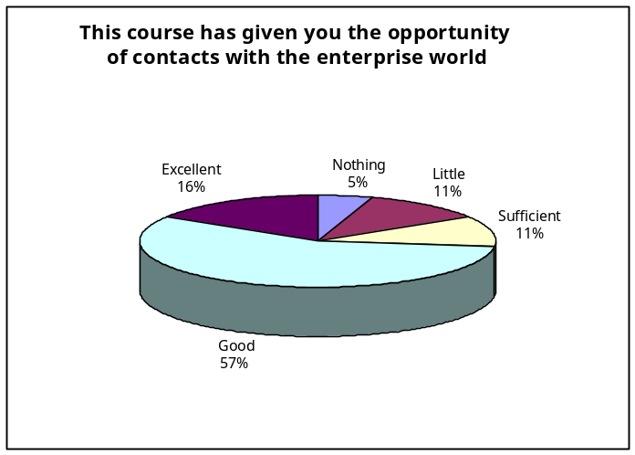

Figure 13b. Assessment of Course Value regarding Contacts
with the Enterprise World

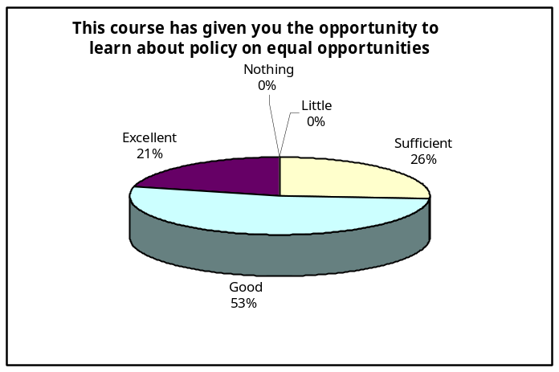

Figure 13c. Assessment of Value Regarding Policy on Equal Opportunities

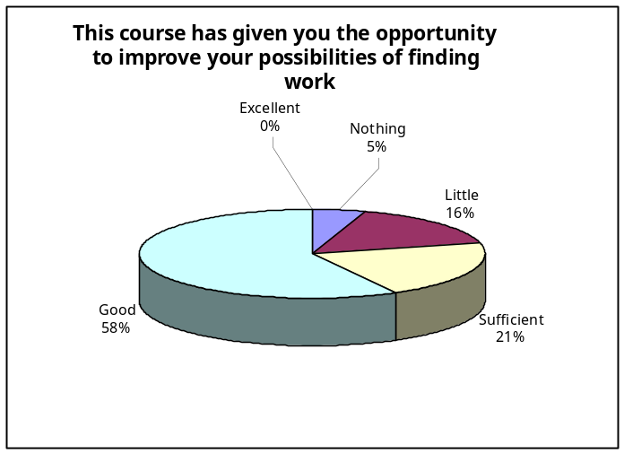

Figure 13d. Assessment of Value Regarding Improved Possibilities of Finding Work

2) The project “Futuro @l femminile by Microsoft , Accenture, HP and Generali Assurance
The project Futuro@lfemminile is an initiative born from an interisting partnership between Microsoft Accenture, HP, Assurances Generali and Italian Ministry of Equal Opportunities.. The objectve of the project is to promote concrete plans and actions in favour of the development of the women with the help of the new technologies.

The initiatives of the project interst 4 lines of the development of women:
- Women and job: Between the initiatives promoted from futuro@lfemminile, on can list the Observatory Women in the PA, in collaboration with the Forum PA, and pa@lfemminile (www.palfemminile.it ), a web site dedicated to the women that work in the Public Administration.
- Women and study: In the scientific faculties, in particular Engineering and Computer science, the percentage of the women registred does not exceed 15-20%. The gap is motivated from the social and cultural factors that discourage the girls undertake the scientific and technical studies.
- The activities addressed to the girls must stimulate their registration in the scientic faculties and must foresee stage, internships, and particular day in the company where the girl can observe the work of the manager-women.
- Women and daily life: Futuro@lfemminile promotes the course of computer, in order to favor the conciliation for the women that work.
- Women and company: The particular attention to the inclusion of neo-graduated, the investments in the training, the realization of the inner nursery, the facilitation as the part-Time work or home working. This are important initiatives to conjugate the management of the professional engagements with the personal life. In Microsoft, as an example, in last the two years, the number of women has grown from the 24 to 26.5%.
3) The Programme “Cantieri”, by the Italian Ministry of the Public Administration
Another project is represented from the Programme Cantieri and in particular the project thet has instituted the Laboratories, as “Women and leadership” started in the 2002 from the departments of the Public Function and the Equal opportunities. The objective was to support the public administrations to start concrete actions of management and development of the human resources in the sense of gender equality.
The project previews a study of the actual condition of the public administrations finalised to deepen specific topics for the innovation. The Laboratories operate through the constitution of work groups, composed from expert coming from from the academic world,
from the research , from the consultancy and from functionaries of the public administration
that have experimented or are experimenting with success innovation plans and projects in the direction of gender equality that:
• sensibilize all the organization on the issue of gender equality;
• valorise the differences of the gender in the policies of development of human resources;
• favour the increase of the women in the decision making process;
• collect good practises.

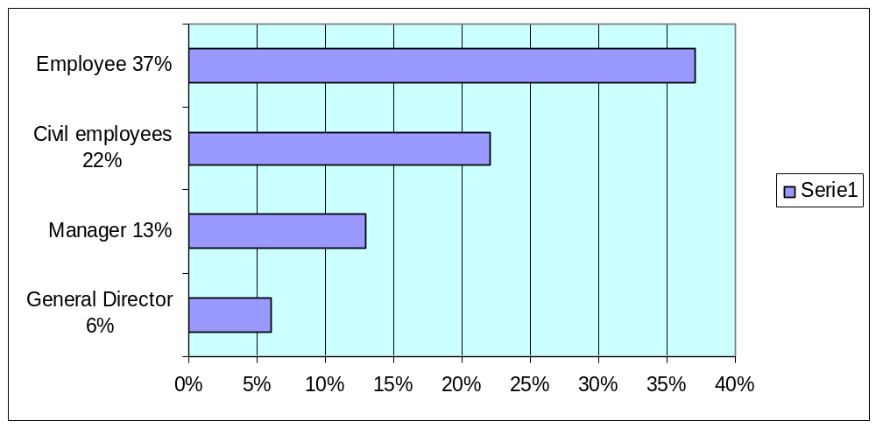

From the 1° to 8 March 2007 on the web site MSN.it it was realized a survey, beyond 2.000 between men and women of agebetween 12 and 50 , about the perception of the feminine stereotypes.

Do you think that in our society exist obstacles to the realization of the women?
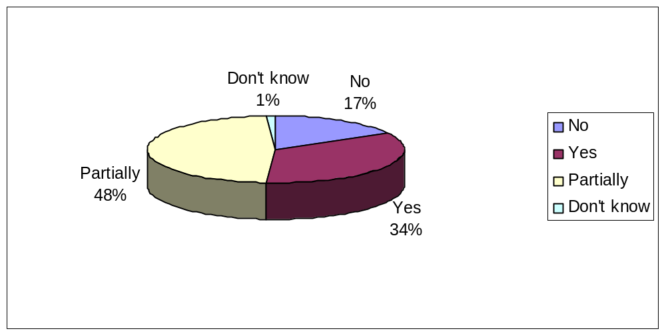

In which field do you think exist greater differences between men and women?
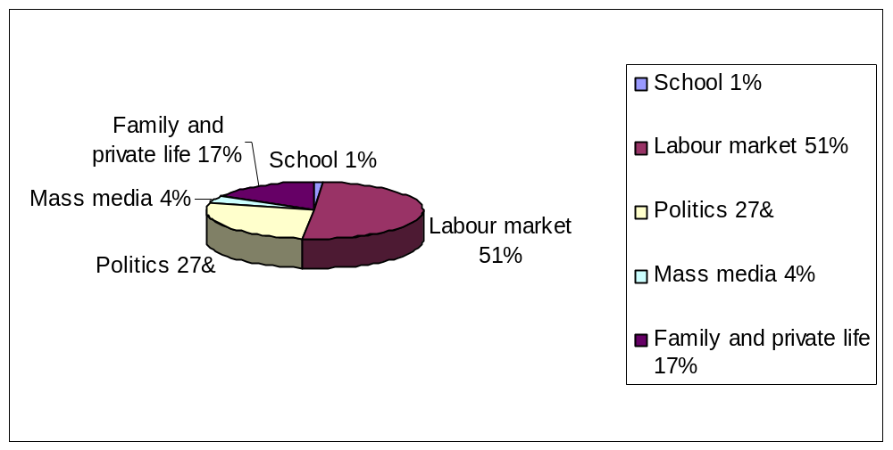

Do you think that the woman must renounce to something in order torealise in the professional life?
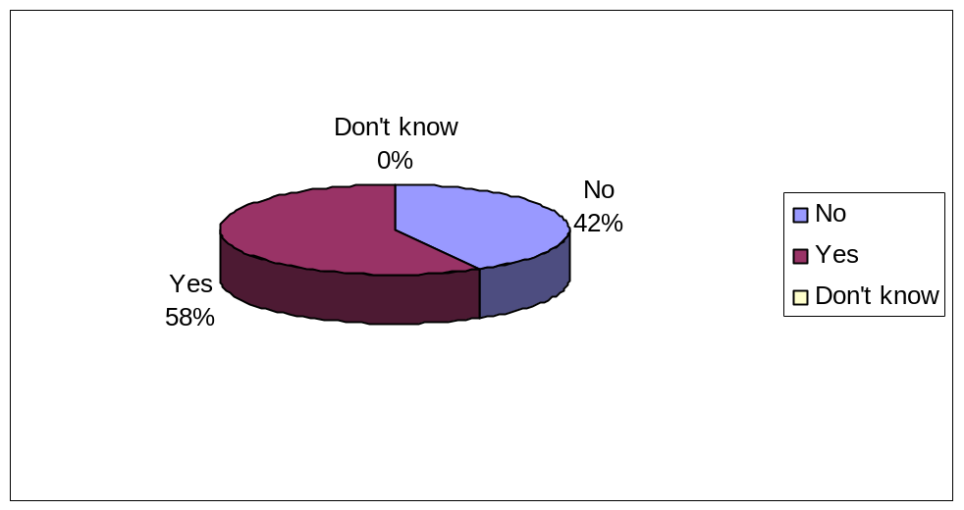

If yes,
To the career if the women is devoted at the family | 46%
To the free time and her hobbies | 26%
To maternity if she works | 18%
To her personality to adapt at the external enviroment | 6%
To aesthetics | 3%

The technological innovation, has contributed to the equal opportunities?
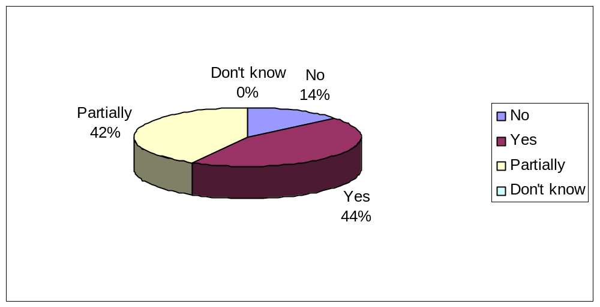

4) Women and New Technologies: an initiative of success, promoted by futuro @l femminile
The technology as instrument of valorization of the professional presence of the women in the companies. Thursdays 18 January 2007 to Milan, in the Union of the Commerce, have kept the round table Women and technology: the succeeding binomial, promoted from futuro@lfemminile. From this meeting emerged that the rate feminine employment , still between lowest of Europe, it is to the 46,7%, even if in the last decade the greater contribution to the increase of the total occupation has grown nearly ten points constituting; The 0,8% of the women employer that became manager the 4,9 has a supervision role. Moreover from a research of the University of Milan results that only 26% of women earns more 100000 € for year, against the 41% of men.

5) “Resource Women”, a project of the Municipality of Rome
The Municipality of Rome and the Region of Latium funded the project “Resource Women” to substain the development of the feminine companies. The goal of this project is to increase the presence of the women in the job market promoting:
- the diffusion of the culture of enterprise between the women;
- improving the ability and competences of the new businesswoman;
- helping to find specific funds for the new companies;
- a brainstorming of knowledge;
- to promote between they the interaction and the exchange of ideas and acquaintances.
In this project are previewed a lot of activities in the centre of the city and in the suburbs:
20 workshops, seminaries, counseling, meeting in order to favour exchanges and partnership.

6) Project “100 enterprises” by Region Latium
The project “Centoimprese” (100 enterprises) is an initiative of the Region Latium (in the within of the Global Subsidy E1). The goal of the project is to promote the women employment in the innovative sectors of the territory. This project previews the concession of fund from a minimum of 10.000 to a maximum of 35.000 euros in favour of new feminine enterprise or enterprises constituted from not more than 24 months to the the 28 date of July 2006.

7) Project in favour of women by the University Roma Tre
The Equal Opportunity committee of the University RomaTre (the third Univerisity of Rome), after the success of the 2005 edition , actives, also for the year 2006, a free training course, titled “Women, Policy and Institution”, opened to 100 candidates to favour the equal opportunities in the decision-Making level and the access of the women to the political assemblies.

8) Network Women’s Program
Established in 1997, the Network Women's Program (NWP), promotes the advancement of women's human rights, gender equality and empowerment as an integral part of the process of democratization. The goal of the Roma Women's Initiative is to improve the position of women in different contexts: families, communities, women's rights movements in Central and Eastern European societies (http://www.romawomensinitiatives.org/directory.asp).

9) Gender Equality in Labour life
In year 2006/2007 it has been constituted an association, called GELL- Gender Equality in Labour and Life-, in order to realize the plan called “CPO Province of Rome”. The objects of this organization are, trough 5 workshops, and 3 researchs previewed for the realization of the Plan:

- to follow CPO in the drafting of the triennial Plan Positive Actions
- to develop to the competences of the 16 women members and substitutes of the Equal Committee Opportunity (CPO) of the Province of Rome
- to value how much the Province has up to now put in existence for the organizational well-being of the staff
- to add value to the actions of the Province in favour of human resources
- to sensibilise l355 business women and 1673 businessman in projectual phase
- to involve all institutional actors in the decisional iter
- to add value the role of the Commission.

10) The Project WomenTV
In 2007, European year of the Equal Opportunities, was born Donna Tv, a new voice in the panorama of the media, first web television entire dedicated to the feminine world. Donna TV is the first Internet tv relaized from the women for the women. It’s a digital platform diffusing in the network journalistic, artistic and cultural contents. Donna Tv launches a positive challenge: the fight agains the gender digital divide that is present in our society. Donna Tv, favours the equal opportunities thanks to the job of her editorial staff and the collaboration of all the internaute that propose journalistic, artistic and cultural contents. Donna TV wants add to value at the positive roles of the women in several fields of the society, contributing to the acknowledgment of the feminine authority contrasted from the traditional media .

Women in Local development in the Public Administration.
In the world we have only 11 women that are Heads of State , 23 women that are Minister of Foreign Affairs, 12 women that are Minister of the Defense, 20 women that are Minister of the Finance, 10 women that are Minister of the Economy, 45 women tath are Minister of the Commerce and the Industry, 11women between Minister and Functionars on Investements and Budget.

The presence of men and women is a fact almost in all the organizations, but it becomes still more obvious in the public administrations where the feminine member is always present in such numerical terms to exceed, in some fields, that male. Italy, with beyond three million dependent with a work contract without expiration in the public sector, is placed in the average of European countries, with one constant and progressive increase. Making a comparison between various European Countries, in the year 2000 the occupation of the women in the public sector oscillates from 73.2% of Hungary and 69.2% of Finland to 52.6% of Ireland and 50.3% of the Germany, in order then to come down in Sweden (46,2%9) and Norway 43% until 36.9% of Holland. In this case Italy is placed in middle position with 50.6% of feminine staff. In this case but our country reveals little in a position to valuing the feminine competences to decisional level, also in the middle positions where the women are less than a quarter of the total.

% Of Women in all the Public Fields
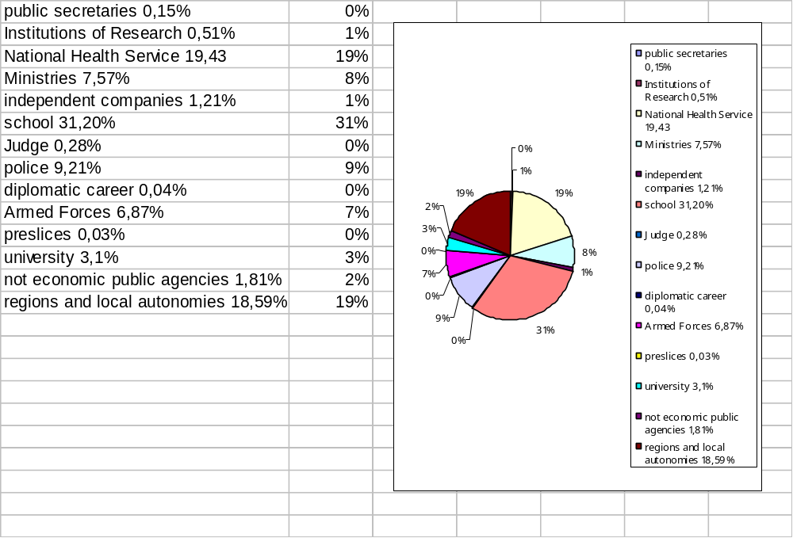

The Digital World Foundation, near with this activities at the world of the school, has evidenced as the school represents a sector with a strong presence of women. For this it becomes meaningful, in terms of vertical segregation, the upsetting of proportions between the two genders passing from the study of the staff to that most specific one of the directive roles. In fact, we see as the women, that they represent 74.3% of the total, become 38% between the leaders, while the men that is alone 25.7% of the total grow to 62% between the leaders. The school is a case where is evident that at a phenomenon of horizontal segregation on add an other of vertical segregation.

Staff of the school with contract without expiration

Qualifications | Men | Men % | Women | Women %
Director | 6.100 | 62 | 3.743 | 38
Teachers | 228.746 | 25.30 | 675.176 | 74.70
Total staff | 234.856 | 25.70 | 678.919 | 74.30

The presence of the women in Parliament is under of 20 % .In particular, on 630 deputies, the women in the Camera represent 17.14% of the total. To the Senate, instead, the percentage is of the 13,51%.
There is a gap between the presence of women and men that cover important position of Public Administration also: in the central administration we have 48 % of women employed, but only the 27 % cover decisional role and only the 15% are women general director.

Percentage of leaders on the total of the dependent

Administrations | Number of Administration | Average | Women | Men
Common | 13 | 3.7 | 3.8 | 3.9
Province | 5 | 3.6 | 2.6 | 4.8
Region | 5 | 9.6 | 6.5 | 12.7
Ministry | 2 | 8.1 | 4.4. | 11.8
Pac | 5 | 3.1 | 2.1 | 4.1
Asl | 8 | 14.5 | 9.2 | 23.5
University | 2 | 2.6 | 2.6 | 2.5
Others | 5 | 5.5 | 10.6 | 2.6
Tot. | 45 | 6.5 | 5.5 | 8.6

The smaller presence of the women in the decisional making is not justified from one low presence of the women in the labour market .The quantitative analysis demonstrates that the organizations that have a whole organic composed from the 60% of women (are remembered that the average total in Public Administration is 52% of women on the total of the dependent publics) is 37% against a 22% where there are beyond 60% of men. But if we go to see the same percentage in the division of kind of the leaders, the percentage of administrations with beyond 60% of leaders women comes down to 13%, while it in the event knows them to 71% of administrations with beyond 60% of leaders men. The imbalance is most obvious considering the general managers. Here the percentage of organizations with feminine general leadership beyond 40% of the total comes down to 6.6%. This percentage refers to organizations where there is a single place of general leader and this is occupied from one woman. In all the other cases the percentages of managing women generate them are very to of under of 20% while in 90% of the cases the places are occupied from men.

The women employed in Public Administration represent 54% of the staff, the presence of the women in the scholastic sector is the 76.2%, but we have (51%) the presence of the women in secondary role, the 33% of women have a role of decision making of second level, the 19% of women have a role of decision making of the first level although the medium degree of instruction between the public employers are held high from the contribution of the women who have one bachelor or a diploma of high school for one percentage of 60%, against 40% of the men.

Population with at leats a title of secondary studies composed by gender and class of age
(Italy, Year 2004)
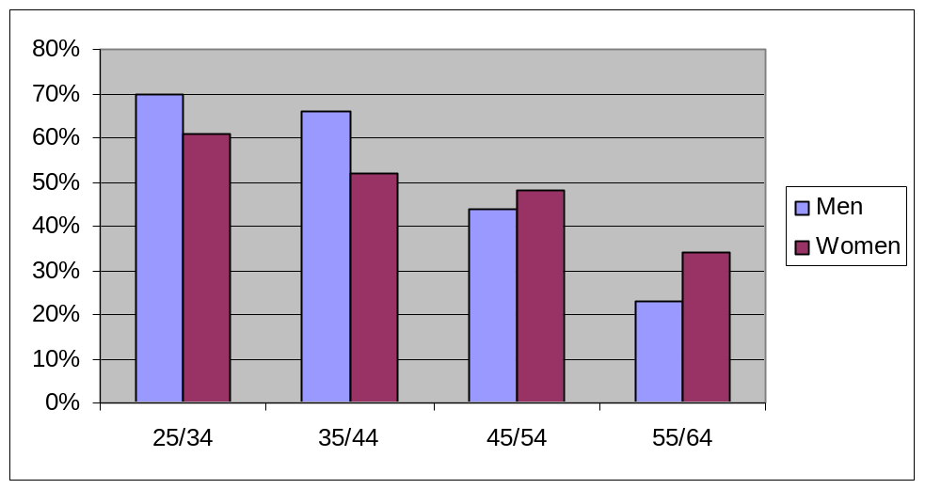

In sight of the 2007 (European year of the equal opportunities for all) it has been lead the search Women and Politics, to the roots of the kind inequality. In the search it has been put in evidence those that are consider the exclusion factors using the jobs and the studies produced from academic reasercher and not, associations of women, studious feminists. have been chosen 147 on 174 phenomena connect to the exclusion of the women from the apex places. It is emerged that the absence of the women in the political field depends in the first place on their distance from the apex fields of the labor market, exists a relative difficulty to the resources: economic, of time and organization, beyond to the ambiguity of the public opinion and to normative inertia.

The occupation of the population in working age represents one of the pointers key in order to measure the kind differences. In the 2005 years the 69.7% of the men turn out occupied againste the 45.3% of the women between the 15-64. Also for the class of age in which the maximum levels of occupation are caught up, that is for persons 35-44 years, the differences are remarkable: 61.3% for women and 91.2% for the men. The differences of the gender are reduced but to growing of the level of instruction of the population: the feminine rates vary from 17.5% of the women with elementary licence to 73.3% of those with a bachelor or a doctorate, while for the men they vary from 51.4% to 84.2%.

Groups | Men | Women
scientific | 75.4 | 24.6
Chemical/pharmaceutical | 37.8 | 62.2
biological | 38.7 | 61.3
medical | 36.3 | 63.7
engineering | 81.6 | 18.4
architecture | 51.7 | 48.3
agrarian | 56.9 | 43.1
economy and statistics | 51.7 | 48.3
Political/social | 38.7 | 61.3
jurisprudence | 41.3 | 58.7
literary | 34.1 | 65.9
linguistica | 18.2 | 81.8
Teaching | 10.3 | 89.7
sychological, | 21.1 | 78.9
physical education | 68.7 | 31.3
defense and emergency | 83.5 | 16.5
Total | 44.2 | 55.8

Also the data of the enterprise are frightful. According to a search of the European Commission, the women, in 2006, represented alone 3% of the presidents of boards of directors and of the general executive managers of the 1,304 greater companies of the Union. Italy is situated hardly to of over of the average of the presidents, with 4%, and under of the average of delegated amministratrici (1%).

An ulterior search lead in the 2005 from the Sun 24 hours in the societies of understood just one councilman on 5 is woman (20.5%), in the S.P.A., the seats reserved for women are alone 14% and the companies where the Cda is nearly all to feminine they are often hardly under way initiatives (19.5% of total).

Rate occupation of the women 15/64 years old for level of study and geographic division (north, south, center) Italy 2005
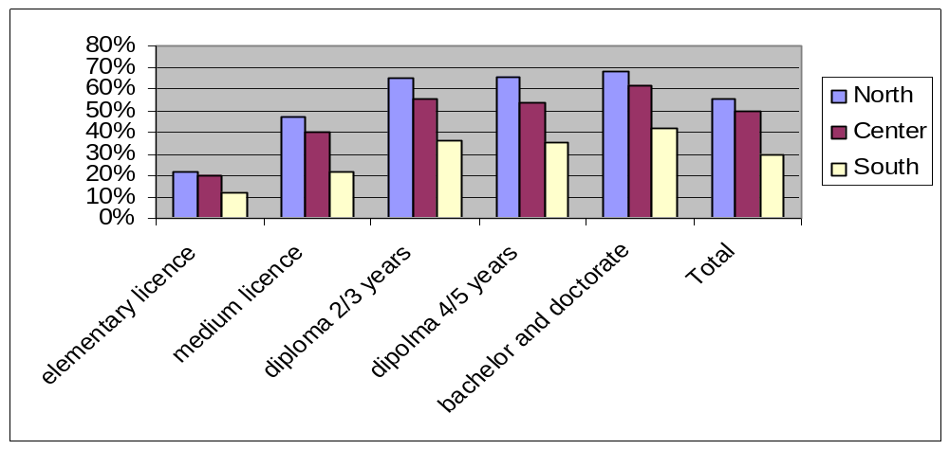

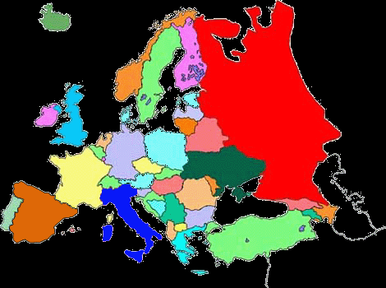
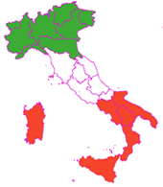
Italy in Europe

Italian Geographic Division

As evidenced from table 1 (pag.5) professional women at work represent 45% of the total but this percentage decreases visibly if we consider the number of directors, manager, of feminine sex and business women. Moreover, tables 6 and 7 show respective the situation in Italy, in which the percentage of women with responsibilities is one/fifth of the total, and in Lazio where during the last few years an opposite tendency to that one of national level has been recorded.
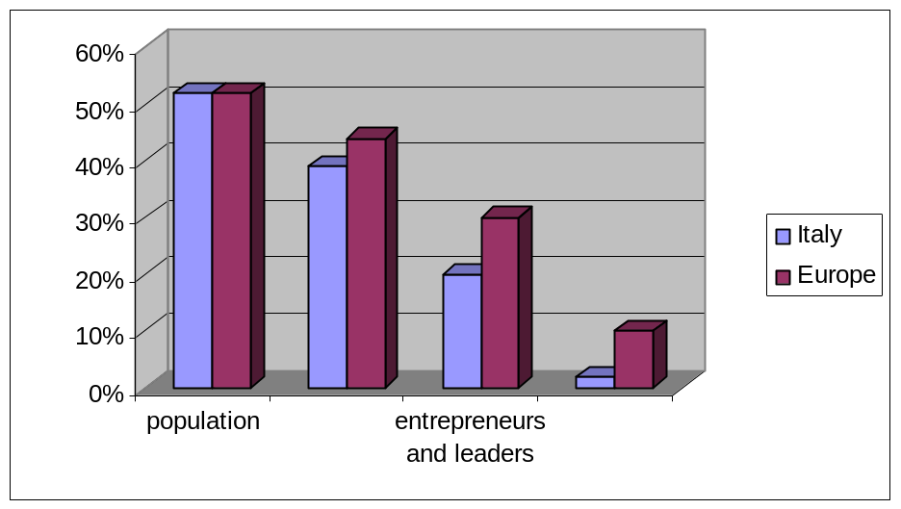

if in the population
the women are the majority
in the apex positions
in Europe
are hardly 10%
and in Italy 2%

The surveying ISTAT on the job forces, published on December 2006, although the most recent occupational increments have regarded the male and the feminine member, permane an important gap in the composition of the Italian force job: to forehead of a rate inactivity of the equal men to 25,6%, a rate inactivity of the equal women to 49.9% with one is recorded heads in the South of Italy to the 63,8%3.

The “Italy Relation 2006” of the Eurispes defines Italian women as “acrobats” more and more engaged between job and maternity and, above all, like a great potentiality that Italy does not value completely. The Eurispes declares:
“In Italy exists a strongly deficiency of the services for infancy (currently the public offer of services covers hardly 7.4% of the question, while it leaves in received 32.7% of the effective demands) that it is accompanied to the remain of a culture that, to thirty years from the beginning of the process of femminilizatin of the labor market, still finds it hard to within recognize the changed role of the woman the family and to the society, and that effective is very far supplying substance to the principle of the equal opportunities.”
Two Italians on three, always second the data of surveying, “say favorable to the introduction of `the quotas rose' since think that the imposition of law for a determined number of places reserves to the women is the only way to guarantee one sure feminine presence in politics. An other part of surveying door to the light since a woman testifies that on five, between those occupied at the moment of the pregnancy, does not work more after the delivery for varies reasons to you, than not always but, they depend on its will. In 69% of the cases she is the women to fire itself, in 23.9% he is because it is expired a contract that them has not been renewed or because it has been directly fired.

Rate occupation of the women 35/44 years for familiar condition
Italy, 2005
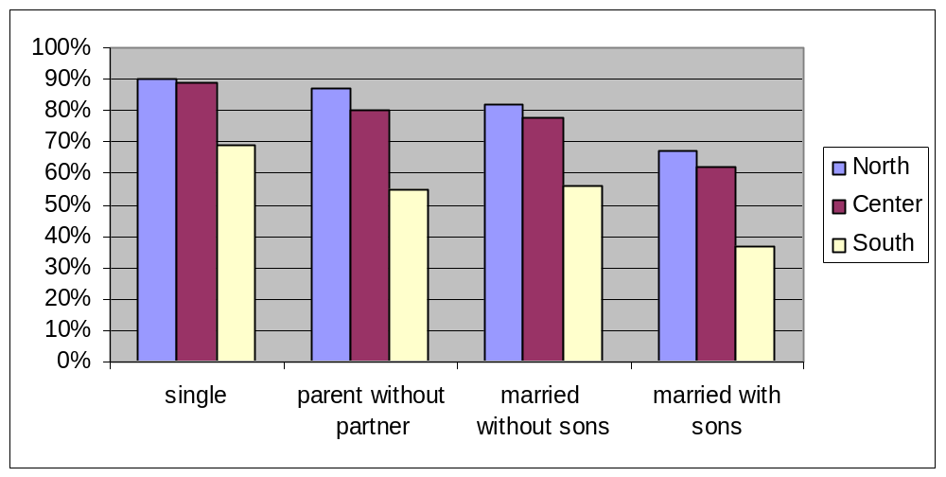

From new surveying on Women and job, lead from the Ipsos Institute on behalf of the Lines company, it emerges that 34% of the interviewed women would prefer a good professional realization also to cost of some renunciation in the private, 46% would prefer a partial realization with minimal renunciations, and only 16% place like priority the private life. Also between who full rivendica compatibility between the personal sphere and that professional one, in 32% of the cases is not wanted to be renounced to one good realization on the job.

As far as the Italian spread of the part-time, women they are still under of the UE average and near to the levels of France and Spain. They are instead much far from the behaviors of the Dutch who in 75% of the cases work to part-Time. For this it is diffuse opinion that this segment of feminine occupation can be ulteriorly developed in future.

APPENDIX I

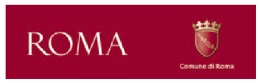


PROTOCOLLO DI ROMA

tra

Comune di Roma

e

Unione degli Industriali e delle imprese di Roma

per

“Favorire le pari opportunità nell’impresa romana”

Roma, 9 ottobre 2006

Protocollo d’intesa

tra
il Comune di Roma, rappresentato dal Sindaco on. Walter Veltroni, residente per la carica presso il Palazzo del Campidoglio, Via del Campidoglio, 1 - 00186 Roma
e
l’Unione degli Industriali e delle imprese di Roma, rappresentata dal Presidente Luigi Abete, residente per la carica presso l’Unione degli Industriali e delle imprese di Roma, Via A. Noale, 206 - 00155 Roma

Visto

- che il primo giugno 2006 la Commissione europea ha dato il suo benvenuto alla decisione del Consiglio e del Parlamento europeo di designare il 2007 “Anno europeo delle pari opportunità per tutti”;
- che questa iniziativa servirà a rendere i cittadini UE consapevoli del proprio diritto a non essere discriminati, a promuovere le pari opportunità in campi quali il lavoro e l’assistenza sanitaria, e per dimostrare come la diversità renda l’Europa più forte;
- le varie iniziative e direttive della Commissione europea per favorire le pari opportunità tra donne ed uomini nella vita economica, sociale, culturale, civile e politica di ogni paese (si veda CEC, Towards a Community Framework Strategy on Gender Equality (2001-2005), Brussels, 7.6.2000, COMM (2000) 335 final);
- le varie iniziative e direttive del Governo italiano in materia;
- l’impegno del Comune di Roma, attraverso l’Assessorato alle Politiche per le Pari Opportunità, volto a favorire una adeguata rappresentanza delle donne in tutti i settori della vita democratica locale ed impegnato nella promozione e tutela dei diritti delle donne;

- l’impegno dell’Unione degli Industriali di Roma, attraverso il Comitato UIR Femminile Plurale, finalizzato a favorire una adeguata presenza femminile nell’industria romana e nei vari livelli rappresentativi dell’Unione;

considerato che
- in tutti i paesi dell’Unione europea sono stati compiuti notevoli passi avanti per quanto riguarda la situazione delle donne, ma nella vita quotidiana la parità tra i sessi viene ancora pregiudicata dalla mancanza di una reale uguaglianza di diritti e dal persistere di discriminazioni sessuali, essendo le donne ancora scarsamente rappresentate;
- è possibile affrontare la situazione in modo efficiente inserendo l’obiettivo della parità tra i sessi in tutte le politiche che esercitano un impatto diretto o indiretto sulla vita degli uomini e delle donne;
- il Comune di Roma ha deciso di raccogliere la sfida di promuovere la produzione del cambiamento strutturale necessario per conseguire la reale parità tra i sessi;
- il Comune di Roma, in linea con le politiche comunitarie, ha deciso di promuovere politiche attive di parità tra i sessi in tutti i seguenti ambiti d’intervento: vita economica, partecipazione e rappresentanza in condizioni di parità, diritti sociali e vita civile;
- l’Unione degli Industriali di Roma, attraverso la propria attività di rappresentanza e di servizi, intende promuovere e sostenere iniziative volte a rendere agevole il dialogo tra mondo del lavoro e tessuto produttivo, nei settori di punta dell’economia del territorio romano in particolare a favore delle donne. Con tale obiettivo ha inserito nel proprio programma strategico di attività il Progetto “UIR Femminile Plurale”;
- il Consiglio europeo di Lisbona ha fissato una serie di obiettivi quantitativi di primaria importanza per conseguire la parità tra donne ed uomini nella vita economica, tra cui quello di aumentare il tasso di occupazione femminile dal valore medio attuale del 51% a più del 60% nel 2010;
- il Consiglio europeo in questo contesto ha chiesto a tutti gli stati membri di rivolgere un’attenzione particolare alla piena integrazione delle donne nella cosiddetta nuova economia;
- le tecnologie dell’informazione e della comunicazione (ICT) stanno esercitando un influsso crescente su tutti i settori economici e ne consegue che risulta indispensabile cercare di dare alle donne pari accesso all’economia della conoscenza, aiutandole ad esserne pienamente partecipi;

- il Comune di Roma ha avviato da tempo progetti finalizzati a favorire la diffusione di una cultura informatica tra la popolazione, costituendo il Consorzio Gioventù Digitale;
- l’Unione degli Industriali di Roma, attraverso il Comitato Strategico UIR Femminile Plurale, è impegnata nella promozione delle pari opportunità in tutti gli aspetti della vita professionale della donna nell’impresa, con particolare riguardo alla promozione e diffusione delle politiche che mirano a conciliare la vita lavorativa con quella familiare;
- il Consorzio Gioventù Digitale promuove pari opportunità di accesso all’economia della conoscenza attraverso progetti e programmi mirati alla diffusione delle tecnologie dell’informazione e della comunicazione per favorire l’accesso dei giovani nel mondo del lavoro;
- UIR Femminile Plurale si rivolge al target di genere con l’obiettivo di qualificare la presenza delle donne nel mercato del lavoro, favorire l’imprenditoria femminile, accrescere il tasso di rappresentatività femminile nelle sedi opportune, realizzare una rete di servizi che agevoli la donna per l’inserimento, la migliore occupazione, la conciliazione dei tempi di vita e di lavoro;
- il Consorzio Gioventù Digitale e UIR Femminile Plurale sono stati i soggetti attuatori del protocollo d’intesa “Favorire le pari opportunità nell’impresa romana” negli anni 2003-2006;
- il protocollo d’intesa “Favorire le pari opportunità nell’impresa romana” anni 2003-2006 ha previsto una serie di azioni quali: una ricerca a livello locale sulla presenza della donna all’interno delle aziende di ICT; la costituzione di un comitato scientifico; la costituzione di una rete di Mentor; un convegno a livello nazionale dal titolo “donne e nuove tecnologie”; la realizzazione di un corso di formazione per giovani neolaureate;
- il corso di formazione, giunto ad oggi alla sua seconda edizione, ha formato in due anni giovani donne, per un totale di 120 ore di corso;
- al termine del corso sono stati attivati degli stage formativi in aziende del settore. In questa fase è stata richiesta la collaborazione dello Sportello Tirocini del Comune di Roma;
- il progetto sviluppato in base al protocollo “Favorire le pari opportunità nell’impresa romana” è risultato vincitore al Forum PA 2005, nella sezione Donne e Tecnologia e descritto come buona pratica della Pubblica Amministrazione nel libro edito dal Il sole24ore Donne e nuova tecnologia;

ritenuto che
- l’industria dell’informazione e della comunicazione ha un ruolo determinante nello sviluppo economico dell’area romana;
- Roma è un polo universitario di primario livello che forma profili di laureati in diverse discipline, alcune delle quali sono di particolare interesse per la realtà industriale del territorio;
- è compito delle amministrazioni pubbliche mettere in opera adeguati programmi educativi e formativi, oltre che idonee azioni sperimentali e strutture di supporto che rimuovano e prevengano potenziali disuguaglianze;
- é necessario promuovere strategie di sensibilizzazione sul tema delle pari opportunità tra i sessi dirette al mondo produttivo locale, ma è altresì importante promuovere azioni specifiche a favore delle donne, al fine di eliminare il persistere di determinate disparità;
- è necessario promuovere la capacità di inserimento professionale delle donne nel campo delle tecnologie dell’informazione, specie favorendo la partecipazione femminile ad appositi corsi di istruzione e formazione;

Si conviene quanto segue
Art. 1
Le premesse costituiscono parte integrante del protocollo d’intesa.

Art. 2
Il Comune di Roma e l’Unione degli Industriali di Roma collaborano al fine di avviare un vasto programma che favorisca le pari opportunità tra i sessi nell’industria romana, avendo particolare cura verso aree di attività dove l’uso delle tecnologie dell’informazione e della comunicazione è strategico.

Art. 3
Il Comune di Roma mette a disposizione le competenze dell’Assessorato alla Semplificazione, Comunicazione e Pari Opportunità e le competenze del Dipartimento XVII. Il Comune di Roma inoltre si avvale della Fondazione Mondo Digitale, ex Consorzio Gioventù Digitale, per l’attività di coordinamento dei vari aspetti relativi alla attuazione della presente convenzione.

Art. 4
L’Unione degli Industriali e delle imprese di Roma mette a disposizione le competenze del Comitato UIR Femminile Plurale per l’attività di coordinamento dei vari aspetti relativi alla attuazione della presente convenzione.

Art. 5
Le parti convengono di operare secondo le seguenti linee prioritarie di intervento:
- puntare sulla diffusione di una cultura dell’utilizzo delle tecnologie informatiche in diversi ambiti produttivi, in particolare a favore delle donne;
- trasferire modelli organizzativi di gestione del tempo che contribuiscano a conciliare tempi di lavoro e di vita, ossia ruoli professionali e sociali;
- porre in relazione il mercato produttivo con le esigenze di professionalità, in una ottica di genere.

Art. 6
Le parti si impegnano a costituire un Comitato di Programma per promuovere gli interventi da attuare per l’esecuzione del presente Protocollo d’intesa. Il Comitato è un organismo bilaterale di indirizzo di cui faranno parte fino a 8 membri scelti dal Comune di Roma e 8 membri dall’Unione degli Industriali e delle imprese di Roma.

Art. 7
Con il contributo del Comitato di Programma le parti si impegnano a promuovere un piano di attività in base alle linee prioritarie di intervento indicate nel presente Protocollo d’Intesa e a definire, fermi gli eventuali provvedimenti di competenza dei rispettivi organi deliberativi, le attività ed i metodi per lo svolgimento delle stesse, compatibilmente con le fonti di finanziamento disponibili, tra le quali potranno prevedersi eventuali sponsorizzazioni o bandi europei.

Art. 8
Tale piano prevederà una serie di iniziative fra loro coordinate e collegate che verranno a costituire il Progetto “Donne e nuove tecnologie”. Si tratterà sia di azioni di sensibilizzazione della popolazione e del mondo produttivo locale (come workshop, seminari e simili) sul tema delle pari opportunità tra uomini e donne nella vita professionale, sia di iniziative specifiche mirate ad aiutare le donne a raggiungere un’adeguata presenza e rappresentanza nell’industria romana.

Art. 9
Tra le diverse attività da programmare vi saranno:
- un convegno di una giornata da realizzarsi nella Sala della Protomoteca del Comune di Roma, sull’apporto dato dalle aziende associate all’Unione degli Industriali e delle imprese di Roma alla parità tra i sessi nella vita economica, a cui prenderanno parte tutte le rappresentanze del mondo produttivo locale;
- corsi di formazione per l’inserimento al lavoro destinati a giovani laureate con l’obiettivo di formare figure professionali che possano incontrare la domanda delle aziende;
- una borsa di studio, da assegnare alla corsista più meritevole, consistente in un corso di formazione sulle competenze relazionali, intitolata alla memoria di Raffaella Alibrandi, imprenditrice dell’Unione degli Industriali e delle imprese di Roma che con il Comune di Roma ha promosso la realizzazione di iniziative a favore della pari opportunità.

Art. 10
Con l’indispensabile ausilio del Comitato di Programma, quanto non previsto nel presente accordo sarà stabilito dalle parti in sede di definizione del Progetto “Donne e nuove tecnologie”.

Art. 11
Il presente protocollo d’intesa ha una durata triennale.
Roma, 9 ottobre 2006

Walter Veltroni Luigi Abete
(Il Sindaco) (Il Presidente)

Bibiography and websites

A cura della Commissione Attività produttive e risorse ambientali, CNEL (2004) La trasformazione silenziosa. Donne, Ict, Innovazione.
a cura della Regione Lazio (2006) Il Lazio e la strategia di Lisbona. Innovazione, Competitività, Occupazione. Rapporto 2006.

A cura del Ministero della Solidarietà Sociale (novembre 2006), Rapporto nazionale sulle strategie per la protezione sociale e l’inclusione sociale 2006/2008.

A cura del Ministero dell’Economia (2002), Conto Annuale dello Stato, Rapporto “Donne e Leadership” (2003)

A cura di Fabio Piacenti, (2006) Tipografia Promoter Italia. Rapporto 2006 sullo statuto delle Province del Lazio.

A cura di Maria Giulia Catemario e Paola Conti (2003) Seconda Edizione Rubbettino. Donne e leadership. Per lo sviluppo di una cultura organizzativa delle amministrazioni pubbliche.

A cura di Maria Giulia Catemario (2005) Edizioni Scientifiche Italiane. Sperimentare in ottica di genere. Le amministrazioni pubbliche verso una cultura che valorizza le differenze.

Antonio Dini (2005) Donne e Tecnologie, le buone prassi nella pubblica amministrazione italiana.

Elaborazione del Comitato Pari Opportunità INPS (2007), Analisi della condizione della donna nel mondo degli ammortizzatori sociali.

Innovazione: il futuro del sistema del Paese, rivista “Le Province” anno IC, num.3, Maggio/Giugno 2007.

Prof. Alfonso H. Molina (2006) Fondazione Mondo Digitale: per una società democratica della conoscenza
- http://www.womenews.net/spip/spip.php?rubrique16
- http://www.ilo.org/public/italian/region/eurpro/rome/info/press/cs0719.htm

http://www.intrage.it/attualita/2007/05/12/notizia13666.shtml

http://www.intrage.it/rubriche/famiglia/genitorielavoro/maternitaflessibile/articolo339.shtml
- http://www.donne-lavoro.bz.it/283v283d3235.html

http://www.vita.it/articolo/index.php3?NEWSID=80386

http://europa.eu/scadplus/leg/it/cha/c10404.htm

http://www.europarl.europa.eu/sides/getDoc.do?pubRef=-//EP//TEXT+TA+P6-TA-2007-0063+0+DOC+XML+V0//IT
- http://www.retepariopportunita.it/Rete_Pari_Opportunita/UserFiles/news/risoluzione_13_3_07.pdf
- http://www.governo.it/GovernoInforma/Dossier/pari_opportunita_codice/codice.pdf
- http://www.womenews.net/spip/spip.php?breve156
- http://www.style.it/cont/sesso-psiche/news/0705/0300/donne-famiglia-lavoro-facciamo-i.asp
- http://europa.eu.int/italia/news/1099cb62de0.html
- http://www.conquistedellavoro.it/cdl/nw/dettaglioNotizia.jsp?preview=false&dataPreview=15-05-2007&checkPublishFlag=true&id=-761164723
- http://mondodonna.blogosfere.it/2007/02/capitale-donna-per-fare-impresa-a-roma.html
- http://www.telefree.it/news.php?op=view&id=30754

http://www.ilsole24ore.com/fc?cmd=art&codid=20.0.1970642389&chId=30&artType=Articolo&DocRulesView=Libero

http://job24.ilsole24ore.com/fc?cmd=art&codid=20.0.1833738435&artType=Articolo&DocType=Libero&chId=53

http://www.labitalia.com/articles/Approfondimenti/13550.html

http://erewhon.ticonuno.it/arch/rivi/vita/occupaz.htm

http://www.lavoce.info/news/view.php?id=43&cms_pk=2713&from=index

http://www.lavoce.info/news/view.php?id=43&cms_pk=2731&from=index

http://www.lavoce.info/news/view.php?id=43&cms_pk=2599&from=index

http://www.istat.it/salastampa/comunicati/non_calendario/20070307_00/
- http://www.comune.roma.it/was/wps/portal/!ut/p/_s.7_0_A/7_0_21L?menuPage=/Area_di_navigazione/Sezioni_del_portale/Dipartimenti_e_altri_uffici/Dipartimento_XVII/Pari_opportunita'/

- http://www.cantieripa.it/inside.asp?id=2031
- http://www.cantieripa.it/inside.asp?id=1960
- http://www.pariopportunita.gov.it/Pari_Opportunita/UserFiles/PrimoPiano/parit%E0_donne_uomini_ed_emancipazione_femminile_cooperazione_sviluppo.pdf
- http://www.pariopportunita.gov.it/Pari_Opportunita/UserFiles/Il%20Dipartimento/Anno%20europeo%202007/intervento_anno_europeo.pdf
- http://www.pariopportunita.gov.it/DefaultDesktop.aspx?page=1069
- http://www.romaeconomia.it/view_rubrica.php?id=459&rubrica=notizie
- http://host.uniroma3.it/comitati/pariopportunita/corsopolitica.htm

http://host.uniroma3.it/comitati/pariopportunita/iniziativealtre.htm

http://www.donnatv.it/tv/mooffanka/?doc=3

Points 1,2.
Pointes 3,4,5.
Points 6,7.
http://www.donneict.it/documents/protocollo_intesa.pdf
Lopez-Claros and Zahidi (2005).
Ibid., p.10.
Tripi, p.5 (2005), in Molina (2006).
http://www.donneict.it/documents/protocollo_intesa.pdf
Dipartimento della Funzione Pubblica per l’efficienza delle amministrazioni (in “Sperimentare in ottica di genere” 2005 p.43)
MSN, research (2007)
Conto Annuale dello Stato (Ministero dell’Economia, 2002), in Rapporto “Donne e Leadership” (2003)
Dipartimento della Funzione Pubblica per l’efficienza delle amministrazioni (in “Sperimentare in ottica di genere” 2005 p.42)
Dipartimento della Funzione Pubblica per l’efficienza delle amministrazioni (in “Sperimentare in ottica di genere” 2005 p.42)
Fonte: Eurostat, 2004 (valori percentuali)
Fonte: Mur “Indagine sulle Università” Anno accademico 2005/2006; Pubblicazioni Istat “Università e Lavoro”, 2005.
Fonte: Istat, 2005 (valori percentuali)
Fonte: Istat, 2005 (valori percentuali)
Fonte: Istat, 2005 (valori percentuali)

