Getting engaged: Women in local development
European project co-funded by the EU

2nd Steering Group Meeting & 1st Peer-Review Workshop
PUSZCZYKÓWO (Poznan) 16 MAY-19 MAY 2007

INFO PACK

1. ACCOMMODATION & VENUE

Rooms have been booked for all participants at the Atrium Hotel. Atrium will also be the venue for the meeting and workshop.

Please keep in mind that all the extra (bar, telephone, internet, pay tv, extra services, etc) will be on your charge.

Atrium Hotel
Centrum Konferencyjno-Bankietowe
ul. 3 Maja
- 041 Puszczykówo
Poland
tel: +48 61 898 3060
fax: +48 61 819 4900
www.atriumhotel.com.pl

Contact details QeC-ERAN
Haroon Saad 0032-498 123403
Annachiara Pecchini 0032-474 668565

2. ITINERARY & MAP

At your arrival at POZNAN ŁAWICA AIRPORT you will be picked up by the shuttle service of the Atrium Hotel. The trip from the airport to the hotel will take approximately 40 minutes.

Atrium is situated in Puszczykówo which is a 15 minutes drive from Poznan in the direction of Wroclaw. Poznan itself is exactly between Berlin and Warsaw and it is equipped with a modern airport and excellent train connections to the rest of Poland.
Puszczykówo became famous as a local retreat already at the beginning of the 19th century when it received a train station. Its healthy micro-climate, charming location on the banks of the Warta River and surrounding national park made it an obvious choice for a get away and today it is still known to be one of the best park areas in Poland. Atrium is surrounded by the Wielkopolski National Park, benefiting from the peace and relaxing atmosphere it provides.

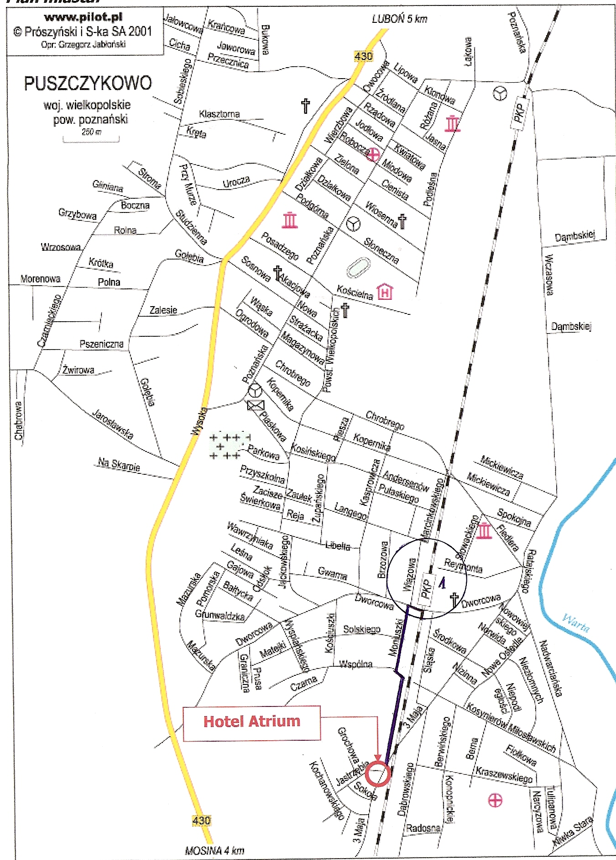

PKP = Puszczykówko Station

By Train
Travelling from POZNAN RAILWAY STATION to PUSZCZYKÓWKO STATION (Atrium Hotel)
- Take the train with the destinations: Wrocław, Leszno, Rawicz, or Kościan
(do not take the fast train “pospieszny”, normal train “osobowy” ONLY)

- Puszczykówko is the 4th stop from Poznań (do not leave the train in Puszczykowo Station!)

- The train departs every hour, due to construction work the schedule has to be checked

- One way ticket is about 4,50 zł

- From PUSZCZYKÓWKO STATION it is a 6 minutes walk to the hotel. See the attached map of PUSZCZYKOWO on the previous page.

Map of Poznan centre

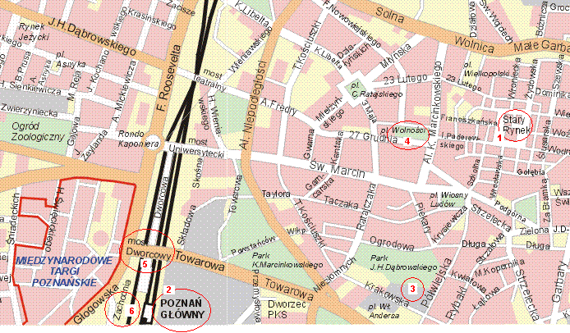
- Old Market
- Poznan Railway Station
- Stary Browar on Półwiejska Street (shopping centre)
- Downtown (tram stops close to the Old Market)
- Most Dworcowy (go up the stairs in front of the Railway Station, cross the street, you will see the tram stop)
- Dworzec Zachodni – Poznan WEST Railway Station

Tram from POZNAN RAILWAY STATION to Stary Browar (shopping centre):

- every 10 minutes (Monday-Friday)
- every 15-20 minutes (Saturday-Sunday)
- ticket price for 10 minutes – 1,30 zł (available in every newspaper shop).
Line 6:
from “Most Dworcowy” to Stary Browar (two stops).
Line 5:
from “Dworzec Zachodni” (Poznan West Railway Station) to Downtown POZNAN
(five stops, approx. 15 minutes).

3. CURRENCY

1 Polish Zloty = 0.26 Euro
1 Euro (EUR) = 3.77 Polish Zloty (PLN)

1 Polish Zloty = 0.18 British Pound
1 British Pound (GBP) = 5.52 Polish Zloty (PLN)

(* exchange rate date May 3, 2007)

4. RESTAURANTS

For all participants dinners are booked at the Atrium Hotel, except for Thursday the 17th. On Thursday we have an organized trip to Poznan where we will have dinner in the restaurant “Pod Pretekstem”.

