In this edition you will find information on the following issues:

MEMBER NEWS

Feature Article
- “QeC- ERAN – 20 years of promoting best practise in urban regeneration”
Network Developments
- QeC-ERAN AGM and city tour
- Staff development
Upcoming Events

PROJECT NEWS
- Intercultural Youth Panels
- Local Forums for Developing Participatory Democracy
EU NEWS AND PUBLICATIONS

News
Publications

CONTACT INFORMATION
Did you know?
You can click on the blue titles in the overview. It will take you directly to the section!

Current Projects Update
- Women, Enterprise, Employment in Local Development
- ESIP
- Building Healthy Communities
- Active AGE

MEMBER NEWS

Feature Article
Qec ERAN – 20 years of promoting best practise in urban regeneration

2009 marks the 20th anniversary of Quartiers en Crise-European Regeneration Areas Network. The organisation came into existence with the support of DG Regional Policy and DG Employment and Social Affairs in order to help develop and implement some of the first Urban Pilot Projects.

During the 1980s many EU urban areas experienced population and economic decline and/or shifts of population from central to more suburban areas. At the same time many of the neighbourhoods that had been created, often with an emphasis on social housing, to accommodate decreases in density and continuing urbanisation were themselves experiencing problems.

As a consequence of these trends neighbourhoods in crisis (“quartiers en crises”) were emerging characterised by a combination of social, economic and environmental stress. In response to these problems a number of member states introduced area based initiatives. In the main these initiatives had a sectoral focus, emphasising interventions in a particular domain such as physical environment, housing, education or the built fabric.
At the EU level negotiations with Member States, cities and regions took place in order to identify how Structural Fund resources could best be applied within urban areas. Article 10 of the European Regional Development Fund (ERDF), adopted to finance pilot actions and innovative measures, enabled the European Commission to use a small proportion of ERDF resources to fund projects that pilot innovative ways of tackling problems of urban disadvantage and unemployment under the Urban Pilot Programme.

In 1989, the QEC-ERAN network was created within the framework of this pilot programme in order to help develop and implement some of the first Urban Pilot Projects. It was recognized that the challenges faced by the cities, whatever their level of prosperity, could not be broached through classical sectoral policies established by traditional public authorities according to the classical principles of good administration. It was more and more necessary to intervene in multiple areas often in a simultaneous and coordinated way by mobilising public and private actors to intervene at different levels of organisation and of society.
”It was a time of huge regeneration works going on throughout Europe yet people were not considered in these processes. The Urban Pilot Phase was a first attempt to make residents of the so-called "quartier en crise" participate in the decision making process and to think of new and innovative approaches to mix civil servants, inhabitants, experts and politicians in order to change things together.” remembers Nicole Purnode, who was at the time with the Region Bruxelles Capitale (Belgium) and an active member of QEC-ERAN.
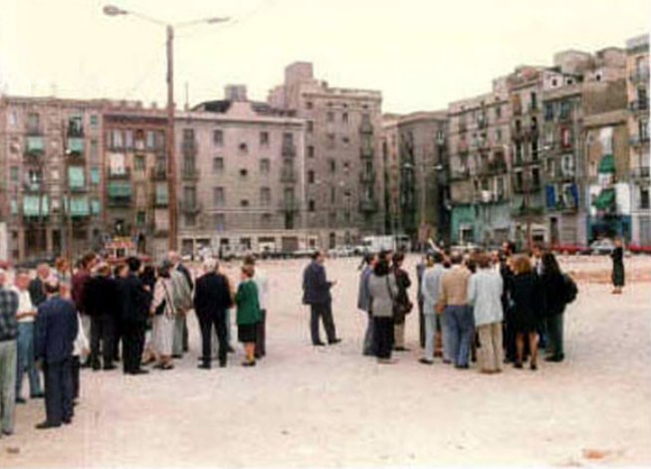
Members of the network visiting a regeneration site in the early 1990s

The integrated approaches for urban development are based precisely on these principles. Their objective is not to substitute for traditional approaches of social and urban management, nor for the professionals involved in this. Instead it is to construct another framework for work in which the approaches can be more effective. Their objective is not to mobilise more finance, more means in addition to what already exists, but it is to use them better and act in such a way as to increase their effectiveness by promoting synergy between the programmes and the projects.
"In those days Northern Ireland was involved in serious political upheaval and it was important to enable our residents to get out of the country and see and learn what was going on in other European cities. In Belfast we didn’t have the integrated approach at that time, but it was strongly promoted in Belgium, France and the Netherlands and this was one of the benefits we got out of the network then. In return we shared our experience in creating new forms citizenship which we had to develop given our political situation”, remembers another activist from Belfast.
The experiences that QEC-ERAN gained during the Urban Pilot Project Phase contributed directly to the design of the URBAN Community Initiative programme which saw two funding periods (1994-1999 URBAN I) and 2000-2006 (URBAN II).
URBAN drew from the previous lessons learned and promoted the integrated approach in urban development in order to tackle the high concentration of social, environmental and economic problems that became increasingly present in urban agglomerations.
Members of QEC-ERAN participated successfully in many of the URBAN projects and in 1994 together with 2 other organisations initiated the Local Integration Partnership Action programme with the overall aim to launch, co-ordinate, animate and evaluate twenty-four innovative pilot projects run by local authorities on the integration of migrants and ethnic minorities in Europe.
Another interesting feature of URBAN II was the creation of the URBACT programme to exchange information and experience on sustainable urban development across the European Union. URBACT's objectives are to highlight best practices and to draw lessons from successes and weaknesses identified under the URBAN Community Initiative.
QEC-ERAN has developed an excellent track record in relation to its work in the Urbact programme. It developed and co-managed with the city of Venice the largest Network in Urbact I - Urban Diversity, Integration and Inclusion Exchange (UDIEX ALEP), which had 26 participating cities. QEC-ERAN is currently involved in 3 URBACT II projects.
In promoting the integrated approach, QEC-ERAN has also developed valuable links with DG Regional Policy and the European Parliament Intergroup on Urban Policy and Housing who are key players in the debate on the future reform of the Structural Funds which has already begun in view of the mid-term review of the EU financial framework scheduled for autumn 2009.

back to: table of contents

Network Developments
Twenty Years of European Urban Policy: AGM and City Tour
On 23-26 June 2009 QEC-ERAN celebrated its 20th anniversary in Brussels and hosted a unique two and half day event in order to review 20 years of EU urban policy using Brussels as a "living laboratory" for undertaking the review.
The event was opened by Ilda Curti, Deputy Mayor of Torino and President of the QEC-ERAN network followed by inputs from Dirk Ahner, Director General of DG Regio, Haroon Saad, Director of QEC-ERAN and Eric Corijn, Professor of Social and Cultural Geography at the Free University of Brussels, Director of Cosmopolis and Chair of UAB Brussels Stadsplatform.
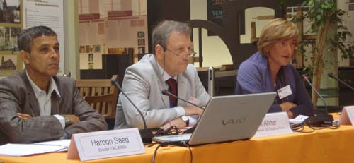
Delegates were then split into four peer review groups which set off on an urban tour using Brussels as a living example for the review. The groups were guided by experts and were split into the following themes:
Creative Industries:
On this tour participants visited the Centre Dansaert, a business incubator with focus on creative industries, City Mine(d), an organisation committed to the development of new forms of urban citizenship and Art2Work, a project aimed to combine work with creative values and assisting the unemployed and employers in a creative manner.
Intercultural Dialogue, Cultural Diversity and Integration
Delegates visited the Molenbeek area which is based next to the city center and has a high percentage of immigrants in particular of Moroccan origins. Delegates visited “Foyer”, an organisation focusing on the global integration problems of ethnic minorities, the center of Cultural and Social Cohesion as well as Forum Espace-Citoyen
Participation
This group was centered around the issue of participation looking at innovative approaches to promoting participatory democracy at a local level. Organisations active in this field such as Parcours Citoyen and Renovas asbl guided delegates to the following areas: L'espace Vogler, Place Houffalize, Place Lehon (Maison communale de Schaerbeek), Parc Reine-Verte.
Urban Planning
This tour reviewed two areas that have undergone significant regeneration works in the past 20 years: the area around the EU institution and the Midi area (around the Brussels main train station).
On the final day, the four groups met at a plenary session and discussed together with Dirk Ahner, Haroon Saad and Chris Brown, Chief Executive of the “Igloo Regeneration Partnership” implications of the reviews undertaken and future perspectives on Urban Policy.
During the urban tours participants filmed the visited areas and organisation, the video of this tour as well as the presentations made during the event can be downloaded from our website.

Staff development
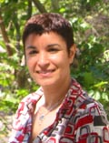
Yamina Guidon has left QeC-ErAN at the end of May 2009. Yamina was the project manager for the INTI and MILE project which have been successfully completed this year. We wish her all the best for the future and professional development.
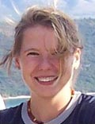
Karolina Rachwal has also left QeC-ERAN at the end of June 2009. Karolina has been the project assistant to the INTI and MILE project. Our best wishes to her and a fruitful career.

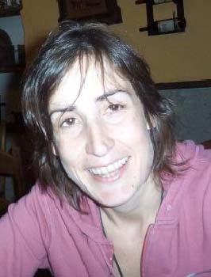
Aliki Vythoulka has started in June 2009 as a part time assistant to the Communication’s Manager to support the communication activities of the 2 URBACT projects and our network.
back to: table of contents

Upcoming Events

Open Days OFF
Following our successful event last year of Open Days OFF, we will be holding a similar event on 6 October 2009 around the theme of “social innovations”. More information will be mailed out to members following our summer break.
Summer Course on urban development
The International Urban Development Association (INTA) Summer Course will be held in St-Quentin-en-Yvelines in collaboration with the University of Versailles St-Quentin-en-Yvelines, France from the 31st August until the 4th September 2009.
This course is designed to enhance the participants' understanding of the challenges of urban development in the modern world. It is aimed at practitioners with a few years experience who wish to broaden their skills from considering the international examples and from mixing with colleagues from many different backgrounds and countries.
For more information please visit the INTA website.

Other Upcoming Events

18 September 2009: FEANTSA 4th Annual Research Conference on Homelessness in Europe, Paris.
20-30 September 2009: EAEA conference on “Active citizenship and adult education”, Gothenburg, Sweden.
1-2 October 2009: 2nd International CIRIEC Research Conference on Social Economy, Östersund, Sweden.
6 October 2009: QEC-ERAN Open Days OFF event, Brussels.
2-3 November 2009: Global Forum on Migration and Development Civil Society Days, Athens.

back to: table of contents

PROJECT DEVELOPMENT

Current Project Update

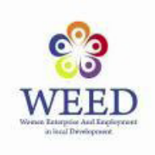
Women, enterprise and employment in local development (WEED)
Preparations for the first Transnational Exchange workshop are underway. The meeting will take place on 2-3 September 2009 in the lead partner’s city of Celje (Slovenia) and will focus on better strategies to foster women entrepreneurship at local level. The first network’s newsletter is due to be published beginning of July 2009.
For more information please contact Annachiara Pecchini or visit the project website

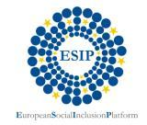
ESIP
Preparations for the fourth and last workshop of the Laps and Raps II project to take place from 16-18 September 2009 in Celje, Slovenia are underway. The theme will be on “Child poverty”. ESIP is a partner in this project and assists with the co-organisation of this event. An ESIP Steering Group meeting will follow the event.
For more information please contact Isabella Haaf or visit the ESIP website
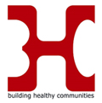
Building Healthy Communities
The first transnational BHC workshop on the theme of “indicators and criteria for healthy sustainable urban development” took place in Lodz, Poland from the 8-9 June 2009. The workshop forms part of the transnational element of the BHC project and brought together 3 Local Support Group members from each of the 10 project partner cities.
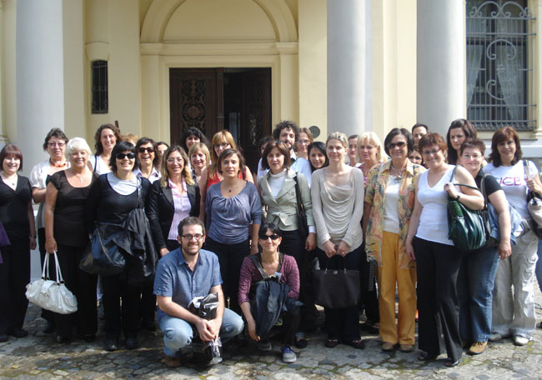
The workshop was followed by a Steering Group meetings and a meeting with the Lodz Local Support Group.
For more information please contact Isabella Haaf or visit the project website
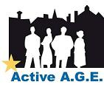

Active A.G.E.
The first transnational workshop of the Active A.G.E has just taken place from 17-19 June 2009 in Wolverhampton. The theme of the workshop was on “Age and the Economy” and involved all the project partners, members of the respective Local Support Groups and invited experts on the theme. A workshop report will be made available on the project’s website.
For more information please contact Maria Elena Bragalia or visit the project website

Intercultural Youth Panels
At the local level the partners have now established local coordination teams composed by young citizens that are going to be involved in the development and implementation of the two local activities related to the promotion of intercultural dialogue. This activity will be presented at the youth transnational exchange workshop on 27- 30 September in Brussels.
For more information please contact Tamara Hodas Garcia or visit the project website

Local Forums for Developing Participatory Democracy
The Local Forums for Developing Participatory Democracy are now preparing their Local Action Plans with the support they received at the first Pier Review Workshop that took place in Brussels on 21-22 April 2009. Additionally, the online platform is being developed through a discussion among all the partners.
For more information please contact Tamara Hodas Garcia or visit the project website


EU NEWS

EU Shared commitment for employment
On Wednesday June 3rd, the Commission adopted a communication on employment, ahead of the June Spring Council meeting. The EU will make available €19 billion of planned European Social Fund expenditure to support people hit by the economic crisis. The proposals will be presented to EU leaders for their agreement at the European Council on 18-19 June. Read more. Social NGOs expressed their disappointment about it.
26.9% of GDP on social protection expenditure in 2006
In the EU 27, social protection expenditure accounted for 26.9% of GDP in 2006. This ratio was 27.1% in 2005 and 2004 and 27.2% in 2003. The EU27 average continued to mask major disparities between Member States. These disparities reflect differences in living standards, but are also indicative of the diversity of national social protection systems and of the demographic, economic, social and institutional structures specific to each Member State. Read more.
2011: European Year for Volunteering
The European Commission has officially adopted the proposal for the European Year of Volunteering 2011. The European Year of Volunteering Alliance welcomes the European Commission's proposal - read here the Joint Press Release.
Housing Rights: Breakthrough Ruling by the Council of Europe
The European Committee of Social Rights (ECSR), the Council of Europe body responsible for monitoring the implementation of the European Social Charter, reached the unanimous decision that France is in violation of the Charter with regards to housing rights. The Council of Europe considers that the full enjoyment of rights is the measure for evaluating public policies and defines their quality standards. Read the press release.
Social Platform expectations for the next Equality Summit
In view of the next Equality Summit which will take place in Stockholm on 16-17 November, the Social Platform sent a letter to the upcoming Swedish Presidency of the EU presenting its expectations. Read more.
Eurostat: One third of the EU’s population can’t afford unexpected expenditure
According to Eurostat figures published on 28th May in 2007 one third of the EU's population lived in a household that could not afford unexpected expenditure. In the EU 7% of the population lived in a household which over the last twelve months could not settle its utility bills for its main residence on time and 3% lived in a household that could not pay its rent nor reimburse its mortgage instalments. Read more.
European Women’s Lobby: Gender Audit Report
The EWL 50/50 Campaign for Democracy, running since September 2008, has published a Gender Audit Report in light of the European elections 2009. The Gender Audit looks at political programmes and electoral lists for the European Parliament (EP) elections in June from a women’s rights perspective. It evaluates the political parties’ commitment to gender equality in view of the EP elections 2009 and encourages voters to be involved in European politics. This report shows that most political parties do not consider equality between women and men as a key priority despite the strong competence of the European Union in the area. Read more.
New FRA report examines discrimination against Muslims
The European Union Agency for Fundamental Rights (FRA) today released a report on discrimination against Muslims in the EU. Read more.
EU begins to rethink growth an jobs strategy
As the recession bites, national governments and the European Commission have begun to reflect on replacing the EU's overarching strategy for growth and jobs, known as the Lisbon Agenda. “Green growth”, innovation and education are likely to feature highly among the EU's new priorities. The European Commission is preparing a broad Internet consultation on revising the Lisbon Strategy in early autumn 2009. Read more.
EU Parliament recognises importance of active inclusion in society
On Friday 30 April EAPN wrote to MEPs to request support for Green MEP Lamberts Report on Active Inclusion, voted in the European Plenary session on 6 May. UK Green MEP Jean Lambert, author of a report on "active inclusion in society", commented on its adoption by the European Parliament. Read more.
European Parliament's analysis of the Lisbon Treaty
A comprehensive review of the European Union's new institutional structure, should the Lisbon Treaty be ratified in 2009, as foreseen by the December 2008 European Council, was approved by the European Parliament on 7 May. Read more.
“The response to the economic crisis should lead to more equality” says Commissioner Hammarberg
“A serious attempt to address the enormous gaps between the wealthy and the destitute is long overdue”, commented the Council of Europe Commissioner for Human Rights, Thomas Hammarberg, on 11 May in his latest Viewpoint. The Commissioner points out inequalities and injustices which afflict European societies and calls for better protection of vulnerable groups. Read more.
EC campaign: “do you know what social Europe can do for you?”
The European Commission has launched a campaign to explain what the EU is doing to create more and better jobs, improve working conditions or remove barriers to job mobility. Read more.

European Health Insurance Card
The European Commission has launched an information campaign to raise awareness of the benefits of the European Health Insurance Card (EHIC). Read more.
EC refers Poland to European Court of Justice on gender equality legislation
The European Commission has on 14 May 2009, referred Poland to the European Court of Justice (ECJ) for non-transposition of EU rules prohibiting gender discrimination in access to and supply of goods and services (Directive 2004/113/EC). Poland has not yet adopted the necessary measures to give effect to the legislation in national law, despite a 'Reasoned Opinion' (second stage warning) sent by the Commission in 2008. Read more.
1st meeting of the EU Roma Platform
The EU Roma Policy Coalition (ERPC) has issued an assessment and recommendations to the European Commission and EU member states regarding the first meeting of the EU Platform for Roma inclusion, held on 24 April, and its future development. Read more.
EDF’s General Assembly in Athens: the future cannot wait!
The European Disability Forum held its 13th Annual General Assembly in Athens on 12 May. the representative organisation of 65 million persons with disabilities in Europe, gathered in Athens more than 200 participants from 30 national federations and 50 European disability NGOs to elect its leaders. Read more.
G20 pledges action on tax havens, but few signs of real reform
The G20 Summit of leaders concluded on 2 April with some progress on the question of tax havens, but no major ground was broken on the key causes of the crisis facing the world today nor was the social investment required to aid those affected by the crisis forthcoming. Read more.
Meeting with social partners on economic crisis and May Summit
The President of the European Commission, José Manuel Barroso, and the Prime Minister of the Czech Republic, Mirek Topolánek – representing the Council Presidency – met the European social partners to discuss the social impact of the crisis, and how to prepare the May summit. Read more.
Active Inclusion, renewed social agenda and cross-border health services on the EP Agenda
31 March was a busy day for European Parliament Committees with two reports and a draft directive. The Employment and Social Affairs Committee adopted an own-initiative report on Active Inclusion (draft 21/1/2009).
Strengthening structural funds’ support to energy efficiency: Parliament supports Commission proposals
On 2nd April, the European Parliament supported a proposal by the European Commission to enlarge support to energy efficiency measures in all EU Member States. The rule changes would mean European Regional Development Fund (ERDF) money could co-fund national, regional or local authority schemes to install e.g. double glazing, wall insulation or solar panels in housing, or to replace old boilers with more energy efficiency ones, in all Member States. More information.
2009 EU peer review programme on social inclusion
The European Commission has launched its 2009 peer review programme on social inclusion. This year, the programme will look at 10 policies/practices related to social inclusion. For more information, see the peer review programme website.
The European Parliament urges the European Commission to regulate micro-credit in Europe
In a new report adopted on March 24th 2009, the European Parliament urges the European Commission to regulate micro-credit in Europe. The document suggests: the creation of a central agency coordinating all micro-credit operations and initiatives in Europe, more EU financing for such initiatives, the promotion and dissemination of good practices within the sector of micro-credit and the elaboration of a new definition of micro-credit. Read more.
Social Platform response to the European Commission consultation on health inequalities
Social Platform welcomes the decision of the European Commission to consult civil society at EU level on its future actions to reduce health inequalities and focuses on five key messages concerning: social exclusion, gender and equality principles, the Open Method of Coordination, participation of people experiencing poverty, mainstreaming social and public health goals in all policies. Read more.

PUBLICATIONS

Spring edition of “Equality in Action” The spring 2009 edition of the European Commission’s on-line magazine dedicated to Equality in Action is now available on the European Commission website. Read more.

Publication of ECRI’s Annual Report The Council of Europe’s European Commission against Racism and Intolerance (ECRI) has published its annual activity report for 2008. Read more.
EPC report on the empowerment of Europe’s minorities
The European Policy Centre has published the report of the Policy Dialogue it organised on 19 May 2009 on “Empowerment of Europe’s minorities: why, when and how?” Barack Obama’s election as US President is empowering many young US citizens from minority groups, but Europe is lagging behind, speakers told the EPC Policy Dialogue. Read more.
The European Parliament, “more power, less legitimate?”
On 25th May the Centre for European Policy Studies (CEPS) published a study entitled "The European Parliament, more power, less legitimate?". The authors confirm that the enlargement of the EU has not impeded the efficacy nor the cohesion of the parliament but they point to another challenge; the loss of legitimacy. Read more.
Council of Europe publication on racism against migrants in Europe The increase of racism against migrants should be discussed at a time when the issue of migration is at the heart of many States’ concerns. This publication analyses migration policies which may have an influence on this increase. Read more (in French)
Council of Europe report on economic migration, social cohesion and development
This report was prepared to support the ministerial debate during the 8th conference of the European ministers. It presents the main aspects and characteristics of migration in the member states of the Council of Europe, analyses policy challenges raised by contemporary migration and identifies an integrated policy agenda. Read more
FEANSTA’s magazine: Spring 2009 edition is online
The Spring 2009 edition of Homeless in Europe, FEANTSA’s tri-annual magazine, is now available online. The theme of this issue is “Homelessness and the Arts: Creativity, empowerment and social change”. Read more.
Transfer, European Review of Labour and Research: “Lisbon: a failed strategy or still relevant for the future?”
This issue of Transfer assesses various aspects of the Lisbon strategy in the run-up to its review in 2010. Published by ETUI, 2009. Read more.
ENAR: 15 Principles for framing a positive approach to migration
Presentation of the conclusions of ENAR’s policy seminar on migration policy through 15 principles for framing a positive approach to migration. Download the publication.
European elections: ELISAN speak to the future European parliament members
On the eve of the European election, ELISAN, the European network for local inclusion and social action, would like to remind the social Europe challenges and the role played by local authorities in its construction via a memorandum that will be distributed to the future European parliament members. Read more.
External evaluation of the 2007 European Year of Equal Opportunities for All (EYEO)
The overall aim of this evaluation was to determine whether the EYEO was a success both at the European level and at the level of the 30 Participant Countries. The final report and its 4 thematic reports are now available.
Eurofound publishes its Second European Quality of Life Survey (2EQLS)
Most Europeans report health and family life as the key elements contributing to a good quality of life, and the survey clearly shows that people’s material conditions, standard of living and well-being strongly depend on income as well as the economic wealth of the country in which they live. Read more.

CONTACT INFORMATION

QeC-ERAN Quartiers en Crise -European Regeneration Areas Network,
Rue Vieux Marchè aux Grains 48, B-1000 Brussels
Tel: +32 (0)2 524 45 45, Fax: +32 (0)2 524 44 31,

E-mail: info@qec-eran.org
www.qec-eran.org
Executive Bureau:
President Ilda Curti segreteria.assessorecurti@comune.torino.it
President supported by Luisa Avedano Luisa.Avedano@comune.torino.it
Vice –President Lionel Martjin lb.martijn@charlois.rotterdam.nl
Honorary Secretary Jude Kehla- Wirnkar
Treasurer Cllr William Humphrey
supported by Deidre Ferguson FergusonD@BelfastCity.gov.uk
Member Luana Zanella
Member Bernad Dallons
Supported by Eric Dosimont dosimonteric@cpascharleroi.be
QeC-ERAN Office:
Director Haroon Saad hsaad@qec-eran.org
Assistant Director, WEED Annachiara Pecchini apecchini@qec-eran.org
Financial and Administrative Manager Daniel Casares dcasares@qec-eran.org
Active Age Maria Elena Bragaglia mebragaglia@qec-eran.org
Information and Communication Manager,
Building Healthy Communities Isabella Haaf isabellahaaf@qec-eran.org
Information and Communication Assistant Aliki Vythoulka alikivythoulka@qec-eran.org
ELRFE Tamara Hodas García thodasgarcia@qec-eran.org
Project Assistant Karolina Rachwal krachwal@qec-era.org
Project Assistant Laure Marquet lmarquet@qec-eran.org
Project Assistant Valeria Schirru vschirru@qec-eran.org
Project Assistant Marika Heilimo mheilimo@qec-eran.org

