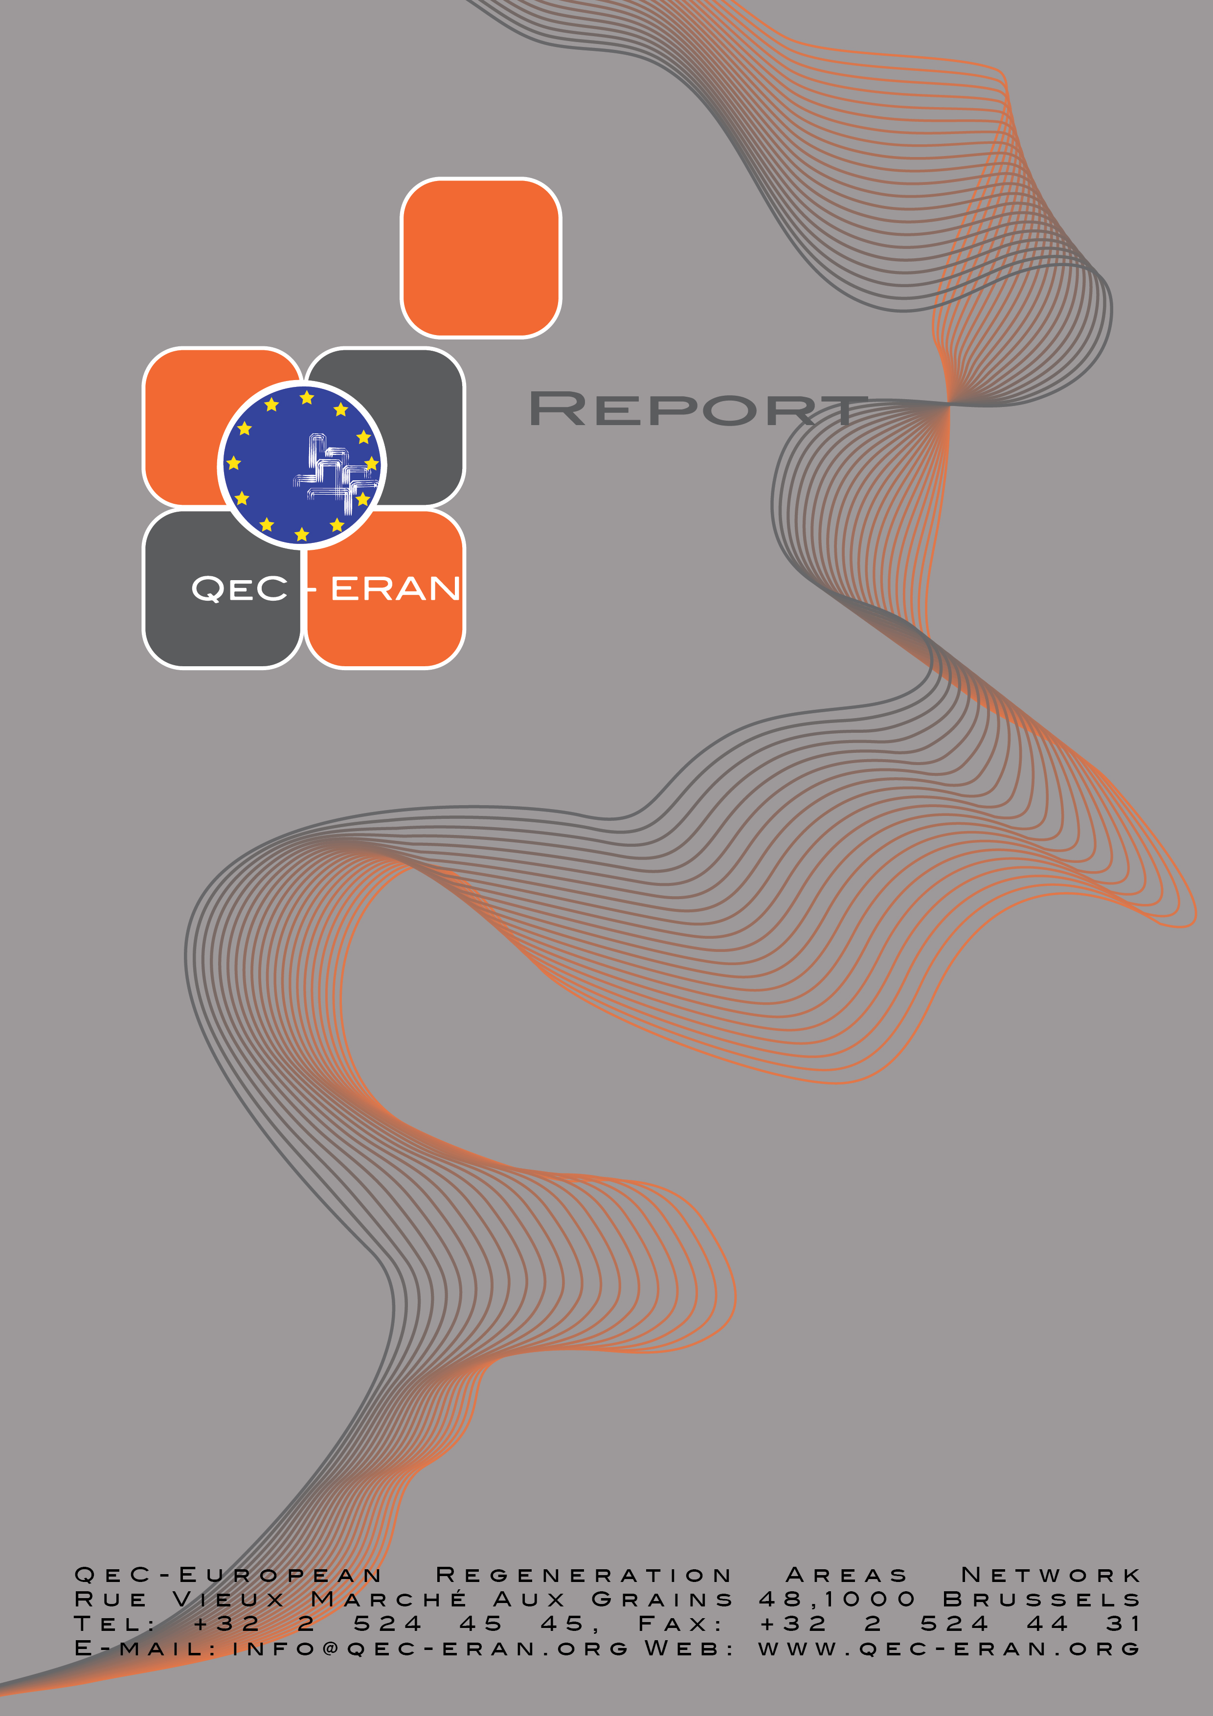

QeC ERAN
ANNUAL REPORT
2008-2009

TABLE OF CONTENTS

1. INTRODUCTION 3
2. REVIEW OF THE YEAR 4
2.1 Policy developments 4
2.2 Organisational Developments 7
2.3 Communication and information activities 8
2.4 QeC ERAN workshop 8
2.5 Open Days OFF 9
3. PROJECTS 10
3.1 Active Aging – URBACT thematic network 10
3.2 European Social Inclusion Platform 12
3.3 Woman, Enterprise, Employment in Local Development (WEED) 13
3.4 Building Health Communities - Urbact thematic network 14
3.5 Presence 15
3.6 Intercultural Youth Panels 16
3.7 Managing Migration and Integration in Cities and Regions (MILE) 17
3.8 Integration Exchange: online integration services for third country nationals 18
3.9 Local Forums for Developing Participatory Democracy 19
3.10 Laps and Raps II 20
4. MEMBERSHIP 22

Annual Accounts 2008 (separate report)

INTRODUCTION

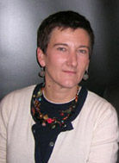
This year is an important year for QeC- European Regeneration Areas Network as it marks the 20th anniversary of our organisation. Qec ERAN was established in order to further local and national policies and initiatives for the regeneration of neighbourhoods in crisis. For the past 20 years it has successfully done this through the promotion and dissemination of the integrated approach for urban development in cities, regions, Member States and the European Commission. This year’s Annual General Meeting and Study Tour will be a unique event to review 20 years of EU urban policy using Brussels as a “living laboratory” for undertaking the review.

2009 also marks a “milestone” in the evolution of EU Urban policy, in that in the new programming period, for the first time, there is no longer a “ring-fenced” budget within cohesion policy for “integrated urban development”. The mid-term review of the “urban dimension” in cohesion policy has already started and key issues regarding the future programming period are already emerging from the EP Intergroup on Urban Policy and Housing and also the EP Committee on Regional Development.

Our highly successful conference in Prague this year on “Monitoring the urban dimension in Cohesion Policy: EU 12 perspective” saw the on-going positive collaboration that QeC ERAN has developed with DG Regio and the European Parliament Intergroup on Housing and Urban Policy and we would like to thank Director General Dirk Ahner from DG Regio as well as MEP Jean Marie Beaupuy and MEP Jan Olbrycht for their input into our Prague event. More details of this event are available in this report.

In 2008 we organised "OPEN DAYS OFF - Caféstyle debates and NON-VIP reception" running parallel to OPEN DAYS, an annual event hosted by the European Commission and EU Committee of the Regions. The aim of OPEN DAYS OFF was to break away from the institutionally determined debates of OPEN DAYS and to better harness its potential by creating a more interactive and informal way for participants to engage and discuss. The feedback from the over 160 participants has been very positive and we are already planning ahead for this year’s OPEN DAYS event in October.

In terms of projects, we have successfully secured funding for three new projects through the Europe for Citizens programme and the Fundamental Rights and Citizenship Programme. More information is available elsewhere in this report.

In short, this year has been highly successful and busy in terms of the work of our network and I believe that we are continuing to grow stronger and offering our members unique services enabling them to better engage in the EU process.

Ilda Curti
President

REVIEW OF THE YEAR

Policy developments

The Urban Dimension in Cohesion Policy:

Within EU Cohesion Policy, cities have moved up the political agenda over the last years. Urban development has become an increasingly important part of it. Starting with Urban Pilot-Projects between 1989 and 1993, and followed by two generations of the URBAN Community Initiative programmes between 1994 and 2006, urban actions have become vital elements in many of the mainstream Operational Programmes in the 2007-2013 period. This so-called "URBAN mainstreaming" constitutes one of the most important changes to Cohesion Policy in recent years. In the new programming period, the Commission intends to reinforce the place of urban issues in the programmes 2007-2013 which implies several things:

- to increase the importance of urban development in the programming process (NSRF and OPs);
- to promote the concept of integrated urban development;
- to valorise the URBAN acquis, and to open it to a broader range of actions;
- to fully include urban actors in the preparation and implementation of Operational Programmes.

Instruments and tools

1. URBACT II (2007-2013), the Urban Development Network Programme is a programme which aims to develop exchanges of experience between European cities within the new objective “Territorial Cooperation”. It has enlarged the eligibility for cities comparing to URBAN II.

2. Regions for Economic Change is a proactive policy tool offered to Member States, regions and cities to help them implement the renewed Lisbon agenda through actions aimed at economic modernization.

3. JESSICA (Joint European Support for Sustainable Investment in City Areas) is a cooperation agreement between the Commission, the European Investment Bank and the European Bank for Reconstruction and Development on financial engineering for sustainable urban development.

4. Urban Development Interservice Group. Created in December 2005, it is led by DG REGIO Director General. DGs participating are REGIO, EAC, EMPL, ENV, ENTR, INFSO, JLS, RTD, SANCO and TREN.

5. Urban Audit may help to design an intelligent urban policy in Europe today with its almost 300 indicators and 258 cities covered.

Fostering the urban dimension in EU Cohesion Policy

In November 2008, the European Commission prepared a working document analysing all 316 ERDF Operational Programmes of all three EU Cohesion Policy Objectives. The document draws the first picture of how different aspects of urban development have been taken up in the 2007-2013 programming period. The analysis is limited to programmes co-financed by the European Regional Development Fund (ERDF), and does not touch upon other European funds. It subsequently also does not capture all sectoral interventions which might have impact on cities and on urban development.

Building upon the analysis of the programming documents, the main findings are the following:

1. In the current programming period, questions related to urban development are an important, reoccurring topic in the strategy and implementation of ERDF Operational Programmes. More than half of the ERDF programmes have an identifiable urban dimension, and address challenges in urban areas.

2. A considerable number of regions and Member States have foreseen urban actions in their Operational Programmes, also committing an increased financial share to urban development operations. This positive result is contrasted by a fairly strong focus on sectoral operations and presents an asymmetric picture when it comes to integrated strategies for urban development:
The analysis revealed a certain difference between old and new Member States when it comes to the programmed activities in cities and to governance provisions. A generally less strong emphasis on integrated urban development seems to be linked to the fact that many EU-12 Member States have little experience in integrated urban development and/or were unable to benefit from the URBAN Community Initiative in the past.

3. Good vertical and horizontal coordination of actions and strong local involvement into programming constitute key elements of the "Acquis urbain". As the programmes from the URBAN Community Initiative proved, the activation of local actors is crucial for the success of urban development operations. This local involvement is essential to reach a high degree of acceptance and visibility on the ground and concerns not only integrated operations, but also sector-oriented activities in cities. The programming documents for 2007-2013 generally show few signs of direct local involvement in the design and implementation of ERDF Operational Programmes. It remains to be seen if this can be improved throughout the implementation of the programmes.

4. The Working Document provides a first complete assessment of the urban strands of all Operational Programmes for 2007-2013. It describes several positive developments, but also identifies a series of challenges which are to be dealt with throughout the implementation phase of the Operational Programmes. Despite the possibility to make adjustments to existing programming documents within upcoming modifications in order to eliminate shortcomings, it might be sufficient in most cases to use the existing provisions and options in the Operational Programmes more intensively and extensively.

Mid-term review of EU Cohesion Policy

Since 2004, the enlargement of the EU to include 12 new Member States has placed significant demands on the cohesion policy. Within EU-12, the EU’s efforts to promote cohesion can be said to be moving slowly, but largely in the right direction. The 5th EC progress report on cohesion (published in 2008) shows that convergence is still ongoing thanks to stronger economic growth in regions which are lagging behind.

Although economic convergence at national and regional levels continues, these results are not so good, if one compares regions within the same Member State (capital/rest of the country), or zones or social groups within the same region. Growing concentration of wealth in national capitals and major cities does, nevertheless, have side effects. Suburbanisation, accompanied by developing and increasingly deprived urban areas cumulating economic and social problems, and declining rural agriculture-based economy are new problems faced by the European regions and territories.

Furthermore, the EU cohesion policy will have to face a number of major challenges in the near future, which will need to be taken into account in the new architecture of Structural Funds from 2014 onwards. These challenges include external challenges (such as globalisation, climate change, difficulties in food supply, gas and oil prices), internal challenges (such as new Member States’ integration, reducing infrastructure deficits, growing competition between regions for investment) and social challenges (such as ageing of the population, economic migration, health and social services, demographic decline in peripheral regions, immigration).

The debate on the future reform of the Structural Funds has already begun in view of the mid-term review of the EU financial framework scheduled for autumn 2009, with possible consequences for cohesion policy. The post-2013 reform is already expected to bring in a new era in cohesion policy.

The European Parliament contributed to this debate by adopting a report on the fourth cohesion report in February 2008. Furthermore, the adoption of the Green Paper on territorial cohesion on 6 October 2008 gave a new drive to this debate which was to define the concept of territorial cohesion, central to the future development of cohesion policy. In March 2009 the Parliament’s Committee of Regional Development’s report on the Green Paper and on the state of the debate on the future reform of cohesion policy was adopted.

For QeC ERAN the main policy focus has been on the mainstreaming of Cohesion Funds and the implication this has for urban development. To date three events have been organised aimed at monitoring the urban dimension in the National Strategic Regulation Framework (NSRFs) and Operational Programme:

- "Monitoring the Urban Dimension in EU Cohesion Policy: EU 12 perspectives", 18-19 March 2009, Prague

- "Monitoring the Urban Dimension in EU Cohesion Policy: Spanish and Portuguese perspectives", 2-3 April 2008, Madrid

- “The Urban Dimension in EU Cohesion Policy: Dutch and Belgium perspectives”, 19 September 2007, Antwerp

The objective is to feed the outcomes of these events into the mid-term review of the 2007-2013 Cohesion Policy AND the discussion relating to the new programme period 2013-2019.

Organisational Developments

Student placement scheme

We have continued our collaboration with several European universities to bring students with expertise and interest in Urban Policy on board and to offer them work experience in an international environment.


Marika Heilimo from Canada has joined us last year after the summer break on a one-year student work placement. She studies European Business and International Business Management between the Metropolia University of Helsinki and the University of Wolverhampton. She is assisting us with the organisation of network events and project development. .

Staff development

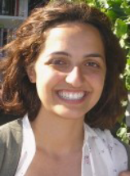
Valeria Schirru from Sardinia, Italy, has started working at QeC-ERAN last summer. She studied Political Science in Rome, followed by a Master’s in European Studies at the free University of Brussels (ULB). She is a project assistant for Women,Enterprise and Employment in Local Development (WEED) and assists with other project development.

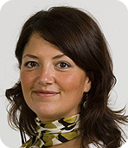
Lola Uña Cárdenas, who joined us in May 2008, has left the network at the beginning of this year. Previously she worked in Finland at the Carelian Business and Innovation Centre managing EU trans-national projects. At QeC ERAN, Lola coordinated the Active Ageing Urbact network and also dealt with financial matters of the network.


Janneke Draaisma from the Netherlands has worked for Qec ERAN from last summer till April this year. She assisted the communications manager and also supported the European Social Inclusion Platform (ESIP). Janneke studied a Master’s in European Studies at the International School of Humanities and Social Sciences of the University of Amsterdam.

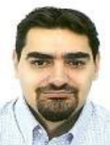
Daniel Casares from Sevilla (Spain) has joined us in January this year. He is in charge of administration and finances both for the network as well as our projects. Daniel has a Master’s degree in Business Administration and previously worked at “Villeroy & Boch” in Germany and “Banco de Santander” in Spain.


Laure Marquet from France has re- joined us at the beginning of February this year. Laure studied geography, city planning and city politics in Paris. In Qec ERAN she assists mainly with project development.

2.3 Communication and information activities

Website:
The QeC-ERAN website remains the main communication tool for disseminating information on QeC-ERAN activities. It’s a rich resource tool for members to access latest information on EU policy developments, QeC ERAN projects and events as well as our workshop activities. The Members ONLY section provides documentation concerning the Executive Board meetings, Study Tours and Annual General Meetings, network workshops, the newsletter as well as an extensive library on EU Policy papers.

QeC-ERAN Live
The inter-active platforms for the European Regeneration Managers Network and the European Local Residents Forums have been renamed to QeC ERAN live which we have set up in the past few months. The platform is now virtually finished and we are starting to use this for the development of some thematic Communities of Practice linked to project that we are implementing.

Newsflash:
Our newsletter, which is available in English, Spanish, Italian and French, continues to be a major source of information for our members as concerns the day to day activities of the QeC ERAN office and in particular with view to our project activities. It also provides readers with updated information on the latest EU developments and publications relevant to urban regeneration and an in-depth article in each issue on topics we believe are of interest to our members. The newsletter is mailed out to our members and can also be downloaded in the Member Service section of our website.

Employment Week
QeC ERAN is an event partner in Employment Week 2009 which takes place in Brussels from 24-25 June 2009. Employment Week is the leading forum for EU stakeholders to meet and engage in constructive dialogue on current and future employment trends, policies and initiatives. Over 800 EU officials, business leaders, social partners as well as European employment practitioners are expected to attend this meeting in Brussels which provides an excellent opportunity for Qec ERAN to promote its activities.

QeC ERAN workshop

“Monitoring the Urban Dimension in EU Cohesion Policy: EU 12”, Prague, 18-19 March 2009
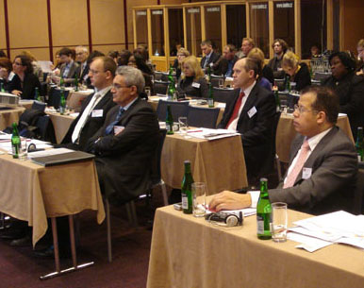
Coinciding with the Czech EU Presidency, the event took place in Prague on 18-19 March 2009 and aimed to highlight how the EU12 member states have addressed the "urban dimension" in their NSRFs and Operational Programmes. The conference was organised with the active involvement of DG Regio as well as the EP Intergroup on Urban Policy and Housing who are both very interested in the current programming period and have already launched a discussion about the future programming period. (see 2.1 policy developments).

The Prague Workshops brought together over 60 participants working in urban development/regeneration and speakers included representatives from the European Commission, the European Parliament, the European Investment Bank, the Managing Authorities for Structural Funds from Czech Republic, Slovenia, Slovakia, Hungary, Romania and Poland as well as city representatives from Poznan (Poland), Prague (Czech Republic), Gyor (Hungary), Ljubljana (Slovenia) and Timisoara (Romania).

Dirk Ahner, Director-General of DG Regional Policy, addressed conference speakers through a video speech. One of his concerns was the continuation of the integrated approach in urban development. Following the assessment of the 316 Regional Fund Operational Programmes it became evident that many Operational Programmes, particular in the new member states, tend to address local development through the sectoral approach. “One way to address this deficit is to make the integrated approach compulsory in the future programming period.”

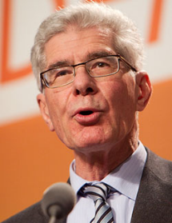
Jean Marie Beaupuy, MEP and President of the EP Intergroup on Urban Policy and Housing pointed out that EU 12 Member States, have been asked to use the "integrated approach", while never having been involved in the practice that generated this methodology. “There is a clear need to develop knowledge and information on the benefits of the integrated approach, which is essential in order to show to elected politicians and civil servants the interest of applying the integrated approach.”

Other presentations included practical case studies from five EU 12 cities, presentations of Operational Programmes from the Ministries responsible for Cohesion Funds and a presentation of the JESSICA programme which is an initiative developed by the European Commission and the European Investment Bank, in collaboration with the Council of Europe Development Bank (CEB).

The full conference report and presentations made during the event can be downloaded from our website>>.

Open Days OFF

On 7 October 2008 QeC ERAN organised "OPEN DAYS OFF - Caféstyle debates and NON-VIP reception". The event ran parallel to OPEN DAYS, an annual event hosted by the European Commission and EU Committee of the Regions. The aim of OPEN DAYS OFF was to break away from the institutionally determined debates of OPEN DAYS and to better harness its potential by creating a more interactive and informal way for participants to engage and discuss.

One of the first debates was on the issue of climate change. It is now commonly recognised that climate change is indeed happening and that it represents one of the greatest environmental, social and economic threats facing the planet. Eivind Hoff from the Environmental Foundation Bellona, an international non-governmental organisation founded in 1986, initiated the first debate and argued that EU policy on climate change was ineffective.

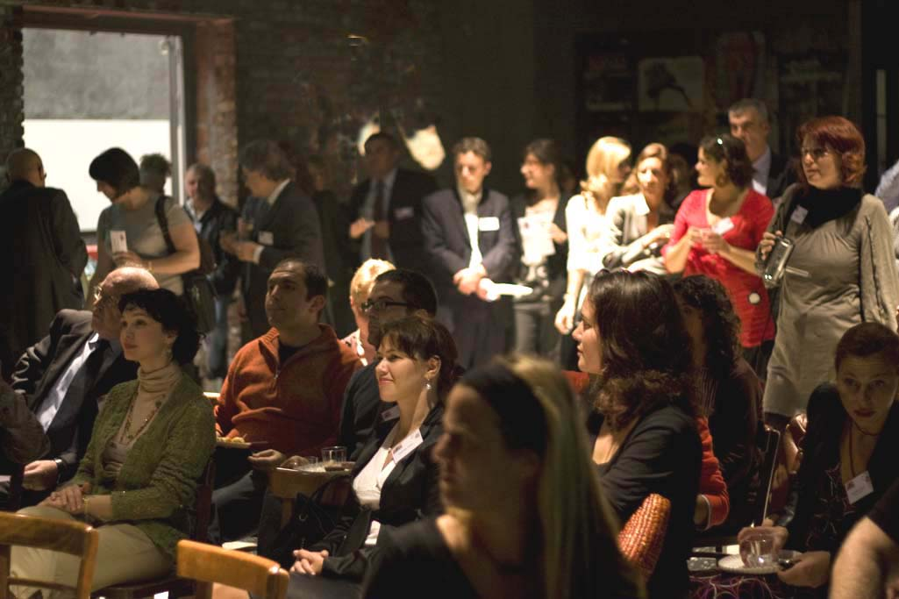
Running parallel to the climate change debate, MEP Jan Olbrycht discussed with participants whether the European Parliament was indeed a representative body. This discussion was held in connection with next year's election to the European Parliament (4 to 7 June 2009) in the 27 member states of the European Union. A survey carried out by Eurobarometer noted that one out of five European citizens was not aware at all that there are European elections and only around 30% of citizens responded that they will definitely vote in the upcoming elections.

Other debates looked at whether the Lisbon Strategy was creating greater exclusion and poverty with Professor Harris Beider from the Institute of Community Cohesion, UK, leading the debate. Jan Olbrycht, MEP, Peter Ramsden, Urbact expert, and Elvira Sweet, Mayor of South East Amsterdam initiated the discussion on whether the mainstreaming of cohesion policy had weakened the "urban dimension" and what needed to be done in order to strengthen the urban dimension in the next programming period.

The final debate was on the Irish no vote to the draft Lisbon treat in June 2008 which threw the EU into a political crisis. Anthony Coughlan from the Irish National Platform, argued that the Irish were right to say NO. Fergal O Regan, from the Institute of International and European Affairs, put forward arguments why the Irish should have voted in favour of the EU treaty.

The speakers’ profiles and opinions/reaction to these debates can be downloaded from our website.

PROJECTS

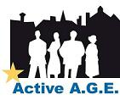

3.1 Active Aging – URBACT thematic network

Source of funding: Urbact II programme

Project Summary:
This project focuses on the issue of demographic ageing and seeks to establish a thematic network of 9 cities to develop an integrated exchange programme based on the implementation and exchange of learning activities on sustainable urban policies on ageing issues. The partners in this network have highlighted the following common sub- themes that will form the basis of the transnational exchange:

- Ageing: employment and economic growth (enterprise and the “silver” economy)
- Impact on care systems/arrangements
- Ageing and insecurity

Project partners:
Rome (Italy), Lead Partner, Prague (Czech Republic ), Maribor, Podravje (Slovenia), Edinburg (UK), Thessaloniki (Greece), Dobrich (Bulgaria), Sevilla Global S.A. (Spain), Starogard (Poland), Wolverhampton (UK).

Activities:
Development phase:
During the development phase the partnership was extended to 9 partners from 8 countries. Two Steering Group Meetings have been held. The outcomes following the first steering group meeting, organised in Rome on 23/24 June 2008, which adopted an agreed framework for local mapping, have been the production of nine local mappings and the production of a baseline study after discussions with partners. The second steering group meeting, organised in Rome on 25/26 September 2008, facilitated a discussion on the draft proposal for phase II as well as identified the main issues of focus in the implementation phase.

Two other activities have been implemented during the development phase, namely the establishment of nine Local Support Groups and the project website compiling information on partner’s activities and events.

Implementation Phase:
The kick-off meeting for the implementation phase of the project was held in Rome on February 26-27, 2009. The outcome of this steering group meeting was to discuss the three themes outlined in the baseline study, which will be developed during the three Transnational Exchange Workshops. It was decided to hold the first Workshop in Wolverhampton from 17-19 June 2009. The theme will be “Age and the Economy”.

The activities of the Local Support Group were established as well as the deadlines to submit the first Action Learning Set by each partner. A methodology to create a Local Action Plan was presented.

Outcomes:

- 1 Transnational Exchange Workshop - Wolverhampton - Theme: AGE AND THE ECONOMY, 17-19 June 2009
- Identification of the first ALS members
- First activity report by June 2009
- Establishment of 10 Local Support Groups with a core Local Action Group.
- Establishment of the project’s website

Project coordinator: Maria Elena Bragaglia

Project length: Development Phase: April 2008-October 2008
Implementation phase January 2009 – May 2011

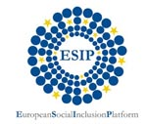
European Social Inclusion Platform

Source of funding: n/a

Project summary:
QeC-ERAN has been active in addressing issues of social inclusion and aims to share its experience and work with other organisations and key individuals in order to more effectively impact on the EU policy process. It therefore has supported the creation of a European Social Inclusion Platform (ESIP) based in Bratislava.

Project partners:
The founding members of ESIP are the Self-Governing Region of Bratislava, the City Council of Pezinok and QeC ERAN. Currently ESIP has 52 members with the majority from the EU12 countries.

Activities:
Steering Group meetings:
Since the last reporting period the ESIP Steering Board has met twice:
- ESIP Board meeting, 12 March 2009 , Lisboa (Portugal)
- ESIP Board meeting,1 October 2008, Prague (Czech Republic)
Both meetings were organised to coincide with the Laps and Raps II workshops in which ESIP Board members are participating. The main discussions of the board meetings focused around the ESIP work programme and strategies for securing funding for ESIP and promoting it more widely. Please see ESIP website for agreed actions and other Board meeting documents.
Participation in Laps and Raps II project:
As partner in the Laps and Raps II project (lead partner Celje, Slovenia) ESIP has assisted with the organization of two workshops since June 2008:

- Lisbon Workshop
ESIP co-organised the third transnational Action Learning Set of the Laps and Raps 2 project which took place on the 12th and 13th of March 2009 in Lisbon, Portugal. The theme of the workshop was demographic change and services for older people. (see also 3.11)
- Prague Workshop
ESIP assisted with the organisation of the second workshop of the Laps and Raps 2 project. The workshop, which had homelessness as its theme, took place in Prague from the 1 -3 October 2008 (see also 3.11)

Outputs:
- ESIP newsletters
- Membership increased to 53 members
- Involvement in two transnational projects dealing with social inclusion
- Co-organisation of transnational workshop on homelessness and active ageing
- Preparation of project application under the Europe for Citizens programme

Project coordinator: Isabella Haaf. (for QeC ERAN)

3.3 Woman, Enterprise, Employment in Local Development (WEED)
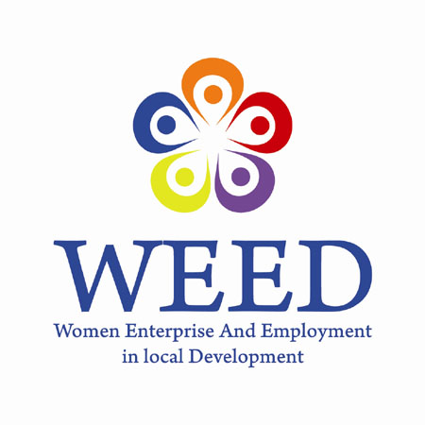

Source of funding: Urbact II programme (EDRF)

Project summary:
The WEED project is a thematic network of nine committed local authorities which aims to capitalize knowledge and practice around the participation of women on the labour market and entrepreneurship development. It is based on the premise that local government can play an important role in transforming positively their social and knowledge based asset linked to the women participation into the local economic life.

Considering that women’s involvement in economic activity has become a key element of the European Union’s move to ‘the most dynamic and competitive economy by 2010’ the network will focus in particular on the key issues of:

- women and entrepreneurship
- women in research and knowledge economy
- gender inequalities in the workplace and the labour market

Project partners:
Celje, Lead Partner (Slovenia),Enna (Italy),Karvina (Czech Republic), Umeä (Sweden), Crotone (Italy), Medway (United Kingdom), Santiago (Spain), Alzira (Spain), Amiens (France), QeC-ERAN (Belgium).

Activities:
Preparatory phase:
This phase consisted in completing the partnership with 4 additional cities and their managing authorities. Local Support groups have been established and undertook a local mapping of needs in relation to the themes of the project. Drawing on those materials a Baseline Study of the 9 partners’ issues and needs has been produced by the lead expert.
A proposal for the implementation phase has been prepared and the application form completed.

Operational Phase:
The first steering group meeting of phase two took place in Brussels on the 26-27 of March 2009. The SGM was the occasion to discuss further the Action Learning Set Methodology. The role of the local action groups and of managing authorities has also been discussed more in detail while Lead Expert Gill Scott explained how to build a local action plan. Moreover, the leaflet and the press release produced for the project by the communication manager were presented during the meeting and discussed by partners.

Finally, the 9 cities agreed to hold the first Transnational Exchange Workshop in Celje at the beginning of September 2009. The workshop’s focus will be on better strategies to foster women entrepreneurship at local level. The first project’s newsletter will be issued in July 2009.

Outcomes

- Establishment of first Action Learning set linked to the sub-theme of the first transnational workshop
- Planning and organisation of the first transnational workshop in Celje.
- Preparation of ALS pre workshop activities to prepare materials for discussion in the working groups
- Establishment of 9 Local Support Groups with a core Local Action Group.
- Preparation of first newsletter due by July 2009
- Establishment of the project’s website

Project coordinator: Annachiara Pecchini

Project length: Development Phase April 2008 - October 2008
Length: 6 months
Implementation phase January 2008 - June 2011
Length: 30 months

Building Health Communities - Urbact thematic network

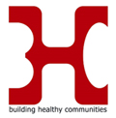

Source of funding: Urbact II programme (EDRF)

Project Summary and main objectives
The Building Healthy Communities (BHC) thematic network consists of a partnership of 10 cities from seven EU member states who will be working together over the next 30 months in order to capitalise knowledge and practices on urban factors influencing health and to create opportunities for cities to shape and implement healthy policies for their citizens. The network will concentrate its efforts on three sub-themes that are described in the Baseline Study carried out during the first phase of the project:

- Indicators and Criteria for a Healthy Sustainable Urban Development.
- Healthy Sustainable Lifestyle
- Use of Structural Funds in developing "Health Gains"

Partners:
Torino City Council (Italy), Lead partner, Lidingo (Sweden), Lodz (Poland), Belfast (UK), Amaroussia (Greece), Bacau (Romania), Baie Mare (Romania), Lecce (Italy), Madrid (Spain), Barnsley (UK)

Activities:
Preparatory phase:
During the preparatory phase the partnership was increased to 10 cities and their respective managing authorities. A Baseline Study was prepared drawing on the findings of the Local Support groups which were established in the 10 cities and which undertook a local mapping of needs in relation to the themes of the project. During the second Steering Group meeting in September 2008 the application to the second phase was discussed with the SG Members and the final proposal submitted in October 2008.

Operational Phase:
The first steering group meeting/kick off meeting took place in Brussels on the on 18-19 February 2009. Participants included project partner cities, Managing Authorities as well as representatives from the Urbact Secretariat and the European Commission (DG Sanco and DG Regional Policy). The Torino Management Team discussed the planned activities and lead expert, Marco Santangelo, explained the Action Learning Set Methodology. Participants agreed to organise the first peer review workshop in Lodz, Poland from the 7-10 June 2009.

Outcomes:

- Establishment of 10 Local Support Groups
- Baseline Study
- Three Steering Group meetings
- Planning and organisation of first workshop to be held from 7-10 June, Lodz (Poland)
- Establishment of project website
- Production of information material on BHC

Project coordinator: Torino Management Team and Isabella Haaf (Communication Manager)

Project length: Development Phase: April – October 2008 (6 months)
Implementation Phase: January 09- June 11 (30 months)

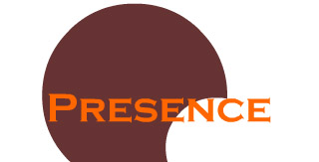

3.5 Presence

Project summary:
Presence is a network of independent experts from across the EU, specialised in regeneration issues which has been created at the beginning of 2007 as a social enterprise called Presence. Presence provides consultancy services to public bodies and third sector organisations that are active in EU programmes. Presence offers such services at a fee that will be determined to reflect capacity in the targeted sectors and not just flat “market rates”. The network of expert is committed to a social aim which is the establishment of a Social Investment Fund developed in order to create a sustainable source of co-financing to support innovative projects at an EU level. Beside that Presence will seek to undertake research for EU institutions through securing of contracts via the EU tendering procedures.

Activities:
Currently Presence counts 25 associates and has issued 15 contracts opportunities since its establishment. The last board meeting was held in Brussels on the 9 October 2008. Ways to further developed services for associates have been discussed. Closure of 2008 accounts as well as provisional budget for 2009 have also been presented. The website provides information on the services as well as information on the associate members. See www.presence-org.eu

Presence co-ordinator: Annachiara Pecchini

3.6 Intercultural Youth Panels

Source of funding: Europe for Citizens

Project Summary:
The project started on the 1st of February 2009 and will last 10 months. The project seeks to create 6 “Intercultural Youth Panels” (IYP) in the different partner locations. The aim of these panels would be to discuss the potentials and difficulties of belonging to a culturally diverse community. These groups would have to identify what are the opportunities that cultural diversity present in their areas in the development of a sustainable and inclusive city.

Project partners:
City of Torino, (IT), Region of Andalucía (SP), City of Lecce (IT), CEPS Barcelona (SP), Forumul Cetatenesc pentru Actiune Sociala si Educatie Civica (RO), District of Charlois, Rotterdam (Netherlands).

Activities:
As scheduled, we have established the Steering Group Committee and we have held the 1st Steering Group Meeting in Brussels on the 23rd – 24th February. According to the discussions and agreement held in the meeting, the project has been scheduled in the following phases, where some very little slight changes have been made to the plan provided in the project application:
- March 2009- Establishment of Coordination Teams linked to every Intercultural Youth Panel
- April 2009- Design of 6 local Activity Programmes
- By mid May 2009- The 6 Intercultural Youth Panels will be established.
- May 2009- August 2009- These 3 months will be the period where partners will develop the different activities at their local areas with their groups. In this period each local coordination team will design a Memorandum which will reflect, not only the activities that have been developed, but also the key messages coming from the panels and that would be directed to the EU institutions. The Memorandum will not be a formal document with a list of activities, but an informal way of expressing the ideas discussed in the panels. Each partner will choose freely the format (video, photo exposition, theatre play…etc)
- September 2009- Transnational Exchange Workshop that will take place in Brussels.
Expected Outcomes

- Profiles of the young members of the Local Coordination Teams
- Initial SURVEY to all the Coordination Teams regarding the issue of Interculturality; participation, etc.
- Local Activity Programmes
- Local Memorandums
- Transnational Workshop

Project coordinator: Tamara Hodas

Project length: 1st February 2009 – 30th November 2009

3.7 Managing Migration and Integration in Cities and Regions (MILE)

Source of funding: Urbact (Phase 1) and Urbact II (Phase 2)

Project Summary:
This project seeks to establish a thematic network of 10 Cities and 10 Regions which is based on the need to develop an integrated exchange programme relating to the theme of “Managing Migration and Integration in Cities and Regions”. The project is a pilot for the “Regions for Economic Change” (REC) programme." Regions for Economic Change is a proactive policy tool offered to Member States, regions and cities to help them implement the renewed Lisbon agenda through actions aimed at economic modernisation. The overall goal of the project will be to assist partner cities to develop and identify good practice project proposals for possible funding from ERDF, ESF or other EU or National sources of funding.

Project partners:
Venice and Veneto region, Lead partner (Italy), District of Rotterdam- Charlois and Rotterdam (Netherlands), Vantaa and Employment and Economic Development Centre for Uusimaa (Finland), Turin and Piedmont Region (Italy), Timisoara and Ministry of Development, Public Works and Housing (Romania), Komotini and Region of Easter Macedonia and Thrace (Greece), Sevilla (Spain), Amadora (Portugal), Nea Alikarnassos (Crete) represented by Heraklion Development Agency (Greece).

Activities:
Implementation of the operational phase of the project started with a first workshop on Enterprise Development for Migrants and Ethnic minorities, held in the city of Amadora (Portugal) 15-17 June 2008. In this workshop partners presented the actions plans they elaborated for this specific sub-theme.

The second scoping and exchange workshop was on Active Inclusion Measures for Labour Market Access organized in the city of Rotterdam (Netherlands) on the 08-11 July 2008. The workshop consisted in an exchange of good practice case studies from inside and outside the partnership and of starting the planning of action plans according to the priority needs identified in each partner city. Presentation of the action plans produced for this sub-theme took place in Brussels, on the 13-14 November 2008.

The third and last scoping and exchange workshop on Intercultural Dialogue and Access of migrants and ethnic minorities to Education, Health and Housing services was held in the city of Timisoara (Romania) on 09-12 December 2008 and the presentation of the action plans produced for this sub-theme took place in Venice on the 27 April 2009.

Action plans developed by each city, Workshops programmes and reports can be downloaded from the project website.

Outcomes:

- 27 action plans to be funded under the Operational Programmes of the European Structural Funds, other EU programmes and national funds, were elaborated by partner cities.
- Three reports on the actions and outcomes undertaken by the cities to develop action plans on the three sub-themes of the project were produced.
- Three newsletters were produced, one for each project sub-theme mentioned above.

Project Expert: Yamina Guidoum

Project length: Preparatory Phase May 2007-October 2007
Length: 6 months
Operational phase November 2007-May 2009
Length: 18 months

3.8 Integration Exchange: online integration services for third country nationals

Source of funding: INTI programme (the European Fund for the Integration of Third-country nationals) - DG Freedom, Security and Justice

Project Summary:
This project seeks to strengthen the implementation and awareness of the Common Basic Principles (CBP) at local/regional level. The CBPs were adopted by the Justice and Home affairs council in November 2004 and incorporated into the European Commission communication on A Common Agenda for Integration in 2005. These 9 CBPs are primarily intended to assist member states in formulating integration policies for immigrants by offering a simple, non-binding guide against which they can judge their own policies.

Project partners:
Qec-ERAN, Bruxelles (Belgium)- Lead partner, Kopint Foundation, Budapest (Hungary), Municipality of Crotone (Italy), Lecce (Italy), Mondo Digitale Foundation, Roma (Italy), Euroconsult, Enna (Italy), Amsterdam South East City Council (Netherlands), ITD, Barcelona (Spain), Diputación Provincial de Huelva (Spain), OLMEC, London (UK).

Activities:
The second and third Transnational Peer Review Workshops took place respectively in Lecce (Italy) on the 25th-26th of June 2008 and Brussels (Belgium) on the 26th-27th of November 2008. The themes of the workshops were:

  - “Access of third country nationals to education, health and housing” http://www.qec-eran.org/projects/inti_prew2.htm#lecce
  - “Promoting Intercultural dialogue & the participation of immigrants in the democratic process” http://www.qec-eran.org/projects/inti_prew2.htm#brussels

Outputs
The project has ended on the 31 March 2009. The main outputs can be summarised as follows:

- 3 reports were produced, one on each of the peer review workshops. These are available in: http://www.qec-eran.org/projects/inti_prew2.htm
- 9 portals were created for migrant new comers and available in the languages of the major migrant groups living in each city. The portals are available in: http://www.qec-eran.org/projects/inti_platform.htm
- 4 DVDs for the dissemination of the portals were produced for the cities of Huelva, Amsterdam, Lecce and London. The DVDs will soon be available on the project website: http://www.qec-eran.org/projects/inti_index.htm

Project coordinator: Yamina Guidoum

Project length: 20 August 2007- 31 March 2009 Total duration: 18 months

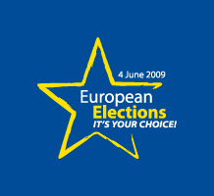
3.9 Local Forums for Developing Participatory Democracy

Source of funding: FUNDAMENTAL RIGHTS AND CITIZENSHIP PROGRAMME
Project summary:
The overall aim of this project is to develop innovative approaches to promote participatory democracy at a local/regional level which will increase the participation of young adults (18-30) in the 2009 EU elections AND raise their awareness of their fundamental rights and responsibilities as union citizens. In order to achieve this overall aim the project will create in each partners' location a Local Forum in order to bring together local expertise. The Transnational Exchange Programme will be organised in order to allow local forums to share their experience internationally.
Project partners
QeC ERAN (lead partner), Nea AliKarnassos (Greece), LOKAAL Rotterdam (Netherlands), Torino City Council (Italy), Municipality of Modena (Italy), Celje (Slovenia), CEPS Projectes Barcelona (Spain), Larnaca District Development Agency (Cyprus) and City Mine(d) London (UK).
Activities:
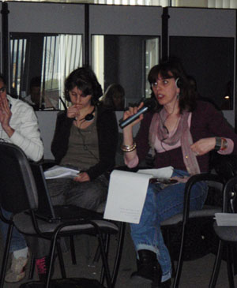
- The First Steering Group Meeting of the project took place in Brussels on the 21st and 22nd of January 2009. in order to discuss the implementation of the project and explain to partners its administrative management. During this meeting it was decided to to hold the First Peer Review Workshop on the subject of “Promoting Youth and EU migrants participation in the EU Parliament elections 2009”
- The workshop (see above) took place from the 20th till the 22nd of April in Brussels and its general aim was to provide partners with support in implementing local strategies for promoting participation, which were developed by each partner since the First Steering Group Meeting. During these two days 30 Local Support Groups members were provided with the presentations of external experts on campaigning tips and effective ways of connecting and communicating with young people and migrants, underlining the use of new technologies like social networking (facebook, twitter, flicker, etc ...), blogging and other internet connected actions.
- In terms of next steps it was decided to create a twitter discussion group on the shape of the Participation on line platform where the next Peer Review Workshop will be held and to prepare a final event on the on lines tools available for the promotion of the Participatory Democracy, which will take place in Barcelona in January 2010.
Outputs:
- 8 local strategies to promote participatory democracy
- interactive platform facilitating communication and Participatory Democracy Promotion
- dissemination material
- workshop reports
- local websites in each partner location
Project coordinator: Karolina Rachwal
Project length: 1 January 2009 – 30 June 2010 Total duration: 18 months

3.10 Laps and Raps II

Source of funding: DG Employment, Social Affairs and Equal Opportunities

Project summary:
The review of the Lisbon Strategy has highlighted the need to strengthen the link between Structural and Cohesion funds and anti-poverty, equal opportunities and social inclusion policies. This project seeks to cascade the outcomes of a the previous Laps and Raps I project which has developed as an outcome a framework and methodology for local and regional action plans for social inclusion. The project will be linked to production of thematic action plans that will seek to secure funding from Operational Programmes (ERDF and ESF) as well as other EU and national sources.
Project partners:
Javni zavod Socio, Celje, Slovenia (lead partner), -Intercultural Institute Timisoara (Romania), -Regional Social Welfare resources centre (Hungary), Institute for Social Security (Portugal), Office of Labour, Social Affairs and Family in Malacky (Slovakia), -Centre for information and support for large families (Lithuania), Ministry of Labour and Social Affairs Department of EU and international cooperation (Czech Republic), Foundation “Our School” (Poland)
Activities:
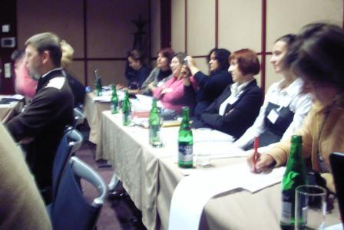
- Second Transnational Exchange Workshop, Prague 1-3 October 2008
The second workshop, which had homelessness as its theme, took place in Prague from the 1-3 October. After a short overview of the project and its relation to the EU social inclusion process, participants focused on the Laps and Raps framework and methodology which was developed under the Laps and Raps I project. On the second day case studies from Slovenia, Portugal, Hungary, Romania and the Czech Republic were presented on the subject of homelessness.
- Third Transnational Exchange Workshop, Lisbon, 12-13 March 2009
The theme of this workshop was demographic change and services for older people. On the first day of the workshop the focus was on the social protection system of host country Portugal. The second day was dedicated to case studies on demographic change and the possibilities for “Active Aging” in Lithuania, Poland, Romania and Hungary. Workshop delegates also participated in field trips to various locations in Lisboa providing services to the ageing population.
All workshop presentations are available on the Laps and Raps website. The fourth and final workshop is planned to take place on 16-18 September 2009 in Slovenia.
Outputs:
- Two workshops and workshop reports
- Two Steering Group meetings
- Information service through the Laps and Raps website
- Production of thematic action plans that seek to secure funding from Operational Programmes (ERDF and ESF) as well as other EU and national sources.

Project Coordinator: Suzi Kvas, Celje Management Team

Project length: January 2008- January 2010, total duration: 24 months

MEMBERSHIP

Executive Bureau

President Ilda Curti, Deputy Mayor for Urban Development and
Integration, City Council of Turin, Italy
Vice-President Lionel B. Martijn, Deelgemente Charlois, Rotterdam, (NL)
(Honorary)
Honorary Secretary Jude Kehla- Wirnkar, District Council Amsterdam South East (NL)

Treasurer The Right Honorable Lord Major, Belfast
Represented by Laura Leonard, Belfast City Council (UK)

Members Bernard Dallons, President CPAS Charleroi, Belgium

Luana Zanella, City Council of Venice, Italy

List of Members and Associate Members

Country | Organisation
Belgium | Centre public d’action sociale de Charleroi (CPAS)
Bulgaria | Ministry of Labour and Social Policy, Social Protection Unit
Bulgaria | Municipality of Varna
Czech Republic | Ministry of Labour and Social Affairs
Czech Republic | Civil Society Development Foundation, NGO
Czech Republic | City of Prague, Department of Social and Health
Czech Republic | Silesian Diacony, NGO
Czech Republic | MEPCO, NGO
Czech Republic | Karvina municipality
Estonia | University of Tartu, Department of Sociology and Social Policy
Finland | Uudenmaan TE-Keskus (Employment and Economic development centre for Uusimaa)
France | Comite de Quartier de l’hommelet
France | Communauté d'Agglomération Chalon/Val de Bourgogne
France | ACCEDO
France | Toulouse City Council
Germany | Kreisausschuss des Odenwaldkreises
Greece | City of Komotini
Greece | Region of Crete
Greece | Municipality of Nea Alikarnassos represented by Heraklion Development Agency
Greece | Municipality of Thessaloniki
Greece | Aristotle University of Thessaloniki – Department of Psychology
Greece | ASDA - Association for the Development of West Athens
Greece | Amaroussia Municipality
Hungary | Kopint Datorg Foundation, Budapest
Hungary | BSZF-BudapestRegional social welfare resources centre
Hungary | Institute of Sociology at the Hungarian Academy of Sciences
Hungary | JOL-LET Foundation
Hungary | Soteria Foundation, NGO
Hungary | Equal Opportunity Office of the Municipality of Budapest
Hungary | City of Budapest, Mayor's Deputy Office for Health and Social Policy
Hungary | Studio Metropolitana, Budapest
Hungary | Budapest - Studio Metropolitana
Italy | City of Lecce
Italy | Fondazione Mondo Digitale, Roma
Italy | Euroconsult, Enna
Italy | Provincia di Crotone
Italy | Rete Sociale Monti- Dipartimento di Studi Urbani
Italy | Rete Sociale Monti – Dipartimento di Studi Urbani – Università Roma 3
Italy | Teatri Del Cielo
Italy | Centro Sicilia Servizi – Enna
Italy | Citta di Cozenza
Italy | Citta di Crotone
Italy | Citta di Torino
Italy | Comitato Progetto Porta Palazzo - The Gate
Italy | Comune di Cutro
Italy | Comune di Roma – Department XIV Local development, training and employment policies
Italy | Comune di Venezia
Italy | Fondazione Brodolini –Roma
Italy | Consorcio Provinciale per i Servizi Social (Crotone) (Crotone)
Latvia | The Latvian Association of Local and Regional Governments
Lithuania | Center of Information and Support for Large Families
Poland | BPW-Poland, Business and professional women
Poland | City of Starogard Gdansk
Poland | Ministry of Labour and Social Policy, Department for Social Protection
Poland | “ Wieś w XXI Wiek” Foundation, NGO
 | Lodz City Council
Poland | Lodz Child and Family Support Association, NGO
Poland | City Council of Gdansk,  Social Policy and Health Protection Committee
Poland | Fundacja Nasza Szkoła, NGO
Poland | The Foundation for Social and Economic Initiatives, (FISE), NGO
Poland | Polska Federacja Klubow “Business and Professional Women”, Federation
Portugal | City of Amadora
Portugal | Faculdade de Letras da Universidade do Porto
Portugal | Montijo municipality
Portugal | Instituto da Segurança Social
Romania | General Directorate Managing Authority for Regional Operational Porgramme, Ministry of Development, Public Works and Housing
Romania | Intercultural Institute Timisoara
Romania | The Bacău Local Development Agency (LDA)
Slovakia | Regional Development Agency Senec - Pezinok
Slovakia | City of Pezinok
Slovakia | Bratislava Self-Governing Region
Slovakia | Labour Office of Malacky
Slovenia | Center of the Republic of Slovenia for Vocational Education and Training
Slovenia | JAVNI ZAVOD SOCIO
Slovenia | Skala, NGO
Slovenia | Javni Zavod Socio, NGO
Spain | City of Sevilla
Spain | City of Herrera de Los Navarros
Spain | Diputacion Provincial de Huelva
Spain | Associación per la Creació i Estudis de Projectes Socials
Spain | Asociación de Mujeres Empresarias de Sociedades Laborales (AMESAL)
Spain | Associacio per a la creacio i estudis de projectes socials
Spain | Federación de Municipios y Provincias de Castilla la Mancha (FEMPCLM)
Spain | Innovación, Transferencia y Desarrollo (ITD) - Barcellona
Spain | Toledo City Council
Sweden | Lidingo City Council
The Netherlands | Rotterdam City Council
The Netherlands | Municipality of Den Helder
The Netherlands | SBO – Council for the Education Labour Market in The Netherlands
the Netherlands | Deelgemente Charlois Rotterdam
the Netherlands | Amsterdam Southeast District council
Turkey | City of Dalaman
Turkey | City of Istanbul
Turkey | Union of Municipalities of Akdaglar
UK | Birmingham race action partnership (BRAP)
UK | Presentation - OLMEC, London
UK | Shantona Women's centre
UK | Birgminham Race Action Partnership
UK | Communities Scotland Glasgow
UK | Social Investment Agency
UK | Refugees and the Arts Initiative
UK | Islington training network
UK | Coventry City Council
UK | Newcastle City Council
UK | Liverpool - Heart of Mersey
UK, Northern Ireland | City of Belfast and HSC Belfast Health and Social Care Trust

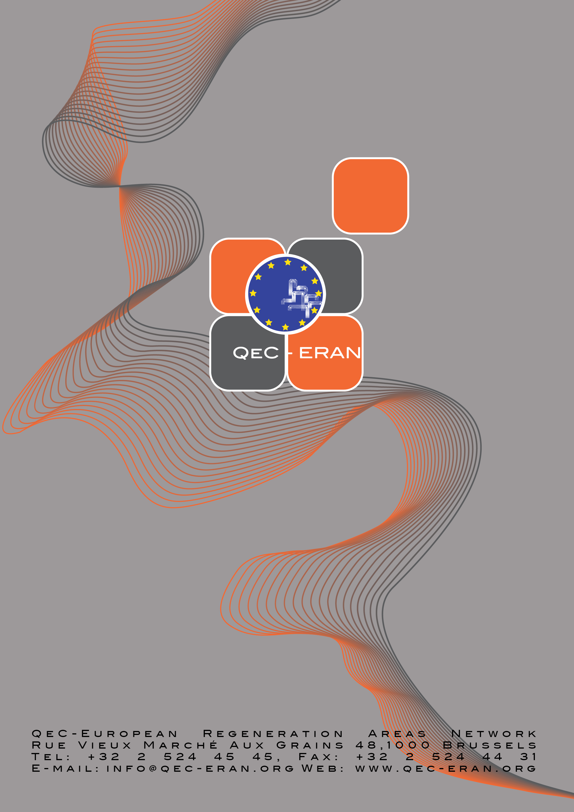

“Fostering the urban dimension – analysis of the Operational Programmes co-financed by the European Regional Development Fund (2007-2013)”, Working Document, November 2008, page 3-6

